OHIO STATE UNIVERSITY EXTENSION
NEWSLETTER

NOBLE COUNTY AGRICULTURE AND NATURAL RESOURCES SEPTEMBER | 2015

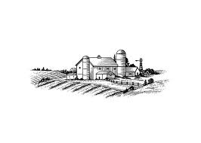
SEPTEMBER NEWSLETTER

Fall

Programs/Inj. Prev Page 2

Upcoming. Page 3

Bagworms Page 4

Research Update…… Page 5

Flyers….…..See Attached

With the month of September brings the official start of fall on the 21st. Thankfully we finally got some summer weather in end of July and through August. Crops, hayfields and gardens are starting to perk back up after the incessant rains and hopefully everyone was able to carry on as “normal” as possible. I’ve had quite a few people bringing in plants and pests and those are always fun to identify, so if you see something unexpected, please share it! I’m also happy to answer any other questions, so feel free to stop by, call or e-mail.

Injury Prevention
Harvesting or Gardening with Arthritis

AG S.T.A.T Newsletter
Andy Bauer, Ohio AgrAbility Educational Program Coordinator

Arthritis tends to affect most farmers and gardeners in their hands, knees, and hips because these joints take the most pressure. These same joints also are affected by people with other physical limitations such as limited mobility, knee pain, fatigue, and unable to get up if sitting on the ground. Simple tips will help in making the task at hand easier to do.

- Plan your day ahead -Do the more physical jobs first early in the day when it is cooler and you are not as tired.
- Don’t try to do all the jobs at one time, take regular breaks and allow your body time to rest and recover.
- If the day is hot, get into some shade to cool off. Change the tasks you are doing to reduce fatigue.
- Use a cart, wagon, or other means to take your bucket, tools and supplies to the garden at one time. Cut down on repeated trips.
- Ask for help in doing cumbersome tasks.
- Avoid stressful positions and change positions frequently.
- Use a garden stool or chair when possible to take the weight off your joints.
- Use knee or kneeling pads to reduce stress when working on your knees.
- Use foam pipe insulation to build up handles on buckets, baskets, or other items used to reduce stress on the hands.

Remember: Pain is the body’s way of telling you to slow down or stop for the day. Respect it. Have an enjoyable gardening experience.

For more information on Arthritis contact the Arthritis Foundation at www.arthritis-ag.org for a booklet titled Arthritis and Agriculture: A Guide to Understanding and Living with Arthritis or the Ohio Agrability Program at www.agrability.osu.edu or Andy Bauer at www.bauer742@osu.edu or (614) 247-7681.
Program Information Online

You can now access information that has been presented at current programs online a week or two after the program has occurred. This mostly includes the PowerPoint’s that were distributed. In some cases, it might not be applicable to post information, especially if the participants have a fee to obtain a large amount of information.

You can also view the newsletter online as well as flyers for current programs that are happening in the area. Please be sure to note registration deadlines.

Things sometimes come up in between newsletter mailings so check the blog for more information :

u.osu.edu/nobleanr/
u.osu.edu/bhanr/

Be sure to “subscribe” for email alerts when new information is available

UPCOMING PROGRAMS

- Noble County Fair
August 31-September 5

- Farm Science Review
September 22-24

- Beef School
October 6, 13 & 20th – Eastern Area Research Station for the 6th and 13th sessions, Ball Farm for the 20th
5:30 p.m. – 8:00 p.m.

- Grazing Day
October 24 – Eastern Area Research Station
10 a.m. – 2 p.m.

- Livestock Photography Workshop
November 4th – OSU Extension Office Noble County
5:30-8:00pm

Look for information on upcoming programs soon!

For more information or to register call the office at 732-5681 or email pye.13@osu.edu

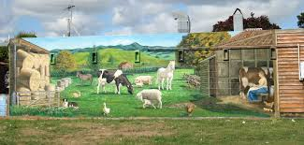
Caption – tell something about what is going on in the picture

For your Home

As I was looking for “farm scene” pictures for my newsletter this month I accidentally came across this very cool website magicmurals.com

They have some really neat farm scenes and you can actually turn your own photo into a wall mural.

I was thinking of asking my big boy if he was interested in picking out some new things for his room, as it still has his nursery theme, and I’m thinking about including these in it!

Q & A

In this new section of the newsletter, I will highlight questions I have recently received in the office and share my findings.

PEST ID:
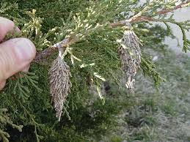

Bagworms

This is the 3rd summer I have been the educator in Noble County and every summer I have received a sample to identify which are bagworms.

Bagworms are actually the larvae of moths. The brown bags shown above are usually attached to twigs and are up to two inches long. At first, the caterpillar drags the bag around as it feeds on leaves enlarging the bag as it grows. These bags are constructed from interwoven bits of dead foliage, twigs and silk. By late August the caterpillar finishes feeding and attaches the bag to a twig. It is at this time the caterpillar will form its pupa and several days later will emerge as an adult moth. The female is wingless and will remain in the bag until a male flies to the bag to mate, at which point she will lay a mass of eggs within the bag and die.

Eggs will then hatch in May or June. The Newly hatched caterpillars will crawl out of the bag and immediately begin feeding on leaves. Infestations may become so severe that complete defoliation occurs, stunting and even plant death can occur in evergreen species.

Bagworms can be controlled with an insecticide such as Sevin Liquid. Application is most effective in late May and mid-July when the worms are active. Be sure to check the label to ensure your plant is listed on the label as safe to use. If leaf damage is still occurring after 10 days, repeat the application. During this time of year, the only control method that can be done is to hand pick the bags from the trees if possible and dispose of them in hot, soapy water. This will help to decrease the number of eggs that will hatch out for next year.

Ortho Problem Solver

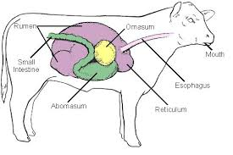

Research Update – Building Gut Health

Yang, M., Zou, Y., Wu, Z. H., Li, S. L., & Cao, Z. J. (2015). Colostrum quality affects immune system establishment and intestinal development of neonatal calves. Journal of Dairy Science. Advance online publication. doi: 10.3168/jds.2014-9238
BACKGROUND: Much literature has been published concerning the difference between either feeding colostrum or milk replacer, but a paucity of published data is available on the difference between feeding true colostrum (first milk after calving) and transitional milk (subsequent 3-5 milk secretions) in neonatal calves.
PURPOSE: The purpose was to explain the effect of feeding either colostrum, transition milk, or bulk tank milk only on the day of birth on IgG absorption, immune and antioxidant status, and intestinal morphology and histology in neonatal calves.
RESULTS: Passive transfer of IgG, serum antioxidant concentrations, growth index, and intestinal development are markedly dependent on colostrum quality ingested on the day of birth. Although effects were similar between colostrum and transitional milk fed groups in some parameters, calves that received colostrum performed better in IgG absorption, antioxidant activities and serum growth factors, villus length and width, crypt depth, and mucosal thickness. On the other hand, villi in bulk tank milk fed calves were severely atrophied, and some histological changes were detected.
CONCLUSIONS: The authors concluded that findings shows that higher quality colostrum can help calves establish their own immune defense mechanism and antioxidant system immediately after birth, which could assist in reducing the effects of harmful microorganisms, promoting intestinal development, and as a result decrease morbidity and mortality in calves. Therefore, it is essential to supply high-quality colostrum to neonatal calves.

While this article focuses primarily on dairy cattle, the principles remain true for all ruminants. The rumen houses the microbes responsible for maintaining the balance of these microbes that enables the animal to digest food properly and efficiently. IgG refers to immunoglobin G which is the smallest but most abundant type of antibody found in the body, making up about 75-80 percent of all the antibodies found in the body. More research continues to explore the importance of gut health and it’s relation to overall animal health and well being.

NOBLE COUNTY EXTENSION OFFICE
46049 Marietta Road
CALDWELL, OH 43724

Phone 740-732-5681
noble.osu.edu

CFAES provides research and related educational programs to clientele on a nondiscriminatory basis. For more information: http://go.osu.edu/cfaesdiversity.

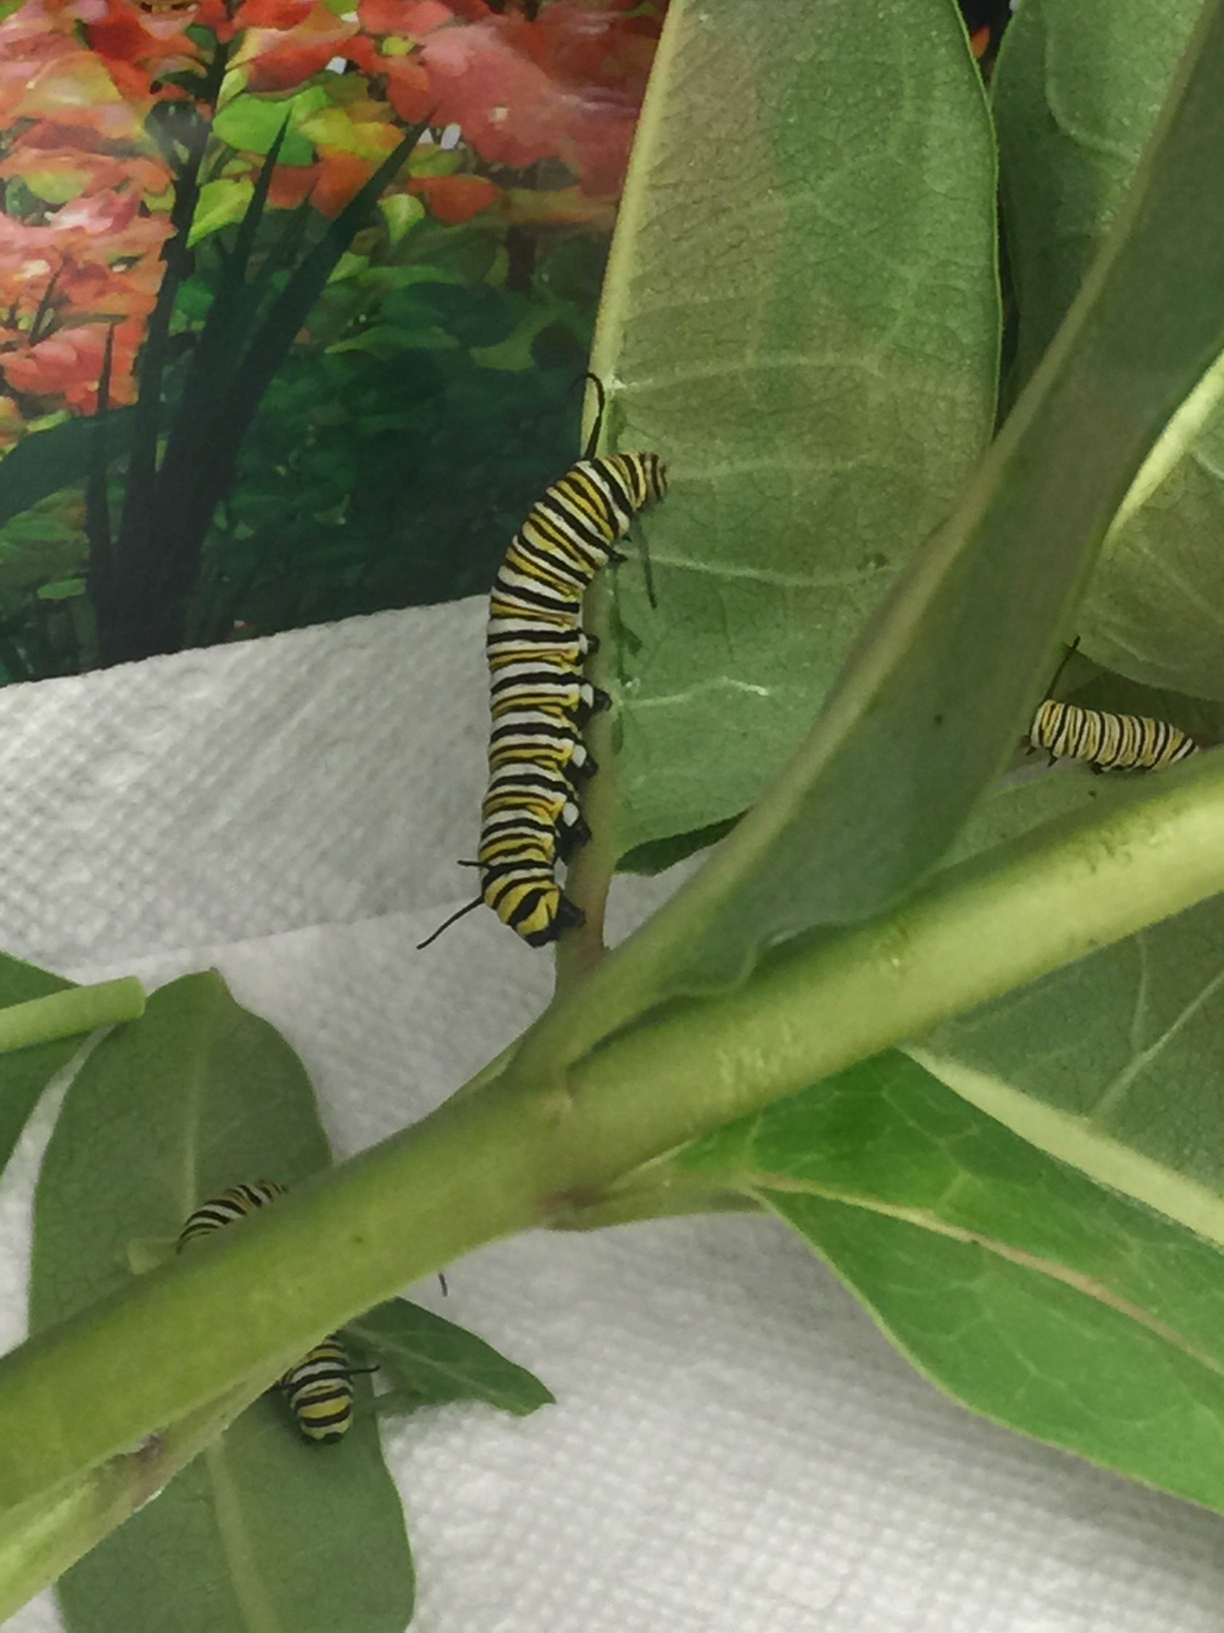

A few of the monarch butterfly caterpillars we have been raising in the office.

