Identifying Black Lasioglossum Leuchalictus subgenus
- Body BLACK without metallic reflections
- Second submarginal crossvein (1rs-m) as strong as first – same thickness
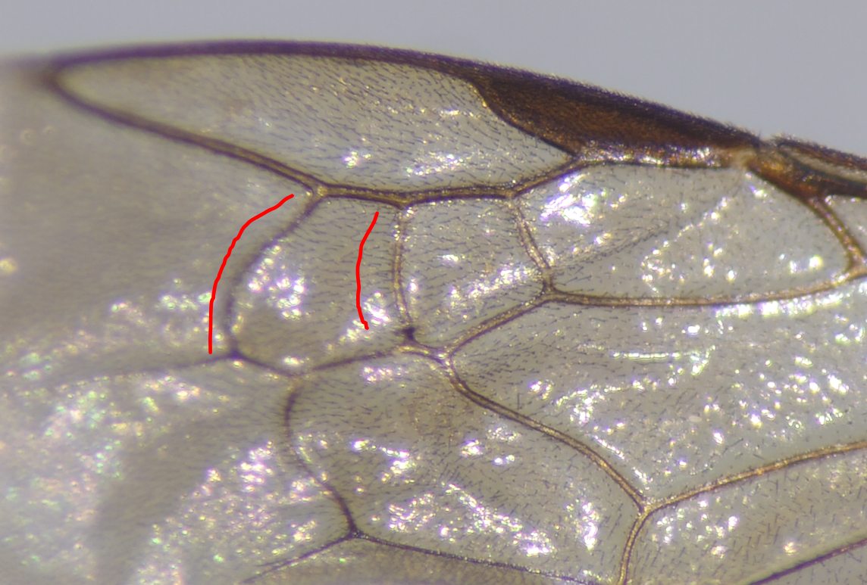
- Propodeum with striations that go all the way to the edge; lateral carina well developed; Metapostnotum coarsely sculpted, shorter than scutellum; t1 WITHOUT basal tomentose band; head long
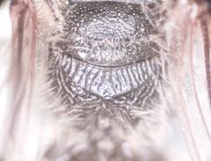
= Lasioglossum (Leuchalictus)

Only 2 species of this subgenus known to occur in North America: Lasioglossum leucozonium and Lasioglossum zonulum.

From 1960 Mitchell Key to differentiate the two species:
L. leucozonium antero-lateral angle of pronotum forming obtuse angle; basal segment of abdomen uniformly punctate and slightly duller this species is considered non-native in North America
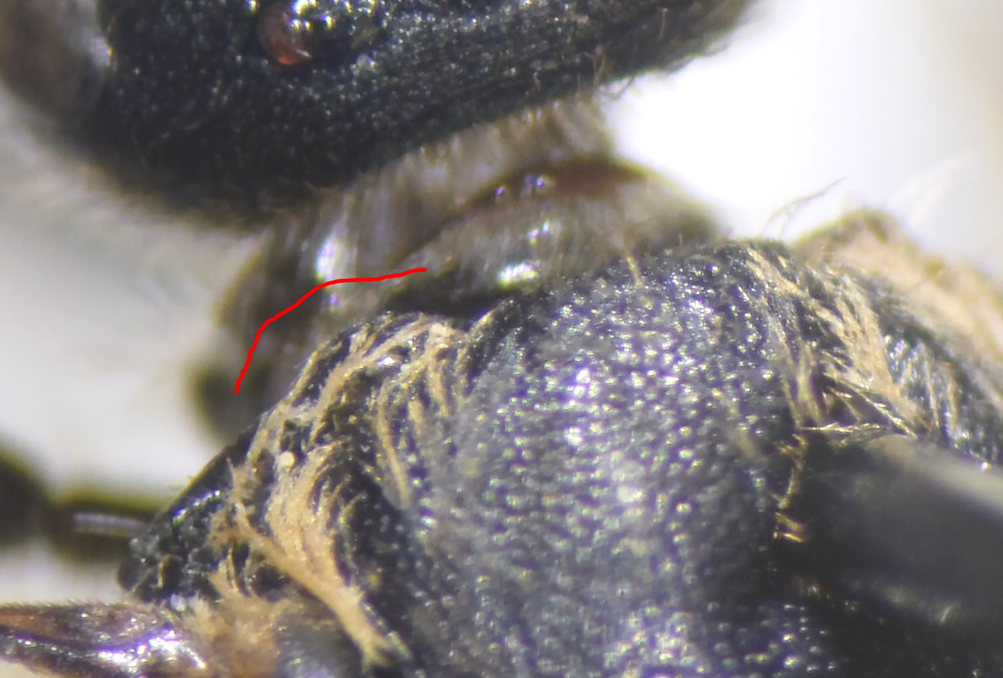
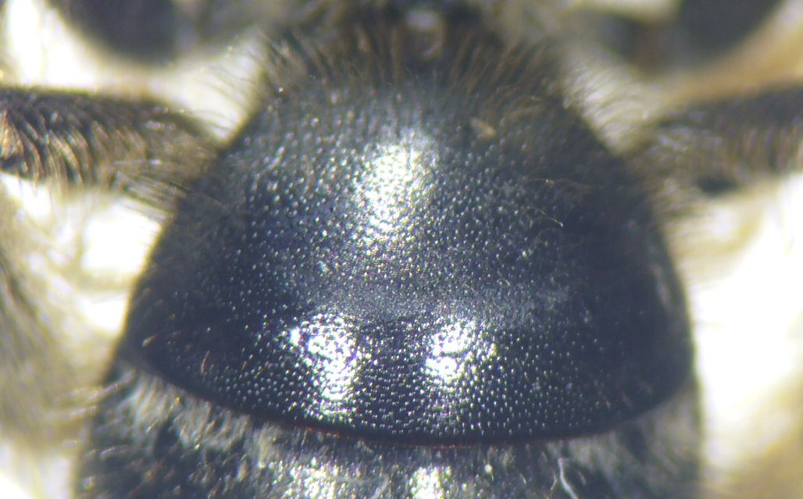

L. zonulum antero-lateral angle of pronotum forming a right angle; basal segment of abdomen sparsely punctate in center – look carefully. Some punctures still evident, but more than 3 puncture widths separated in center. T1 shiny in comparison to that of L. leucozonium
