Identifying Big Female Black Lasioglossum Lasioglossum Sensu Strictu
The specimen MUST fit all of characters 1-3. The 4th determines species.
- Black integument with NO metallic reflections.
- Propodeal sculpting less than 25% - smooth and unmarked over posterior half Lasioglossum Sensu strictu group
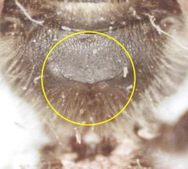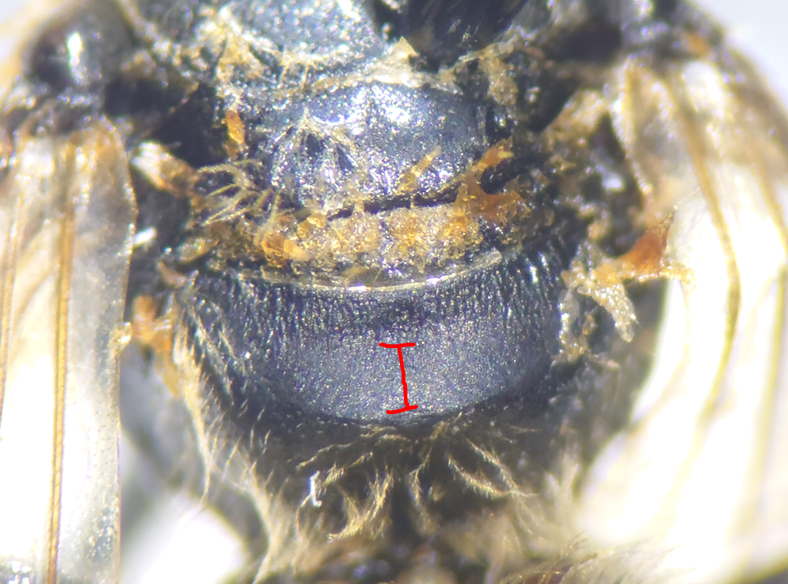
- T2 on abdomen with a complete white band of appressed hairs along the BASE of the segment. Sometimes hard to see or mucky.
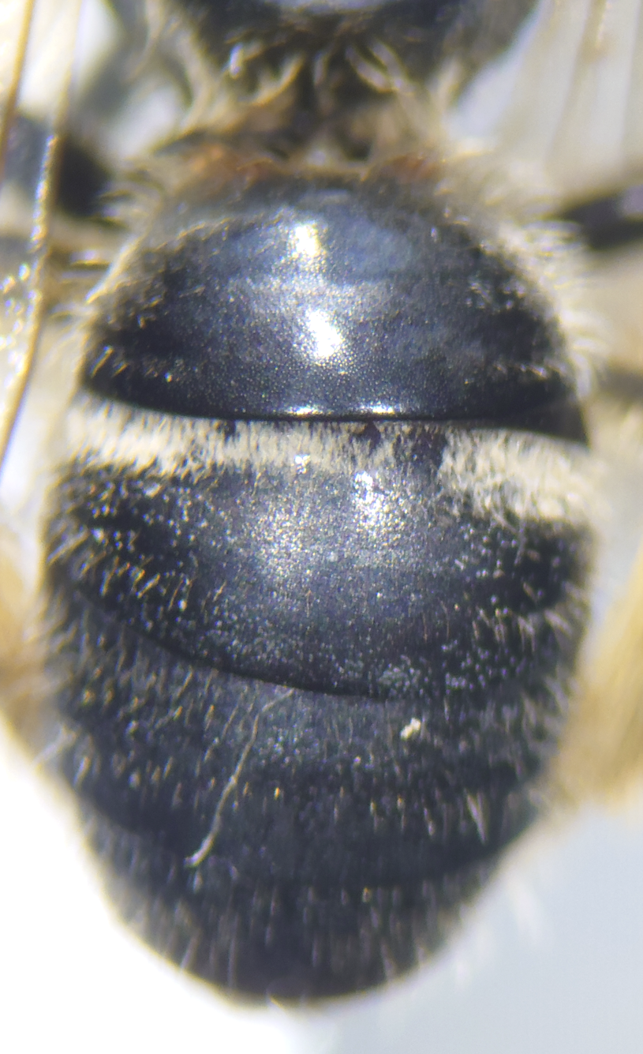
- T1, part that is facing the propodeum, hard to see. Move specimen around under microscope to get a good view when their abdomen is held close to the body
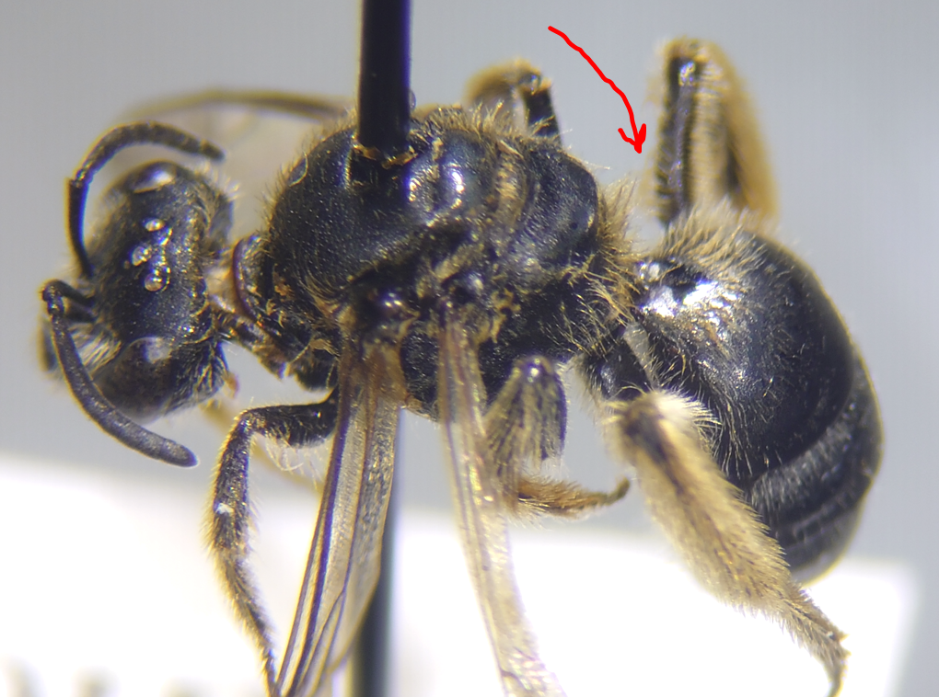
a. Hairs are present to form a circle with a ROUNDish or heart shaped bare spot in the center.
This is Lasioglossum coriaceum
Most of our Ohio specimens are this species, but keep an eye out for the other species listed below.
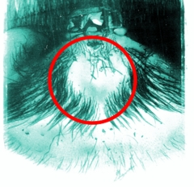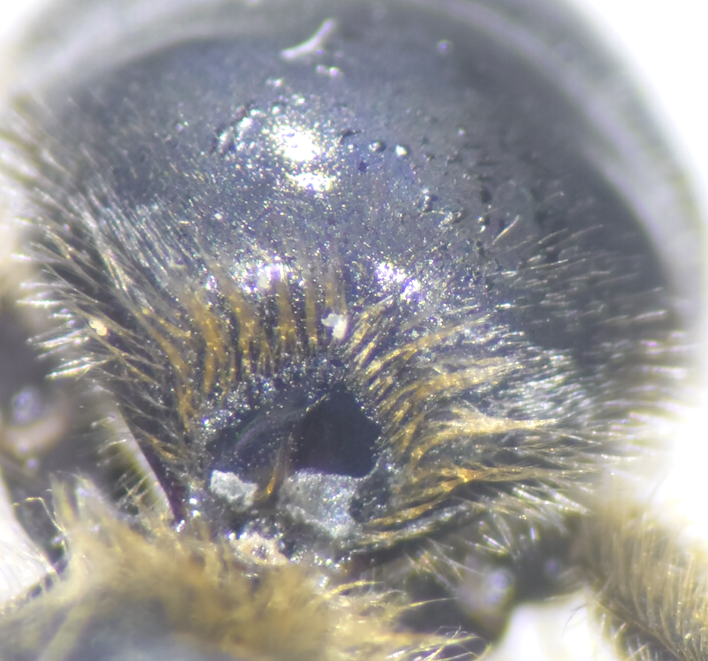
b. If the bare spot on t1 is more triangular/arrow shaped, then it is Lasioglossum acuminatum
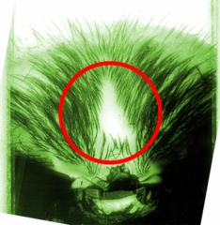
- If bare spot encircled by hairs but with an opening at top that is as wide or wider than fringe of hairs on either side then it is Lasioglossum paraforbesii
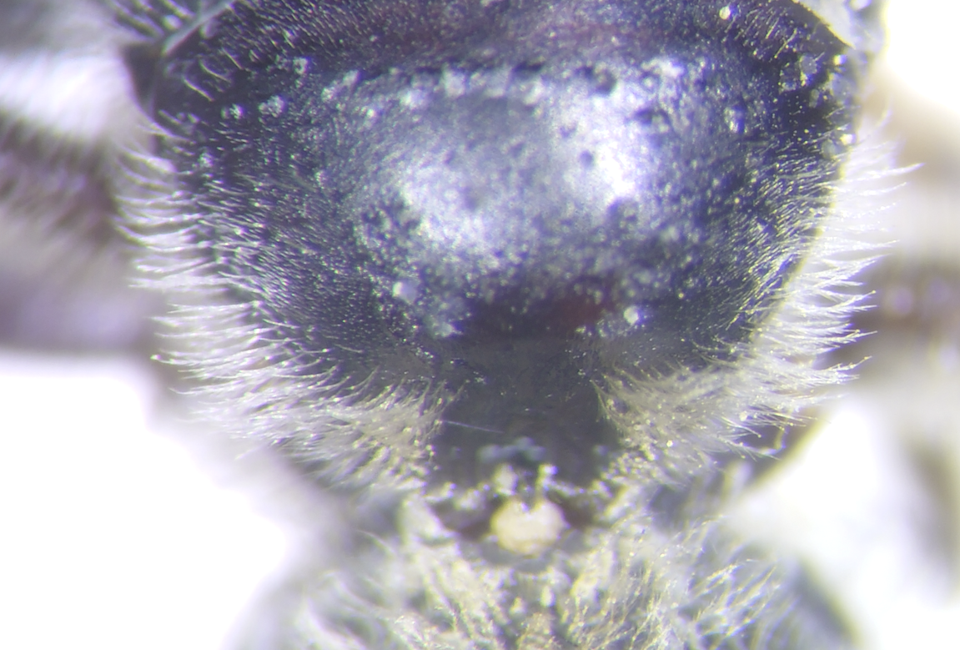
- If there is no distinct bare spot, and only sparsely scattered hairs, then it is Lasioglossum fuscipenne. Note that fuscipenne has a sharp, almost 90 degree pronotal angle. Note also that this species should have a propodeum with longer longitudinal striae that do not quite reach the margin, so if you followed step 2 above you will have already ruled out this species. Be careful with confusing this species with Lasioglossum (Sphecodogastra) truncatum.
Photo needed of t1 for fuscipenne

