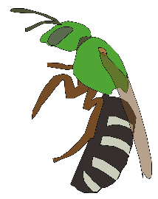
Ohio Bee Survey
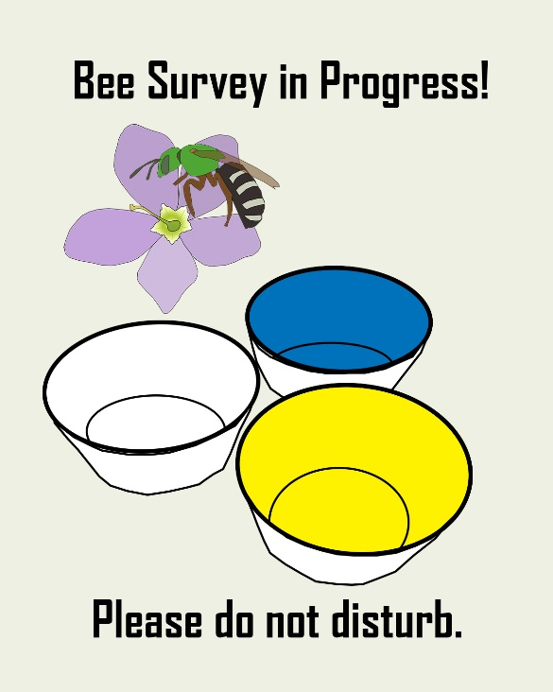
Ohio has an estimated 400-450 species of bees based on what has been found in other states. However, we have never had a statewide survey that attempts to document our own biodiversity. The Goodell and Mitchell Labs recently completed a bumblebee survey for Ohio, but that is only a subset of species we would expect.
A majority of bees are not identifiable to species without viewing them under a microscope to see the characters necessary to differentiate them. Thus, we need to collect specimens to properly identify them. Specimen collections generally do not have an impact on the overall bee population. The numbers of specimens collected in the traps are often less than what a typical bird consumes in a year.
As part of our statewide effort to document native bees across Ohio, we have distributed 150 collection kits to collectors across Ohio. These collectors are gathering specimens once a week using bee bowls. The goal is to repeatedly sample the same site across the year to get a better understanding of the species turnover and therefore maximize the number of species we document across Ohio.
Support for the Ohio Native Bee Survey via Collection Kits comes from The Manitou Fund.
Questions?
Check out our webpage:
https://u.osu.edu/beesurvey/native-bee-survey-via-specimen-collections/

