When a Focusing Event Does Not Solve the Problem: The Case of the Toledo Water Crisis

For three days in August 2014, half a million Toledo residents could not drink, brush their teeth, or do their dishes with water from their faucets. The cause was a large bloom of the toxic algae near the city’s water intake in Lake Erie, overrunning the treatment plant’s ability to treat the water to a safe level. The crisis received worldwide news coverage, acting as a focusing event on the decades-long problem of harmful algal blooms in Lake Erie. While this focusing event had the potential to galvanize policy to solve the problem, five years after the Toledo water crisis continuing algal blooms make it clear that potential has not been realized.

Focusing events open a window of opportunity in which problems can be matched with solutions and politics can be aligned to make adoption of the solution more likely. Previous studies have examined how focusing events pull together the problem, politics, and policy streams to create rapid change in the cases of Hurricane Katrina (Farley et al., 2007), avian influenza (DeLeo et al, 2012), the Deepwater Horizon disaster (Bishop, 2014), and more. However, most previous research looks only at how the initial policy change was created and does not go beyond that point. Thus, the gap in knowledge addressed by this study is: What happens after a focusing event creates policy change – particularly if the initial policy change is not enough to address the problem that led to the focusing event in the first place? For example, we don’t know whether stakeholders will see the problem has not been solved and decide to make additional change, or if legislative mandates will be needed. Answering these questions will help policy makers, stakeholders, and advocacy groups understand the strategies needed to solve the root problem. Without this understanding, the problem may not get solved at all.

A focusing event is an event that is sudden, uncommon, harmful, concentrated in a geographical area or community of interest, and known to both policy makers and the public (Birkland 1998). Focusing events create change by pulling together three streams: the problem stream, which contains ideas about various problems in society; the politics stream, which contains public opinion, agenda setting, and electoral politics; and the policy stream, which contains ideas about how problems can be addressed by government (Kingdon, 2003).

The long-term goal for this project is to understand the role of focusing events in public opinion, agenda setting, and policy-making. The objective is to examine not just how focusing events lead to initial policy change, but also how events play out in the years after, especially for cases in which the initial policy change does not solve the problem. This project will examine these dynamics through a case study of the Toledo water crisis. In this case, the chief cause is phosphorus, which has been widely eliminated from point-sources but is unregulated from non-point sources such as fertilizer runoff. About 85% of phosphorus runoff in the Maumee watershed comes from fertilizer used in agriculture (Scavia et al, 2016). Phosphorus drives the growth of algae in Lake Erie, leading to large often toxic blooms, with significant economic, public health, and environmental impacts.

In the aftermath of the Toledo water crisis, policy changes took place on three levels. First, Ohio, Michigan, and Ontario made a commitment to reduce phosphorus runoff 20% by 2020 and 40% by 2025. Second, the Ohio state legislature passed laws prohibiting farmers from applying manure to frozen fields and requiring farmers to obtain certification on managing runoff. Third, the state established a voluntary certification program for farmers who want to implement conservation methods to reduce phosphorus runoff. But under pressure from farm lobbying groups, the state stopped short of passing regulations over how farmers must operate on their farms or requirements to measure and lower amounts of phosphorus runoff from farms (Arenschield, 2016).

Since the Toledo water crisis, it has become clear these initial policy changes are not enough. Rather than a reduction in harmful algal blooms, Lake Erie saw severe algal blooms in 2015 and 2017, with another severe bloom forecast for 2019. Many agricultural fields in the Maumee watershed have phosphorus runoff levels far above the target recommended by Annex 4 of the Great Lakes Water Quality Agreement (King et al, 2018). Thus, it is important to identify next steps when focusing events do not lead to the policy change needed to solve the problem. Will stakeholders in the Maumee watershed make additional change because they see the problem has not been solved, or will mandates – possibly as the result of another crisis -- be required?
I will study this question in the case of the Toledo water crisis by examining two scenarios for additional policy action – voluntary action vs. mandatory requirements. In Scenario 1 of voluntary action, farmers receive state assistance to install Best Management Practices (BMPs) that lower phosphorus runoff from their farms, including cover crops, riparian forest buffers, wetland restoration, subsurface fertilizer application, and phosphorus filters. They are incentivized but not required to install one or more these systems. In Scenario 2, the state sets up a licensing and inspection system for farm fields in the Maumee watershed. Farmers still get state assistance to install BMPs, but must do so in order to get a license to farm.

These scenarios will be tested in three steps:
- A survey of farmers will be conducted to assess how many would voluntarily install BMPs on their farms with state assistance, and if they would not, what the barriers to adoption are. The survey will also assess their reactions to a mandatory licensing and inspection program. This survey will be supplemented with three sets of focus groups to gather in-depth information from a) farmers whose farms have high phosphorus runoff, b) agriculture organizations, and c) and policy makers.
- Based on the results of the survey and focus groups, scenarios for voluntary and mandatory policies will be will be entered into a watershed model to see how much these scenarios lower the amount of phosphorus runoff from farms, and if that is enough to reach a 40% reduction by 2025.
- The costs of both scenarios will be calculated. Scenario 1 involves sending state agents to farms and paying for BMP installations. Scenario 2 involves the same expenses for installing BMP systems, with the additional expense of setting up a state licensing and inspection system.

The hypotheses for this study are:
- Although stakeholders are more aware of the problems with harmful algal blooms as a result of the Toledo water crisis, they will still prefer voluntary action.
- Voluntary action will not be enough to lower phosphorus runoff by 40% by 2025. Mandatory programs will be necessary.
- Mandatory programs will cost more than voluntary measures.

Figure 1 (next page) describes this project, outlining both the current state of knowledge about how focusing events lead to creation of public policy, as well as the gap in knowledge about what happens if the initial policy does not solve the problem. At that point policy makers have the choice of allowing stakeholders to make additional change to address the issue voluntarily or enacting mandatory requirements for change. While stakeholders may prefer voluntary change, if that is not enough to solve the problem, then they risk the occurrence of another focusing event that would likely lead to mandatory changes anyway.

As someone who holds dual master’s degrees in public administration and environment and natural resources, I am well suited to do this research. I have an understanding of both the policy process as well as environmental issues such as toxic algae blooms, and am in a position to apply research in one to solve problems in the other.

The aims of this study are to determine whether voluntary adoption of best management practices by farmers will be enough to reach the goal of lowering phosphorus runoff in the Maumee watershed 40% by 2025, or if mandatory programs will be necessary, and to determine how much voluntary and mandatory programs cost.

Addressing our gaps in knowledge about policy change in the wake of focusing events will provide a roadmap not just for dealing with harmful algal blooms in Lake Erie, but also for the long-term outlook after any focusing event, especially those in which the initial policy change does not solve the underlying problem. Such a roadmap currently does not exist, but would help policy-makers, stakeholders, and advocacy groups understand the dynamics for addressing major societal issues, as well as how to pass effective policies and what these policies cost. Results from the Toledo water crisis case could be applied to many other cases, providing a much-needed path forward in creating policy robust enough to solve the world’s toughest problems.

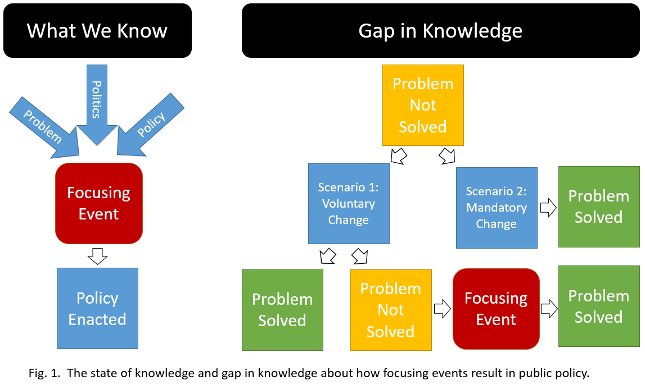

REFERENCES

Arenschield, Laura. (May 26, 2016). Ohio plan to restore Lake Erie won’t mandate farming changes. The Columbus Dispatch. Accessed at https://web.archive.org/web/20160801131937/http:/www.dispatch.com/content/stories/local/2016/05/26/states-plan-to-restore-lake-erie-stops-short-of-mandating-farming-changes.html

Birkland, Thomas A. (1998). Focusing Events, Mobilization, and Agenda Setting. Journal of Public Policy 18:1, 53-74.

Birkland, Thomas A., and Megan K. Warnement. (2017). Focusing events, risk and regulation. In Policy Shock: Recalibrating Risk and Regulation after Oil Spills, Nuclear Accidents, and Financial Crises, edited by Edward J Balleisen, Lori S. Bennear, Kimberly D. Krawieck, and Johnathan B. Weiner. Cambridge University Press.

Bishop, Bradford H. (2014). Focusing Events and Public Opinion: Evidence from the Deepwater Horizon Disaster. Political Behavior 36:1, 1-22.

DeLeo, Rob A., (2012). Anticipatory‐Conjectural Policy Problems: A Case Study of the Avian Influenza. Risk, hazards, and Crisis in Public Policy 1:1, 147-184.

Farley, Joshua, et al. (2007). Opening the policy window for ecological economics: Katrina as a focusing event. Ecological Economics 63:2-3, 344-354.

King, Kevin, et al. (2018). Addressing agricultural phosphorus loss in artificially drained landscapes with 4R nutrient management practices. Journal of Soil and Water Conservation 73: 1, 35-47.

Kingdon, John. (2003). Agendas, Alternatives, and Public Policies, 2nd ed. Longman Classics in Political Science. New York: Longman.

Scavia, Donald, J.V. DePinto, and I. Bertani. (2016). A multi- model approach to evaluating target phosphorus loads for Lake Erie. Journal of Great Lakes Research 42:6, 1139-50.

