PUBAFRS 6510 Final Project
Cathy Becker

In this final project, I will attempt to recreate part of a visualization from the Yale Program on Climate Change Communication. YPCCC has a long-running series of Climate Opinion Maps in which they break down public opinion on 28 questions about climate change on the national, state, county, metro area, and congressional district level. On their map, you can choose which level you’d like, then choose which question. The result is an extremely interesting and often surprising view of public opinion on various aspects of climate change that inform how to talk to people about this little-discussed, often controversial, and extremely important issue. We will be working with the 2018 Yale Climate Opinion Maps released on August 7, 2018.

Here is the visualization we will try to recreate:
http://climatecommunication.yale.edu/visualizations-data/ycom-us-2018/?est=happening&type=value&geo=state

For purposes of this final project, we will be looking only at the state level. However, the same maps could be created with data on the county, metro area, and congressional district levels.

STEP 1. Download and clean the data.

Go to http://climatecommunication.yale.edu/visualizations-data/ycom-us-2018

Click on the Data Download tab at the top.

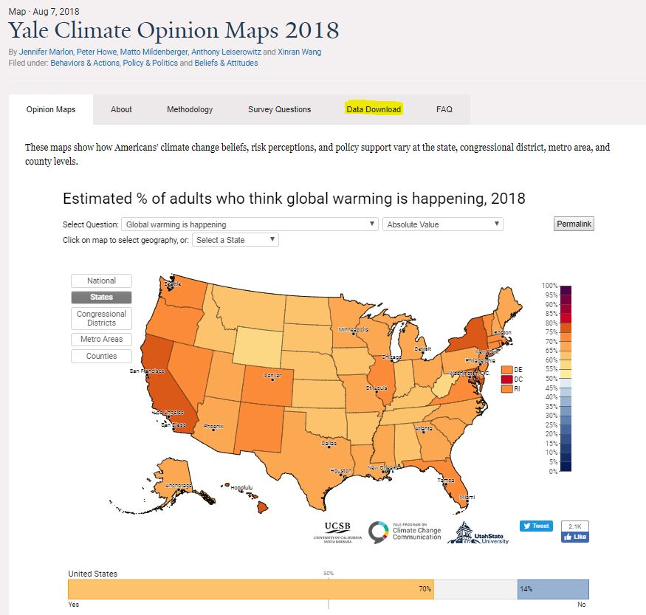

Enter all the required information to subscribe to the newsletter. The information in the newsletter is very useful, but you can unsubscribe anytime if you wish.

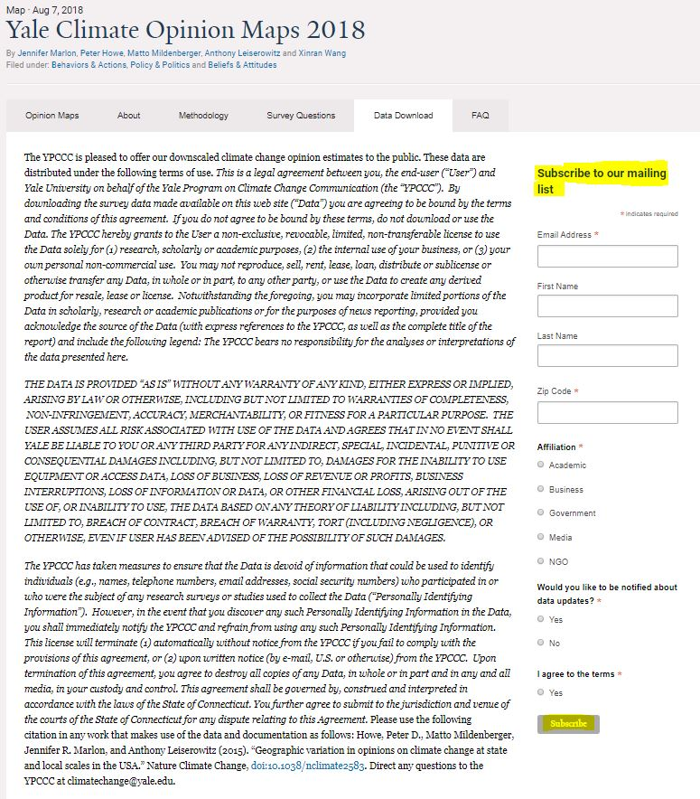

YPCCC will send you a separate email to confirm your subscription. Go to your inbox, find that message, open it, and click on “Yes, subscribe me to the list.”

That will open another web page that says “Data Request Confirmed.” On that page are links to download YCOM 2018 Data and YCOM 2018 Metadata.

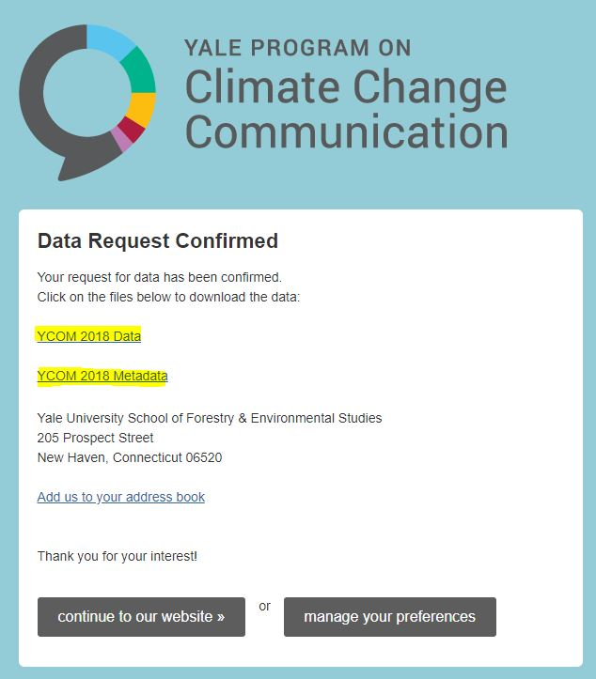

Click on each link to download the data. The main file you will be working with is YCOM 2018 Data. But YCOM 2018 Metadata is useful for you to understand what is entailed in each question asked about climate change.

When you have downloaded each file, move the files from the Downloads folder on your computer to whatever folder you want to contain your Tableau project.

Next, open YCOM 2018 Data. This is a .csv file that will open in an Excel spreadsheet. Now we are going to clean this data so we upload only the data we want into Tableau.

Here is what the opened spreadsheet looks like:

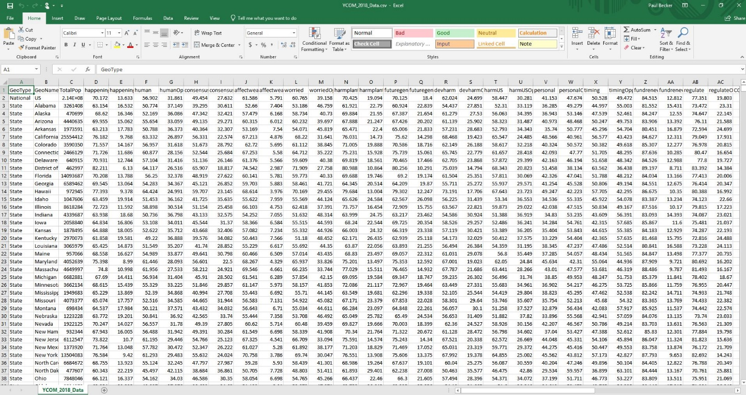

This spreadsheet has 4563 rows with data on the national, state, county, metro area, and congressional district levels for 59 rows of survey questions and data types. We will be working with only one data type (the 50 state names) and 28 survey questions. So we want to remove all the data that doesn’t apply to our project before loading it into Tableau.

Because there are so many rows, the easiest way to do this is to move the data we want to a second sheet rather than deleting the data we don’t want from the first sheet. Once we have finalized the data we want on Sheet 2, we can delete Sheet 1. Here’s how that works.

- Click the + sign on the lower left to create a new sheet. Because the current sheet already has a name, the new sheet will be called Sheet 1. Right click on Sheet 1 and rename it YCOM_2018_States
- Go back to the first sheet and highlight Rows 1-53. Click Control C to copy. Then click on your second sheet, put the cursor in the top left cell, and click Control V to paste all the data you copied from the first sheet.
- Highlight Row 2, the National data, then right click and select Delete to delete that row.

Now we are going to delete the columns we don’t need.

- Because we are only dealing with state data, we don’t need Column A, GeoType. Hover your cursor over the A in Column A, right click, and select Delete to delete the column. This moves all the data over one column to the left.
- We also don’t need Total Population, which has moved to Column B. Hover your cursor over the B in Column B, right click, and select Delete to delete the column. This moves all the data over one column to the left.
- There are 28 questions about climate change on Yale’s public opinion survey. However, each question has two columns – one for people who support the question or issue being asked about, and one for people who oppose it. We will be dealing only with support for each question or issue, so we need to remove all the columns with data regarding opposition.

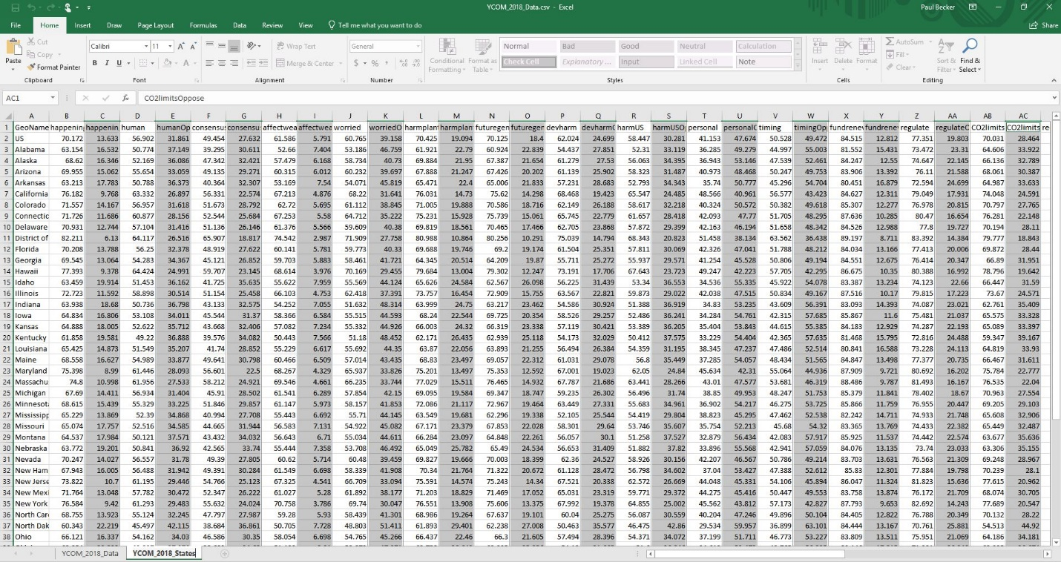

- Each question is signified by a shorthand moniker, with support as the first column for that moniker and opposition as the second column. So we want to delete the second column for each moniker. That means we will delete Column C for happeningOppose, Column E for humanOppose, Column G for consensusOppose, and so on. This will be every other column from Columns C through BE.
Tip: If you click on each column, you can check the name in the box at the top of the spreadsheet to ensure you are only deleting columns with the word Oppose in the name.
- Once you have deleted all the columns and rows of data you don’t need, you will end up with 52 rows (all 50 states plus District of Columbia, plus the top row of labels) and 29 columns through AC (28 questions plus the first column of state names)

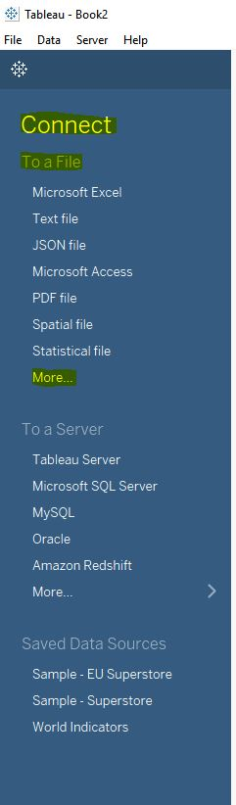
Now you will finalize and save your spreadsheet.

- Delete the first sheet, YCOM_2018_Data, and keep just the second sheet you created, YCOM_2018_States.
- Click File in the upper left of the spreadsheet, then Save As. Name your new file YCOM_2018_State_Data. The file type is .csv Comma Delimited

- Navigate to the folder where you are keeping your materials for this project and save the .csv spreadsheet file.

STEP 2. Load your data into Tableau

Open Tableau

Go to Connect in the upper right corner and click More. (see right)

Navigate to the YCOM_2018_State_Data.csv file that you just saved. Select the file and click Open.

Check to make sure you imported data in rows for all 50 states plus the District of Columbia, and columns for 28 questions about climate change.

Here is what the Data Source will look like in Tableau:

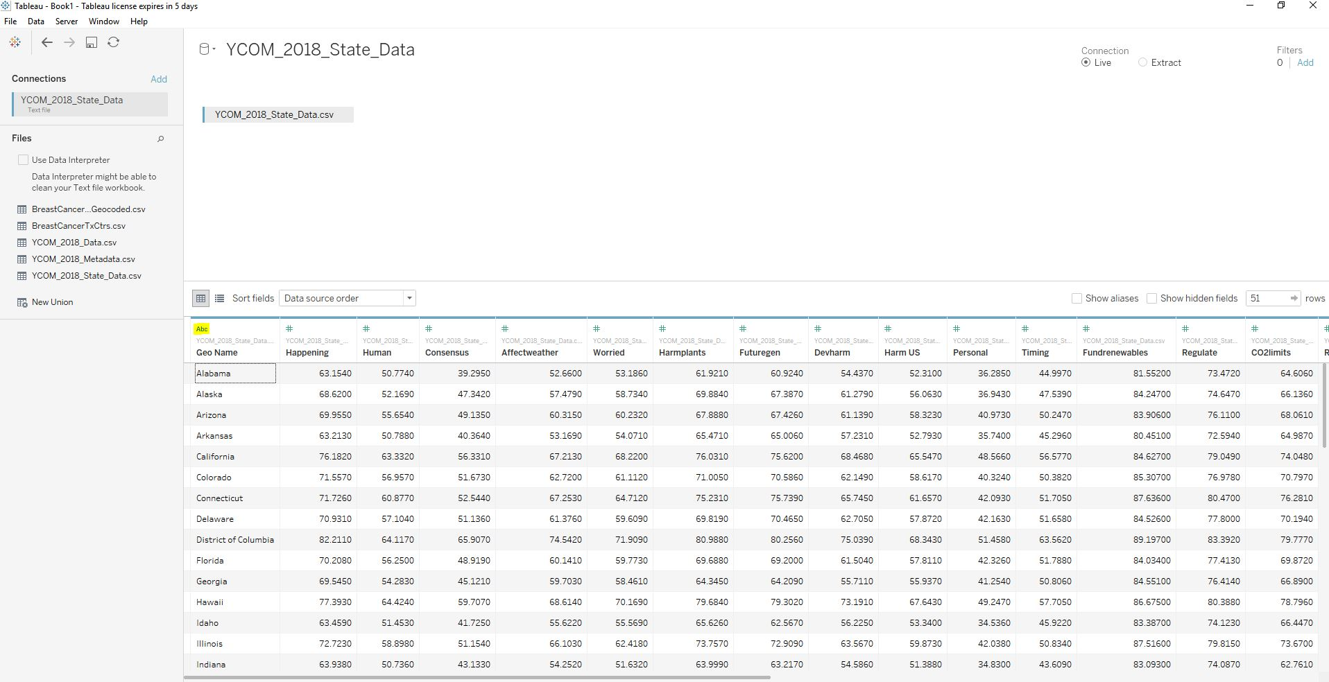

Most of the columns will be numerals with the # sign. However, we need to change the Geoname from text-based data to geography-based data. Here’s how to do that:

- Click on the small letters Abc above Geo Name.
- Select Geographic Role State/Province
- The letters Abc should now have changed to a small globe.

If everything looks good, you are done with the data.

STEP 3. Recreate the Yale Climate Opinion State Maps 2018

Now we are ready to recreate the Yale Climate Opinion Maps for states in 2018.

- Go to Sheet 1 on the lower left. Then right click on Sheet 1 and rename it Yale Climate Opinion State Maps 2018.

- Drag Longitude from Measures into Columns, and Latitude from Measures to Rows. That will tell Tableau that we are working with maps.

- Drag Measure Names from Dimensions into Filters. That will open a box of options for measure names with all items checked. Keep them all checked, then click Apply, and OK.

- Drag Measure Values from Measures onto the Colors card under Marks. This will bring up a new Measure Values panel with separate pills for each Measure.

- Drag Geo Name from Dimensions to the Detail card under Marks. This will tell Tableau that we are working with the 50 states.

- Hover over Measure Names under Filters. Click the dropdown arrow on the pill and select Show Filter. A new table with all the Measure Names will appear on the right.

- Hover over the Measure Values color legend below the new table. You will see the crossbars to move the item. Click on the item to move Measure Values above the new Measure Names list.

Here is what the project will look like so far:

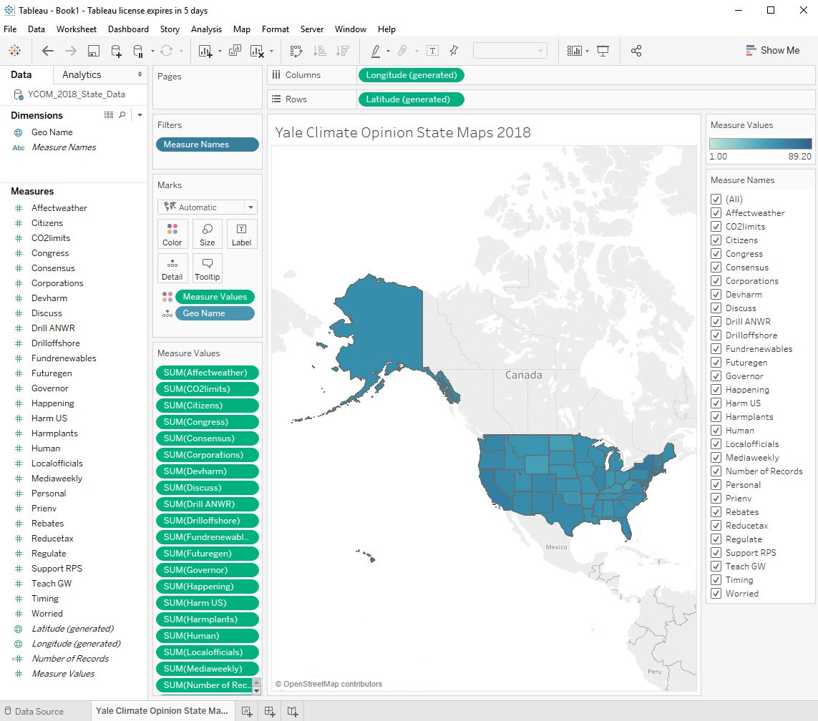

Next we will format the legend of colors that shows the amount of support in the states for each of the questions in the Measure Values:

- Right click on the color bar under Measure Values and select Edit Colors

- Under Palette, select Orange-Blue Diverging

- Click Stepped Color and tell Tableau to step the color 20 times to show changes in opinion for each 5%. This is how the Yale Climate Opinion Maps are set.

- Click Reversed to make orange signify more support and blue signify less support.

- Click Advanced. Then click Start and put 0 into the box. Then click End and put 100 into the box. This will ensure the scale of measurement is the same across all questions.

Here is what the color box settings should look like. If everything looks good, click Apply and OK to save these settings.

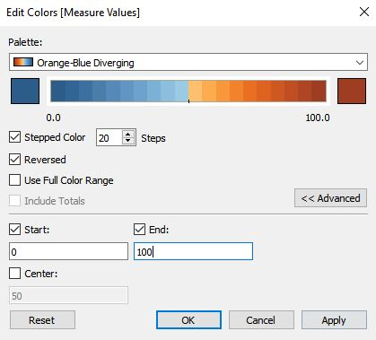

Finally, we need to clarify the questions asked in each map for readers, and set up the map so readers can easily page through each question and see how support for each question changes.

First, edit the title for the maps. The title will correspond to each Measure Name

- Double click on Yale Climate Opinion State Maps 2018 at the top to open the title editor.

- Change <Sheet Name> to <Measure Names>. Reformat the text from Tableau Light 15 point font to Tableau Bold 18 point font so it is easier to read.

- In the next line, add in Tableau Light 12 point font: Yale Climate Opinion State Maps 2018

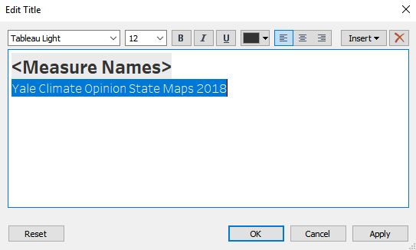
If everything looks good, click Apply then OK to save the settings.

Now we need to change the short monikers in the Measure Names for each question to the actual questions. These Measure Names are what readers will see at the top of each map, so we need to change the monikers from short code to an actual question that makes sense.

To do that, you first need to know what each question is. Go to http://climatecommunication.yale.edu/visualizations-data/ycom-us-2018

There you will see the public opinion map. Underneath the map is a list of the 28 questions asked in the Yale survey. The questions ask people’s agreement with the following statements:

- Global warming is happening
- Global warming is caused mostly by human activities
- Most scientists think global warming is happening
- Global warming is affecting the weather
- Worried about global warming
- Global warming will harm plants and animals
- Global warming will harm future generations
- Global warming will harm people in developing countries
- Global warming will harm people in the US
- Global warming will harm me personally
- Global warming is already harming people in the US
- Fund research into renewable energy sources
- Regulate CO2 as a pollutant
- Set strict CO2 limits on existing coal-fired power plants
- Require fossil fuel companies to pay a carbon tax
- Require utilities to produce 20% electricity from renewable sources
- Provide tax rebates for energy-efficient vehicles or solar panels
- Drill for oil in the Arctic National Wildlife Refuge
- Expand offshore drilling for oil and natural gas off US coast
- Schools should teach about global warming
- Corporations should do more to address global warming
- Citizens should do more to address global warming
- Congress should do more to address global warming
- My governor should do more to address global warming
- Local officials should do more to address global warming
- Environmental protection is more important than economic growth
- Discuss global warming at least occasionally
- Hear about global warming in the media at least once a week

These are the statements we will need to substitute for the short monikers in each Measure Name. Here is how to do that.

- Go back to your data by clicking on Data Source at the bottom left of the project.

- Right click on Happening and rename it 01 - Global warming is happening

- Right click on Human and rename it 02 - Global warming is caused mostly by human activities

- Right click on Consensus and rename it 03 - Most scientists think global warming is happening

- And so on through all 28 Measure Names. You can shorten some of them if it is easier, but the name should be something that represents the question in a way general readers can understand.
Note: You must use the numbers before each Measure Name, or Tableau will alphabetize them instead of putting them in the order that Yale has them. Yale is asking questions about climate change beliefs, risk perception, policy support, and behavior, and it makes more intuitive sense to group the same types of question together.

Here is what the data source will look like when you are done:

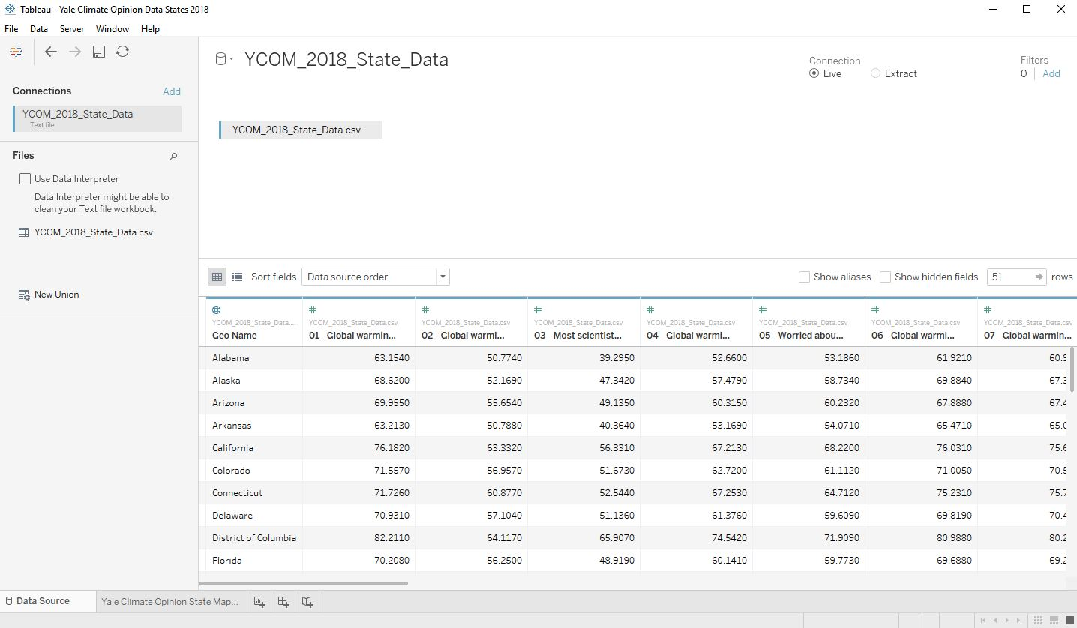

The final step is to create the drop down menu so people can select which question they want to see responses to. Here is how to do that.

- Hover over Measure Names. Click the dropdown arrow to the right. Select single value dropdown.

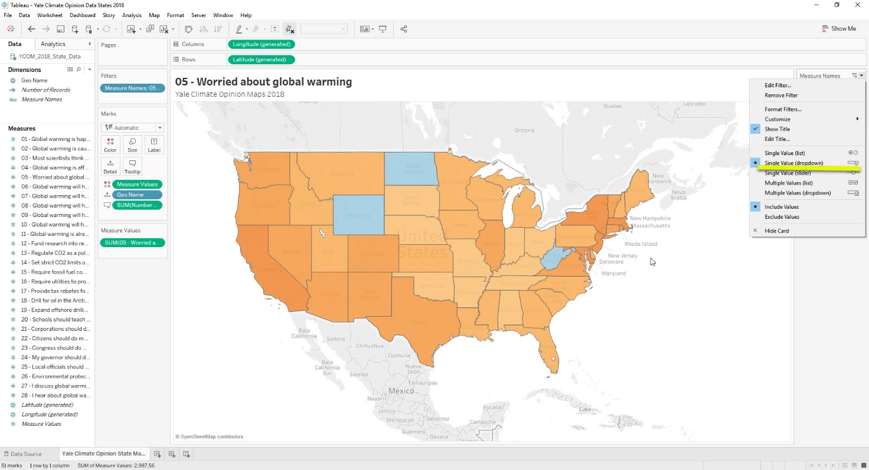

- This will create a dropdown menu that lists each question on the Yale Climate Opinion Maps. Readers will be able to click through each question to see how the colors on the map change, signifying more or less support for each question asked.

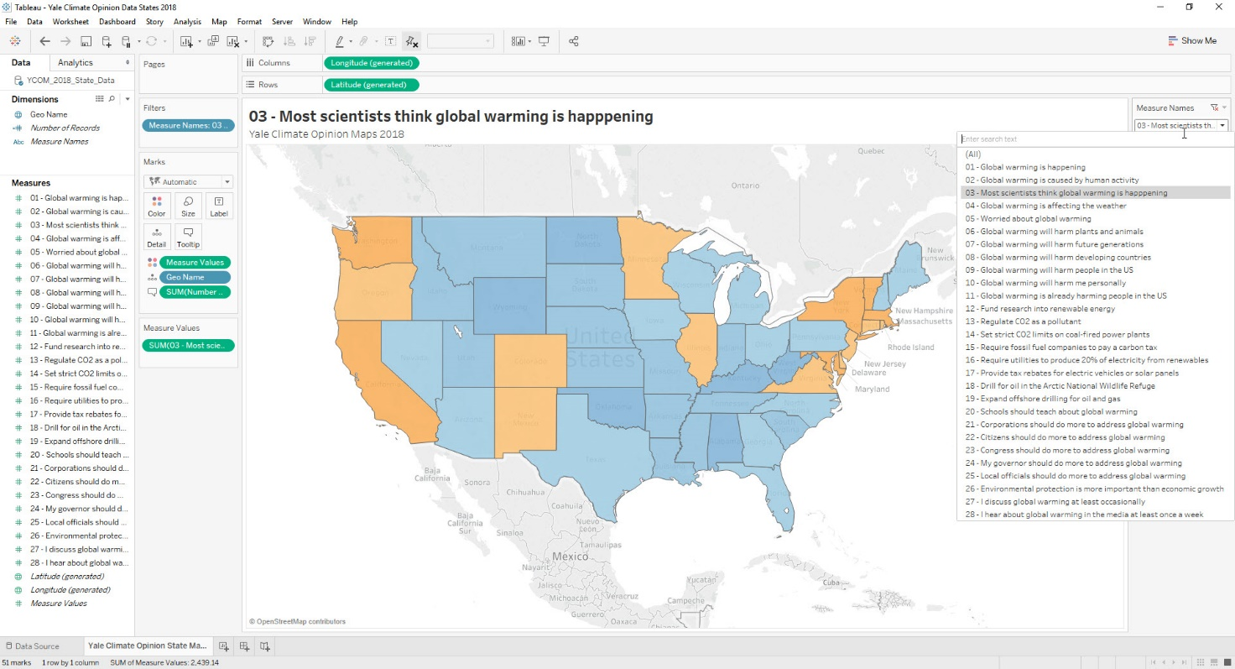

Congratulations! You have now recreated the Yale Climate Opinion State Maps for 2018!

