Strategic Planning – Ohio Sierra Club
Cathy Becker

The Sierra Club is the nation’s oldest, largest and most influential grassroots environmental organization, with more than 3 million members and supporters across the country. Founded in 1892 by conservationist John Muir, the Sierra Club helped to establish the National Park Service and was instrumental in passing landmark environmental legislation such as the Clean Air Act, Clean Water Act, and Endangered Species Act. Currently, the Sierra Club’s major initiative is to lead the move away from fossil fuels that cause climate change to a clean energy economy.

The overarching mission of the Sierra Club is “to explore, enjoy, and protect the wild places of the earth.” To accomplish this, the club’s mission has several sub-components, including:
- To practice and promote the responsible use of the earth's ecosystems and resources
- To educate and enlist humanity to protect and restore the quality of the natural and human environment
- To use all lawful means to carry out these objectives.

Ohio Chapter

Within the national Sierra Club is a network of 64 chapters, one of which is in Ohio. Most chapters correspond to a state, but some states such as California, where the Sierra Club was founded, have more than one chapter. The Ohio Chapter was established 50 years ago, and currently has more than 23,000 dues-paying members across seven local groups.

The Sierra Club Ohio Chapter advocates for energy efficiency, renewable energy, and public transit. It works to defend Ohio’s forests, state parks, and nature preserves, as well as to preserve water resources by advocating for green infrastructure, factory farm regulation, and protections for Lake Erie and watersheds throughout the state. Finally, the chapter promotes Ohio’s transition to a 21st-century economy through the creation of good-paying, green energy jobs.

The Ohio chapter currently employs a staff of six, including:
- Jen Miller, chapter director (the first person to hold this position)
- Matt Trokan, conservation director
- Elissa Yoder Mann, water program manager
- Chad Stephens, climate action coordinator
- Jocelyn Travis, energy program coordinator
- Nathan Alley, transportation program coordinator

Most of the substantive work of the chapter is done through a series of volunteer-led committees on issues such as:
- Water
- Energy
- Forests and Public Lands
- Dirty Fuels and Pipelines
- Agriculture
- Transportation
- Nuclear Free
- Political
These committees report to a Conservation Committee led by a volunteer conservation chair, and a member-elected Executive Committee led by a volunteer chapter chair. The Conservation Committee and Executive Committee meet every two months in Columbus to oversee the work done by the issue committees as well as provide overarching direction for the chapter staff.

Stakeholder analysis

Before examining its mission, conducting a SWOT analysis, or putting together a strategic plan, an organization should undertake a stakeholder analysis. Stakeholders are broadly defined as anyone who has an impact on the organization as well as anyone who the organization has an impact on. In order to be successful, public interest and nonprofit groups must understand who their key stakeholders are and what they want from the organization.

If the leaders of an organization don’t know who its stakeholders are, what criteria stakeholders are using to judge the organization, and how the organization is performing against those criteria, they can’t satisfy key stakeholders -- and without key stakeholders, the organization cannot carry out its mission. A stakeholder analysis can help identify solutions “that are technically and administratively feasible and politically acceptable, that are legally and morally defensible, and that create public value and advance the common good,” organization expert John Bryson says.

Through interviews with key staff and volunteers at Ohio Sierra Club, and by going through the chapter’s draft strategic plan and minutes from Conservation Committee and Executive Committee meetings over the past three years, I have identified a diverse list of stakeholders.

They include:
- Dues-paying members. Memberships start for as little as $15 the first year, with renewals at $39 a year, or a one-time payment of $1,000 for a lifetime membership.
- Volunteers. Volunteers lead and do most of the work at Sierra Club Ohio Chapter through the state campaign committees, leadership committees, and local groups.
- Supporters. Supporters are people who sign petitions, attend rallies and events, or contact their legislators on behalf of Sierra Club, but are not dues-paying members.
- Foundations. Much of the funding for staff salaries and chapter resources comes from foundation grants. For example, Aveda funds virtually the entire clean water program.
- Concerned citizens. Often issues are brought to the attention of Ohio Sierra Club by citizens who are worried about discharge into a creek or a pipeline in their back yard.
- Elected officials. This is mainly state elected officials such as the governor, state legislators, and their staffs and aides, who make decisions that affect the environment. It can also include local officials such as Columbus mayor and city council members.
- Government administrators. This includes leaders and civil servants in key state agencies that create regulations and carry out policy affecting the environment, such as Ohio EPA, Ohio Department of Natural Resources, and Ohio Department of Agriculture. It can also include city officials such as sustainability administrators.
- Partnering organizations, including
  - Environmental groups such as Ohio Environmental Council, Center for Biological Diversity, Friends of the Earth, and Heartwood.
  - Non-environmental groups such as labor unions and civil rights groups.
- Media, including newspapers, TV, radio, and blogs.

Power vs. Interest Grid

In order to understand how Ohio Sierra Club can effectively work with such a wide range of stakeholders, it is helpful to sort them on Bryson’s Power vs. Interest Grid. In this grid, power on the X axis describes how much influence the stakeholder has over the organization, while interest on the Y axis describes how much influence the organization has on the stakeholder.

The result is a graph with four quadrants representing four types of stakeholders:
- Players, with high power and high interest. These are the key stakeholders whose preferences must be taken into account by the organization.
- Context setters, with high power and low interest. These are often the funders of an organization.
- Subjects, with low power and high interest. These are often the clients of an organization.
- The crowd, with low power and low interest. These are often citizens not involved directly with the organization.

Through this exercise, stakeholders for Sierra Club Ohio Chapter can be sorted as follows:
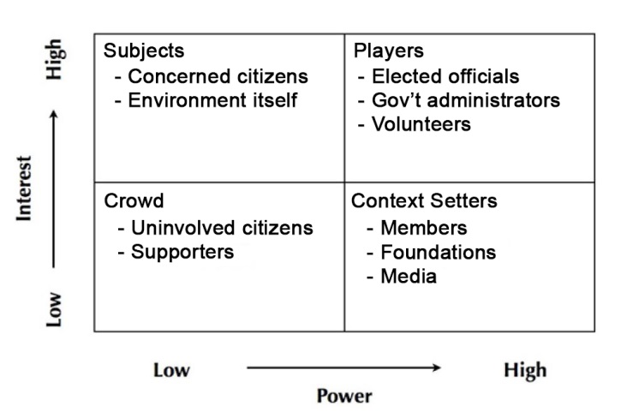

Players are the high power, high interest key stakeholders of the organization. For Ohio Sierra Club, this encompasses three main groups. First, elected officials such as governor, state legislators, and their staffs are high power because they shape much of the legislation that protects or doesn’t protect the environment. For example, recently Ohio Sierra Club had to navigate between a Republican majority in the state legislature determined to roll back the state’s clean energy standards, and a Republican governor who bucked his own party to veto this bill.

Elected officials are high interest because Ohio Sierra Club can influence votes for or against them. The chapter Political Committee runs an endorsement process during elections to identify environmental champions as well as those who do not support environmental protection. Endorsements go to thousands of voters in across the state. The chapter can also speak out in the media for or against elected officials who are friendly or hostile to the environment.

Another set of players with high power is administrators in key state agencies such as Ohio EPA. Recently this agency, though not known to be hostile to business interests, levied fines of almost $1 million against Energy Transfer Partners for 18 violations of the Clean Water Act during construction of the Rover pipeline across the state, including a spill of 2 million gallons of bentonite drilling fluid that destroyed a high-quality wetland in Stark County. Craig Butler, director of Ohio EPA, consulted with Ohio Sierra Club during the discovery of these violations.

Administrators in key government agencies are also high interest because they can be named and praised if they do the right thing by the environment or named and shamed if they don’t. State environmental agencies are often the object of Ohio Sierra Club action alerts that shape opinions about them among tens of thousands of engaged members and supporters across the state.

Finally players also include Ohio Sierra Club volunteers. This core group is high power because they do much of the work of Ohio Sierra Club -- the chapter literally cannot accomplish its mission without them. The volunteer Executive Committee also steers the overall direction of work. But volunteers are also high interest because spending so much time on Sierra Club activities helps them gain leadership experience, develop skills, and shape their identity.

Context setters are high power and low interest stakeholders, often funders of an organization. For Ohio Sierra Club, this encompasses three groups: members, foundations, and the media.

Members are context setters because their membership dues fund much of the work of the organization. Members pay dues to the national Sierra Club, which then distributes funds to the chapters and local groups where the member lives. Although members are not involved in the daily activities of the club in the way volunteers are, they join the organization because they want to see it make progress on protecting the environment, and if they perceive that progress not happening, they will find another organization to send their money to.

Foundations are also context setters because they award grants that allow the organization to do much of its work. For example, Aveda funds the clean water campaign at Ohio Sierra Club, allowing the chapter to hire a water program manager and two fellows as well as conduct water sentinel and water stewardship programs in which citizens across the state test water quality and restore degraded waterways. The loss of grant money can be devastating. At one point Aveda gave its water grant to another organization, but the next year they came back to Ohio Sierra Club because they thought the chapter did a better job of fulfilling the mission of protecting clean water in the state. Conversely, Gund Foundation withdrew its grant that funded the anti-fracking campaign because they thought it was not making enough progress. This withdrawal of funding forced the chapter to sharply curtail its anti-fracking activity in the state.

Finally, the media are context setters because they tell the stories of Ohio Sierra Club. The chapter has developed relationships with a few key reporters such as environment and public affairs reporters for the Columbus Dispatch and Ohio Statehouse News Bureau. These stories shape how the public views environmental issues in general and Ohio Sierra Club in particular.
Subjects are low power and high interest stakeholders, often the clients of an organization. In this quadrant I would put two groups, concerned citizens and the environment itself.

Concerned citizens are people who have not previously been involved with Ohio Sierra Club but come to the organization with a specific environmental issue. Citizens have come to the chapter with concerns about such issues as spraying for mosquitoes, cracks in the Davis-Besse nuclear power plant, and timber harvests in state forests. Sometimes such concerns lead the chapter to take substantive action. For example, citizens in Fremont raised $35,000 for Ohio Sierra Club to hire an attorney to sue over removal of Ballville Dam on the Sandusky River because they were concerned about releasing sediment that had built up for decades behind the dam. The lawsuit forced U.S. Fish and Wildlife to test the sediment for toxins and delay dam removal until fall when fish-spawning season was over, then remove it in stages to minimize release of sediment.

Another entity that could arguably be counted as a subject stakeholder for Ohio Sierra Club is the environment itself – the living animals and plant species as well as the land, air, and water that is their home. The environment has no money to donate or vote to cast, so it has no power in the human political or economic system -- yet so many decisions made in that system directly impact it. Sierra Club works to influence these decisions to protect the environment from human harm.

Finally, the low power and low interest crowd is made up of millions of citizens not currently involved in environmental issues, but who Ohio Sierra Club works to motivate into becoming supporters by taking actions such as signing petitions, attending rallies and events, and contacting their legislators. Although most organizational consultants counsel leaders to ignore the crowd, Ohio Sierra Club does the opposite. For example, the chapter started a series of clean energy dialogues in Cleveland to solicit the thoughts of citizens about how to transition to 100 percent renewable energy community wide by 2050 in a fair, just, and equitable manner. Such engagement can help push elected officials and administrators to pass environmental programs.

One stakeholder group not in any quadrant is partner organizations, both environmental and non-environmental. That is because they do not determine the ability of Ohio Sierra Club to fulfill its mission, nor is their ability to fulfill their mission determined by the chapter.

Rather, they are peer organizations that can decide to work with Ohio Sierra Club on issues of mutual concern, such as when Center for Biological Diversity, Heartwood, and Ohio Environmental Council partnered with the chapter to sue the Bureau of Land Management over its auction of land in Wayne National Forest to oil and gas companies for fracking. Alternatively, these peer organizations may decide to compete with Ohio Sierra Club, such as when one group agreed to provide t-shirts for people riding a co-sponsored bus to the People’s Climate March in Washington, D.C., but gave shirts only to those who had signed up through their own group.

Peer organizations can support or detract from specific actions Ohio Sierra Club takes, but they don’t determine whether or not Ohio Sierra Club can take these actions. The chapter could sue the BLM over fracking by itself, but the lawsuit is stronger with other organizations on board. Ohio Sierra Club was also able to take supporters to the climate march in Washington, though its participants didn’t get a t-shirt. For these reasons, I would put partner organizations in the general operating environment for Ohio Sierra Club, but not in the Power vs. Interest Grid.

Managing stakeholders

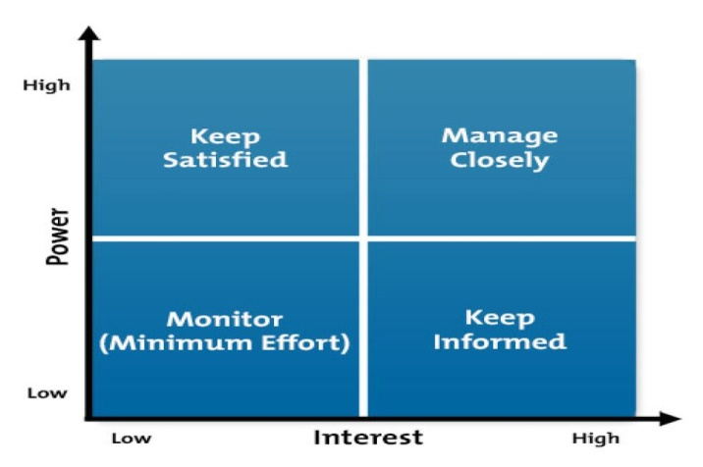
Sorting stakeholders on a Power vs. Interest grid helps organizational leaders decide how to manage these various groups. Bryson suggests managing each type of stakeholder as follows:
- Players: Manage closely by keeping an ongoing relationship, listening to them, and being attentive to what they want.
- Context setters: Keep informed of how the organization is using their resources to carry out its mission.
- Subjects: Keep satisfied by providing this group with a high level of service.
- The crowd: Monitor and engage with the goal of turning this group into supporters who can help move players in a way that fulfills the organization’s mission.

Of the four types of stakeholders, players with high power and high interest are most crucial to the mission, so it is important to understand their preferences – what they want both in general and from the organization. The preferences of players for Ohio Sierra Club are as follows.
- Elected officials such as the governor and state legislators want first and foremost to get elected, then to stay elected. To do that they want to be seen well in the eyes of voters and raise money and volunteer support for their political campaigns.
- Administrators in environmental agencies may be political appointees who want members of their party to get elected and stay elected, since that is who appoints them. They also want the support and freedom to promulgate and enforce regulations.
- Volunteers are mission driven, choosing to spend their free time on chapter activities because they want to make a difference. They may also want to gain experience leading initiatives and campaigns as well as gain recognition in their communities.

Understanding the preferences of key stakeholders helps organizational leaders better manage them. Here are some ways Ohio Sierra Club could manage these players given their preferences:
- Elected officials
  - Endorse environmental candidates and turn out volunteers to help elect them.
  - Use action alerts to help constituents contact representatives with policy asks.
  - Hold events for citizens to meet with their elected representatives.
  - Recognize and reward environmental champions in political office. Name and shame those who advocate for programs that harm the environment.
- Environmental administrators
  - Use action alerts to drive public comments on proposed environmental regulations.
  - Use the media to call out the need for regulations to be passed or enforced.
  - Recognize environmental civil servants who are doing good work, while naming and shaming those who are gutting or not enforcing important regulations.
- Volunteers
  - Define volunteer roles with clear goals and responsibilities.
  - Create paths to leadership with coaching and support.
  - Recognize contributions that help the chapter carry out its mission.

SWOT Analysis

SWOT stands for Strengths, Opportunities, Weaknesses and Threats. A SWOT analysis is a tool for diagnosing whether the internal environment of an organization – its strengths and weaknesses – is aligned with the external environment –opportunities and threats – so that organizational leaders can see how well the organization is positioned to carry out its mission.

The national Sierra Club mission, goals, and metrics have not been specified on the chapter level. Instead, chapters and local groups are responsible for carrying out the national mission in their geographical area. A SWOT analysis is important because it can help organizational leaders understand where their organization does and does not align with the overall mission.

Mission

The overarching mission of the Sierra Club is “to explore, enjoy, and protect the wild places of the earth.” Because this is large and amorphous, in 2013 the national Sierra Club undertook a multiyear strategic planning process. In 2015 the Board of Directors published a strategic plan identifying five overarching visionary goals and outlining strategies to achieve each goal.

The visionary goals from the 2015 strategic plan include
- Solve the climate crisis in a way that protects the environment and is enduring, fair and equitable.
- Steward our natural resources to safeguard them for present and future generations.
- Attract and empower a base of supporters and activists strong enough to challenge the status quo and accomplish our ambitious programmatic goals.
- Function as a high-performance environmental organization by building on our legacy and embracing innovation.
- Ensure that the Sierra Club and its entities have a combination of diverse, secure, sustainable, and flexible funding.

Strategies for solving the climate crisis include:
- Transitioning to 100 percent clean energy
- Maximizing energy efficiency
- Returning greenhouse gas concentrations to a safe level below 350 ppm
- Addressing emissions in agriculture
- Rebuilding the capacity of forests and supporting biodiversity.

In 2017 shortly after the election of Donald Trump, these goals were updated with new key metrics. Key metrics in solving the climate crisis included:
- Securing 139 gigawatts of coal for retirement by end of year.
- Making clean energy the No. 1 source of new generation with over 15 gigawatts added.
- Slowing or defeating the proposed construction of at least 20 gigawatts of new gas plants, and launch a carbon-free campaign in at least five states.
- Getting 25 cities to make a commitment to equity-centered 100 percent clean, renewable energy, in addition to the 20 existing commitments.
- Slowing or defeating at least $12 billion in dirty fuel infrastructure projects.

Strategies identified to meet those goals in 2017 include:
- Resist attempts by Congress and the Trump administration to roll back environmental progress and undermine air and water safeguards and land and wildlife protections.
- Leverage our strategies, systems and people to grow our base of champions, members, and leaders.
- Contribute to the larger environmental, progressive and social justice movements by working respectfully on shared strategies with leaders and partners who share our values.
- Provide management and movement-building training for our staff and volunteers.
- Develop metrics and train staff and volunteer leaders to advance equity and justice.
- Strengthen the long-term health and financial flexibility of the organization through small-dollar fundraising, prudent reserves management, and flexible large gifts.

SWOT Analysis

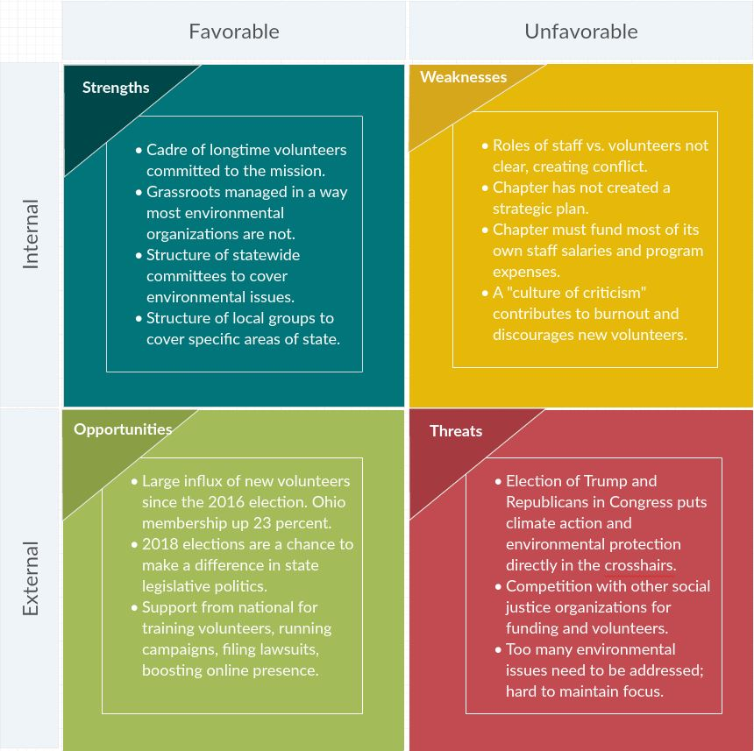

In the external environment, Sierra Club Ohio Chapter has several opportunities to carry out its mission. First, the chapter has experienced a huge influx of new members and volunteers since the 2016 election. Paid membership is now above 23,000 Ohioans, an increase of 23 percent in just over a year. Local committee meetings that used to attract three people now get 10 or 20.

Second, 2018 will see elections for Ohio governor, executive offices and legislators across the state. This is an opportunity to change the makeup of state office holders from a majority hostile to environmental protection to one with more environmental supporters and champions. This can be done through political endorsements and campaign help for environmental candidates.

Finally, national Sierra Club is providing more support to chapters for initiatives such as training volunteers, running campaigns, filing lawsuits, and boosting online presence. The chapter has been able to send volunteers to trainings in Oakland and Washington, D.C., support volunteers in carrying out campaigns such as Ready for 100, file lawsuits against fracking in Wayne National Forest and the Rover pipeline, and launch a series of redesigned websites.

Sierra Club Ohio Chapter also faces several threats. First and foremost, the election of Donald Trump and Republicans in Congress has put programs to address climate change along with all environmental protections and regulations on the chopping block. This has consequences in Ohio. Trump’s approval of the Dakota Access Pipeline has emboldened its owner, Energy Transfer Partners, to force the Rover pipeline through the state. Trump’s suspension of the Clean Power Plan stopped efforts to lower carbon emissions from Ohio power plants. His staff and funding cuts at the U.S. Environmental Protection Agency have also cut support for Ohio EPA.

Second, Ohio Sierra Club is competing with other social justice organizations for funding and volunteers. Although the Ohio Chapter is seeing new volunteers, many are also looking into other groups, and could end up staying with other groups if Ohio Sierra Club does not find a home for them. Grant-funding agencies also have many social justice groups to choose from.

Finally, since the election of Trump, the nation is experiencing a five-alarm fire on dozens of issues. It is hard for volunteers to choose between the environment and other issues, and hard for Sierra Club to focus on a few environmental issues when so many programs are under attack.

Now let us turn to the internal environment of Ohio Sierra Club – its strengths and weaknesses. Ohio Sierra Club has several important strengths to leverage. First, the chapter has a cadre of longtime members and volunteers committed to its mission and work. Some of these volunteers have been around for two decades, so they have institutional memory and experience. As one longtime volunteer told me, “Staff come and go. To them it is a job. To us it is a mission.”

Second, Sierra Club has a unique governing structure among environmental organizations in that it is member- and volunteer-driven and managed. The national Board of Directors consists of volunteers elected by the membership, as does the chapter Executive Committee. Members of the chapter Executive Committee, Conservation Committee, issue committees, and the governing committees of the seven local groups are all volunteers. Volunteers set the agenda for the chapter, while staff help them carry it out. This governing structure means Sierra Club is driven by a broad bottom-up grassroots base rather than a narrow top-down hierarchy. That keeps the club in touch with issues on the ground and relevant to a broad swath of Americans.

Finally, the structure of the statewide issue committees and local groups gives the Sierra Club both breadth and depth in Ohio. Issue committees focus on one issue such as water, energy, or forests across the state, while local groups focus on all issues in a particular region. This matrixed structure provides a place for volunteers to contribute no matter what their interest, and allows the organization to address a wide range of environmental challenges.

The Ohio chapter of the Sierra Club also has several weaknesses that it will need to address in order to make the most of its strengths and opportunities. The most important weakness is that the roles of staff and volunteers are not clearly defined. Although the Sierra Club is a member-driven organization, many volunteers feel that chapter staff too often takes actions without consulting them. Meanwhile, staff say that issues often must be dealt with quickly, and they are there full-time while the volunteer Executive Committee meets only once every two months.

Another weakness is the Ohio chapter has not created a strategic plan. A strategic plan was started in October 2016, but never completed. Without this key document, chapter members, volunteers, and staff have no common understanding of their direction, strategies, or goals.

Third, the Ohio chapter must fund its own staff salaries and program expenses. With a staff of seven, that means a lot of fundraising. Each staff member must fundraise, and some are better at it than others. Entire programs depend on grants, and losing a grant can doom an initiative, such as when the loss of a key grant in 2014 ended the chapter’s campaign to counter fracking.

Finally, a “culture of criticism” contributes to burnout among current staff and volunteers and discourages new volunteers from getting involved. In some cases, inappropriate or bullying behavior interferes with progress, and there is no structure in place to rein this in.

Organizational alignment

By examining both the external environment – opportunities and threats – and internal environment – strengths and weaknesses – organizational leaders can see how well the organization is aligned to fulfill its mission and where it needs to focus its efforts.

Externally, the Ohio chapter faces a huge threat from the Trump administration, but it also has a huge opportunity with the influx of new members and volunteers. Internally, the Ohio chapter has a strong group of longtime volunteers, but conflict over roles and lack of direction put the chapter’s ability to leverage the commitment and talent of these volunteers at risk.

For those reasons I have four recommendations for where Ohio Sierra Club should concentrate its efforts. First, the state chapter must finish its strategic plan. Hopefully this strategic planning analysis will help provide direction to do that, and the chapter can draw from the detailed planning done by the national organization. But creating a strategic plan is a must.

Second, the chapter must clarify the roles of staff vs. volunteers, and how the two can work together. Part of the problem may be that the current director is the chapter’s first, and those roles have not previously been defined. Perhaps the chapter could look to other chapters that have had more than one director to see how they worked out these conflicts.

Third, the chapter needs to shore up fundraising. That could mean getting training for staff who are not comfortable doing it or hiring a professional fundraiser, either on staff or outsourced. However it is done, fundraising needs to become more stable and less onerous.

Finally, the chapter must deal with its internal culture of criticism and lack of trust between volunteers and staff and among volunteers with each other. Any bullying behavior must be stopped, and a productive working relationship needs to be fostered. Taking steps to enact the first three recommendations will help to reduce conflict. In addition, the chapter should adopt group agreements for productive meetings such as the national organization has been using.

Here is the set of group agreements used at national trainings:
- Be thoughtful about your personal power and privilege
- W.A.I.T. (Why am I talking? Why aren’t I talking) Notice how air time is shared (or not!)
- Notice and take responsibility when your actions or behaviors impact others differently than you intended.
- Use “I” statements
- Practice active listening.
- Calling folks in … not out!
- Minimize use of jargon and explain terms when you speak
- What’s learned here leaves here, what’s said here stays here
- One mic
- Try it on
- Share your personal pronouns - how you identify yourself - as she, her, hers or he, him, him or they, them, theirs.

Ohio Sierra Club would not have to adopt this wholesale, but could look toward adopting the items that work for the chapter and/or creating their own. The purpose is to foster productive working relationships while ensuring an environment of equity, fairness, and inclusion for all. For more information, see Appendix 2 on group agreements attached to this report.

Appendix 1: SWOT Identification Table

 | Staff 1 | Staff 2 | Volunteer 1 | Volunteer 2
Strengths | Volunteers  Passion  Brand  History  Confederated structure  Environmental law program  Digital communications  Has a PAC  Rapid response–jump on issues | Longtime volunteers with institutional knowledge  Support from national – financial, training, legal, web  Grassroots volunteers – motivated by mission | Members and volunteers | Good staff  Good ExCom – volunteers  Outings program
Weaknesses | IRS C3/C4 laws cumbersome  Passion not always strategic  Too many environmental issues – hard to keep focus  Lack of clarity regarding grassroots vs staff | Institutional knowledge not written down  Confusing national structure – don’t know where to get info  Grassroots slows down process  Lack of funding for important campaigns such as fracking  Staff comes and goes | Low engagement rate of members | Need to finish strategic plan
Opportunities | 2018 election in Ohio  New civic engagement – opportunity to grow base  Coalesce – take October strategic plan – make it real | New volunteers from Trump election – but challenge to find a place for all of them | Hostile government brings new volunteers streaming in | Trump’s election has brought in more members – now 23,000  Outings as way to recruit members and volunteers
Threats | Losing funding  Losing key volunteers without a transition plan  Openly critical culture  Losing elections creates division, cynicism, low morale | Toxic people – no way to rein them in  Competition with other enviro groups for volunteers, funding | Government wants to gut all agencies that regulate enviro

Appendix 2: Community Agreements from National

Understanding More About Value of Group Agreements

CONTEXT:

The Sierra Club is working to prioritize making all of our meetings together welcoming and inclusive and ensure that each person has an opportunity to bring their full selves into the conversation.

Doing this helps to foster individual and group learning and development. It also is part of a set of internal organizational practices and processes that are being identified to help achieve the Sierra Club’s equity and justice goals and fight against power, privilege and oppression.

It’s important to realize that each person is making a commitment to each other to have a productive discussion process AS WELL accomplish the goals of the meeting. Each person taking part in the discussion should take responsibility for fostering a welcoming and inclusive conversation for others by being aware both of their own participation and that of others.

The Process - Getting Familiar with Possible Group Agreements

First, review the list of possible group agreements and identify any that are unfamiliar. Then reflect on whether you would want to propose adding any others.

Next - think of how you will support this meeting by holding yourself and others in the group accountable for a good discussion.

Examples of group agreement accountability practices

INDIVIDUAL

Commit to not check phone or email during meeting sessions - social science has shown that one person on their phone can lead to others to take out their phones “just to check.”

Make a plan to offer more input if you are usually quiet, or count the times you are offering input if you are outgoing. Encourage quiet people to speak and then wait for them to join conversation.

GROUP

Using terms like “oops or ouch” can be a way to indicate that someone recognizes they have not stuck to the agreements (Ex. Oops - I just said - “we all love data” when I really should have said, “I love data and I hope others here might find it valuable as well.”)

People can ask for a time-out to discuss if the group discussion practices need to be reviewed or altered.

People can use a code word or hand signal to indicate a norm has been broken.

Finally, contribute your thoughts to the group discussion and help the group to reach agreement.

Practice holding each other accountable to your group norms.

LIST OF PROPOSED GROUP AGREEMENTS
- Be thoughtful about your personal power and privilege
- W.A.I.T. (Why am I talking? Why aren’t I talking) Notice how air time is shared (or not!)
- Notice and take responsibility when your actions or behaviors impact others differently than you intended.
- Use “I” statements
- Practice active listening
- Calling folks in … not out!
- Try it on
- Minimize use of jargon and explain terms when you speak
- What’s learned here leaves here, what’s said here stays here
- One Mic
- Share your personal pronouns - how you identify yourself - as she, her, hers or he, him, him or they, them, theirs.

Additional description of each norm

Be thoughtful about your personal power and privilege
Be aware of the personal power and privilege that you may have in the room relative to your age, your role or title, your organization, gender, race, class or other factors. For example, if you are an older white man, senior executive or expert on a topic, you may be unaware of how you are given or take privilege in a room. We just ask you to be mindful of both your own behavior and that of others and be willing to step back or decline invitations to speak, encourage others to speak up.

W.A.I.T. (Why am I talking? Why aren’t I talking) Notice how air time is shared (or not!)\
If you tend to speak a lot, lean into listening. If you are often more silent in a group conversation, learn into speaking. We want to create a conversation where we can hear the ideas and perspectives of folks in the room and some of our communication habits prevent that from occurring. That said, we would like everyone to be an active participant in the conversation, especially if we are having a tough conversation where you may think, “I will just sit this one out.” The point of this practice is to ensure that everyone is helping to create shared understanding, promote learning and avoid having one person dominating or getting more of the group’s time than others.

Notice and take responsibility when your actions or behaviors impact others differently than you intended.
Intent and Impact: In the course of our conversations today, something may be said that doesn’t sit right for another person. It’s important that we acknowledge harm if something has not landed well and not get defensive or argue with the other person’s point of view. We are seeking to promote conversation and ask that we practice listening and learning about each other.

Use “I” statements
Speak from your personal experience, rather than speaking of another person’s experience or generalizing about a group. For example, try to not say, “we all have a shared belief in…” or “they don’t want to do this.”

Practice active listening
Listen to understand what the other person is saying, not so you can formulate a response

Calling folks in … not out!
Give permission for mistakes to happen. Invite others into learning moments, as opposed to shaming and blaming moments.

Try it on
Be open to new ideas; suspend judgment until you have a chance to learn from the experience.

Minimize use of jargon and explain terms when you speak.
Avoid words and expressions that may be difficult for others to understand. Explain acronyms.

One Mic
If someone is already speaking, let them finish their thought rather than talking over or cutting that person off. The facilitator will try to call on people in turn or ask someone to help “keep stack” or track who should speak next.

What’s learned here leaves here, what’s said here stays here.
Respect confidentiality. It is good to share what we learn from our experiences and dialogue with others. It is not good to share another person’s story or to express personal attributions unless given permission to do so.

Share something about your identity (physical need, share your personal pronouns if comfortable - how you identify yourself - as she, her, hers or he, him, him or they, them, theirs.) For some, certain spaces may not feel safe/brave/comfortable enough to identify pronouns or other identities, and that’s okay. The concept of gender is evolving, and therefore so are gender identities. Some people use nontraditional pronouns. Someone’s name and pronouns may change after you have already been introduced to the person. Some people use more than one set of pronouns for themselves. Click here for more information from this article. Or, check out this helpful video. Students and younger activists are used to sharing pronouns as a norm in classes and other spaces to ensure that trans and other people are welcome.

Powerpoint Slide with Group Agreements

ENDNOTES

Mission Statement, Policies, Sierra Club, accessed at http://sierraclub.org/policy.
Smith, Michael, Membership Chair, Sierra Club Ohio Chapter. “Membership Numbers for February 2018,” e-mail sent March 15, 2018, lists the following membership figures: - Miami Group – 6,409 - Northeast Ohio – 5,683 - Central Ohio – 5,094 - Portage Trail – 2,986 - Western Lake Erie – 1,653 - Salt Springs – 759 - Appalachian – 494 - Statewide – 23,166
Bryson, John. 2011. “Stakeholder Analyses,” Chapter 4 in Strategic Planning for Public and Nonprofit Organizations, 4th ed., p. 132.
Bryson, John. 2011. “Resource A,” in Strategic Planning for Public and Nonprofit Organizations, 4th ed., p. 335.
For a discussion of the Power vs. Interest Grid, see Bryson, John. 2011. “Stakeholder Analyses,” p. 137, and “Resource A,” pp. 338-339, in Strategic Planning for Public and Nonprofit Organizations, 4th ed.
For a discussion of stakeholder preferences, see Brown, Trevor. 2017. “Stakeholder Identification, Prioritization & Engagement,” Week 4 Slides, and “Stakeholder Identification and Prioritization,” Video 2 in Week 4 Videos, for PUBAFRS 6050: Managing Public Organizations.
Brown, Trevor, “Organizational Alignment and Mission,” PUBAFRS 6050: Managing Public Organizations, slides 15-20.
Visionary Goals, Sierra Club Strategic Plan, Approved May 7, 2015, by the Board of Directors, pp. 3-4. Accessed in Clubhouse intranet, http://clubhouse.sierraclub.org.
2017 Organizational Priorities, Adopted January 19, 2017. Accessed in Clubhouse intranet, http://clubhouse.sierraclub.org.

