**Supplementary Material**

1. Study Site Pore Water Chemistry

A sediment core from the study site (43.9162oN; 124. 6938oW; 203 m) was sectioned in depth intervals of 1, 2 or 3 cm thickness immediately after collection. The sectioning was done within a refrigerated van regulated to ~7oC. The sediment was extruded and sliced at the top of the core tube, inside a glove bag that had been flushed and filled with N2. Sediment sections were transferred to 50 ml tubes and capped under N2, and centrifuged. Supernatant pore water samples were then filtered and analyzed using the same methods presented in Materials and Methods. We note the 0.45 µm syringe filters introduced a dissolved nitrate + nitrite background concentration of ~2 µM. Pore water dissolved manganese concentrations (not shown) ranged from 0.2-1 µM throughout the core, with the highest concentration in the 0-1 cm section. The results of other analyses are plotted below. Values plotted at 0 cm depth represent samples of bottom seawater collected from above the sediments in the core tubes. No dissolved OC measurements were made below 10 cm depth due to insufficient sample volumes.

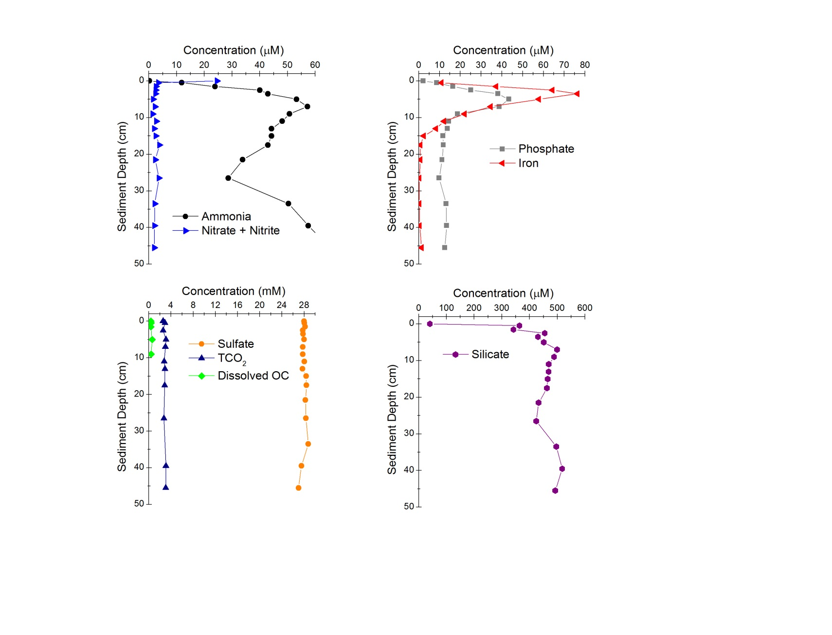

1. Realism of Chemoautrophic Organic Carbon Enrichment

Lenk et al (2011) have assessed rates of carbon fixation by sulfur oxidizing chemoautrophs in intertidal sediments with high sulfide fluxes throughout the sediment column. Dark CO2 fixation rates ranged from approximately 60-4 µgC L-1hr-1 in sediments collected from the upper 2 cm to 10-11 cm depth, respectively. 16S rRNA gene analysis suggested that distinct clades of uncultured Gammaproteobacteria**,** especially members of the WS-Gam209 group closely related to the sulfur-oxidizing endosymbionts of the tubeworm *Oligobrachia* spp., were abundant. If similar rates were sustained over 748 days in the incubated anoxic sediments of this study, 0.24 to 0.016 gC could have been added to each treatment bottle containing ~0.22 L wet sediment. Compared to the initial OC content of 2.9 ±0.2 g, such enrichments would increase the OC content by from approximately 8 – 0.5% above initial concentrations.

1. Percentages of 16S rRNA Gene Sequences from Sediments and Anodes Determined by Parallel High-Throughput Pyrosequencing



