Group 1：Emily Liu

Managing Your Time Well
In this article, I would like to write about the topic that I use as my article’s title-- managing your time well. It is well known that making a reasonable schedule for ourselves daily life is a quite important thing for freshmen to do. More over, learning how to manage one’s time well is also a necessary skill for our life.
After I graduated from high school and I take a summer class before I go to university, then I found that, the life of university might be freer than it in high school, my parent might not notice me when I forgot to finish my assignments, which means many things need me to manage, for example, I will do more self study, and remember the due date of every things mentioned in the to do list. So it is more important for us to make a plan for our student life. This is the thing that I met in the past few weeks. As the summer class first start, I usually relax, and try to finish all assignments at the last day before the dead line, which means I always need to stay up late at the last day for finish all the assignments. After stay up late for finish the homework, I usually feel really tired and cannot get up in the morning, and my life become mess. Even though I finish the assignments in time, I cannot get good grades for those assignments, because when people do something in harry, they cannot do it with high quality. After managed my life a week like this, I felt tired and disappointed about my life and grades, so I began to manage my time. To be more specific, I separated my assignments into several parts, and finish one part each day. Then I found I can finish all my assignment easily, and get a good respond for my assignments, and I did not feel tired any more. That why I think it is necessary for freshmen to manage their time well, so their efficiency can be improve.
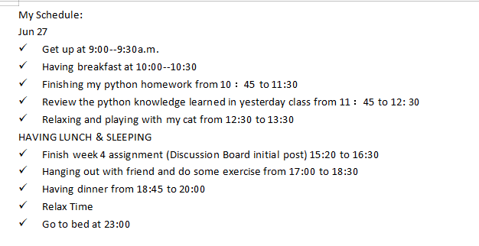
(One of my time schedule’s screen shot)
All in all, it is really important for freshmen to managing their time well, this is a useful skill in our future life, not only in our university life, but also can help us in our future life about working and relaxing. Then I would like to explain why we should learn how to managing our time well.

