S.T.E.P. PROJECT PROPOSAL

Project Summary

In an effort to further my professional business skills by exposing myself to the dynamic of the financial services industry, this summer I will serve as a Financial Representative Intern for Northwestern Mutual in Columbus, OH. This position will cultivate my professional development through challenging real-life business experiences.

Project Description

This summer, I will be working at Northwestern Mutual’s Grandview Heights office, serving as a Financial Representative Intern. For the past 20 years, since 1997, Northwestern Mutual’s Internship Program has earned Vault’s ‘America’s Top 10 Internships’ honour. This is due to the profitable challenge of the program that comes as a result of the real-world job application of the position. As a Financial Representative Intern, I will be holding almost identical responsibilities as a full-time Financial Representative with the company. This includes exposure to a real-world work environment (as I will be working out of the office), intensive training and unparalleled support in my business endeavors for the company, the chance to work with an experienced financial representative and/or wealth advisor, and the opportunity to experience the dynamic of mentorship through the business coaching that is offered within the office. As a financial representative intern, I will learn and master Northwestern Mutual’s personalized financial planning process in order to provide financial solutions tailored to my particular client’s needs and wants, with the ambition of gaining referrals and constructing my own clientele. Through this dynamic of financial planning, I will improve my understanding and application of finance knowledge, a perk that I can carry with me and further build upon the remainder of my undergraduate and professional careers.

I pursued this particular internship program and accepted the company’s formal offer to work with them this summer due to the professional growth that I know I will receive by participating in this hand-on, real-world job experience. The primary objective of holding this summer internship is to develop and cultivate my business and professional skills by doing authentic work in the finance service industry, a realm of business that highly fascinates me. I hope to gain a thorough understanding of what this particular industry consists of, and use this experience as a ways of gauging whether or not I would be interested in holding a position of similar nature as a profession upon graduation.

As is clear from my paragraph above, this project will fit into the Internship category of the Six Categories presented by S.T.E.P.

This project will be quite transformative for me. I haven’t had the opportunity to experience a challenge such as this. It is one thing to take difficult classes and master the course material; it is a completely different manner to be in a position where I can apply the skills and knowledge that I have gained in a real-life job setting. This internship will be a test for me, in several regards.

First, I will have to work extremely hard to prove myself, for I will be one of approximately 40 interns in the office for this summer. The interview process for Northwestern Mutual took me roughly one month in length before I was given a formal offer. It consisted of four total interviews/meetings with the senior recruiter and one of the wealth advisors in the office, and two forms of evaluations in which the company used to gauge whether or not I am cut out for the program’s curriculum. My reason for mentioning this is to show that Northwestern Mutual is very selective and competitive in their intern hirings. I will be among some of the brightest and most competitive business students from Ohio State’s Fisher School of Business as well as other nearby universities. In order to stand out in a positive manner and excel at my position, which I have a strong desire to do, I must ‘be on my toes’ every single workday and push myself to reach, and even exceed, the high standards that the program has of its interns and I have of myself.

The second manner in which this internship will be a test for me is due to the fact that I will be a minority amongst my college peers, in regards to my academic status. For their Financial Representative Intern position, Northwestern Mutual tends to recruit and hire upperclassmen (Juniors – Fifth-year Seniors), due to the challenging nature of the program’s demands and expectations. Especially in the Grandview Heights office, they hire very few Sophomores for their summer internship. The fact that I am a Sophomore puts me at a slight disadvantage, for most of the other upperclassmen intern hires will have an additional internship experience over me, in addition to an extra academic school year’s worth of business classes. This does not intimidate me; it means I will have to work even harder then my peers to perform at a high caliber in my position.

In regards to the academic component of this project, this internship allows me the opportunity to practice the business, communicative, and intrapersonal skills that I have fostered over my first two years as an undergraduate business student at Ohio State. Additionally, I will be able to apply the context of what I have learned in my business courses thus far, such as CSE 2111 and BUSMGT 1430.

My project is perfectly feasible in regards to time and resources. This internship will officially begin on May 23rd. At this point in time, I am unaware as to when the official end date is, but it will be around the beginning of the Autumn 2016 semester, most likely a week or two prior to.

In the development of this proposal, I have utilized several individuals and resources. First and foremost, my S.T.E.P. coordinator, Dr. Nancy Santagata, has helped tremendously in the areas of communicating with me what the requirements are for this proposal, in addition to what my options are for wisely using my funds to cover certain internship-related expenses. Aside from Dr. S, I have used a couple of my 3rd-year friends’ accepted proposals as visual examples as to how the format of the completed proposals should look like. That’s about all I used their proposals for, since the requirements from last year’s S.T.E.P. cohort compared to this year’s has changed in expectations. Lastly, I used the documents and materials that were made available through the S.T.E.P. Dashboard in order to ensure that I have met all of the necessities.

Personal Statement

This project enhances my experience at The Ohio State University by providing me with an opportunity to grow by experiencing the dynamic of an industry that I am highly interested in, perhaps even to the extent of becoming a professional in this industry upon graduation. The action of accepting this internship is a tad unorthodox for someone in my position, for I am a Marketing specialization within Fisher, pursuing a minor in Entrepreneurship and Innovation, and this position is heavily on the finance side. The reason for my interest is due to the fact that I constantly challenge myself to go beyond my comfort zone, both in professional and personal terms, and allow myself the exposure of various fields and dynamics. I do not wish to get caught up in the labels of business. Just because I am pursing a primary education of Marketing on paper does not imply that I will end up doing anything marketing related as a career. Aside from the finance services industry, I am also very interested in consulting, due to its diverse and problem-solving-oriented mindsets. I was honoured and blessed to hold a position as a consultant intern with Asher & Abram LLC. last summer, and in an effort to further expand my horizons, I wish to experience a finance-related opinion, which is exactly what Northwestern Mutual will provide for me.

I know that this experience will aid me in my search for what it is that I truly envision myself doing for a living. I am confident that I will be a businessman, but of what kind is the question. Aside from being exposed to the work of a financial representative, I will just as importantly be introduced to the resources made available by the company, in particular the current employees. Just through the interview process alone, I’ve had the chance to sit down and converse with various employees and listen to their respective career paths and life decisions. This is very helpful for someone in my position, who is attempting to slowly figure out what it is that I am truly passionate for professionally and work towards turning that into a career opportunity for me in the near future.

I will have the honour of networking with some of the most prolific professionals of the industry through holding this internship. Whether it be befriending and initiating professional relationships with the wealth management advisors at the Grandview Heights office or getting to network with some of the company’s most caliber financial representatives through a company trip to Milwaukee, Wisconsin where the Northwestern Mutual headquarters hosts an annual conference over the summer, the people whom I will come into contact with will play a vital role in the experience that I will have over the summer, the skills I will attain through the internship program, and my understanding of what the finance services industry truly entails.

Business aside, on a more personal level, this internship will prove beneficial for my self-confidence and drive for success. Just by being in an office as proficient as Northwestern Mutual’s, wearing business professional attire everyday, interacting with like-minded and hard working young professionals as myself, and being in the presence of the numerous successful financial representative who were once where I currently find myself, all of these will prove to inspire me to continue to work hard and do the best work that I can do every time. This inspiration will motivate me to excel in my position over the summer, which will in turn result in the upsurge of my self-belief. If I was able to earn a position in a ‘Top 10 Internship’ program as an underclassman, I can definitely shine in said position, and gain an experience that will only serve to convalesce my professional skills and self-confidence.

Budget

The following is my budget proposal for my internship project. Without these components, it would be difficult for me to have the positive internship experience due to the heavy financial burdens. I hope S.T.E.P. understands my elaborations on each component of my budget, which can be found below the budget.

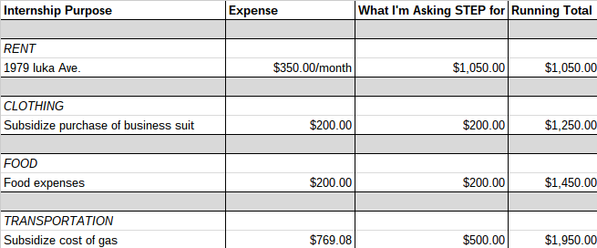

RENT - The largest aspect of my budget is the cost of rent. In order to undertake the Financial Representative internship for Northwestern Mutual in Columbus, I need a place to live this summer. I found a very good deal living on 1979 Iuka Ave. Columbus, OH 43201. This is the Alpha Gamma Rho house, home to an agricultural fraternity of Ohio State. I will be renting a single room for $350.00/month, totaling $1,050.00 for the three months I plan to live inside the house. This $1,050.00 total expense includes: wifi, laundry, parking spot, cable, air conditioning.

CLOTHING- My position as a Financial Representative intern for Northwestern Mutual requires me to be in the office [in Grandview Heights] Monday-Friday, 9:00 AM-5:00 PM during the length of the program. Additionally, this position calls for me to be dressed in business professional attire every weekday. I will buy a business suit over the summer that will cost more than $300.00, I’m sure. I do not know the exact price of the suit at this moment because the final price upon purchase depends on which company I purchase the suit from, what fabrics the suit is made out of, and if I decide to have the suit tailored. I am asking S.T.E.P. to help me in the financial strain of buying a new business suit by subsidizing the final cost by $200.00.

FOOD - During my time living and working in Columbus over this upcoming summer, I will have to purchase food, whether this be in the form of groceries to take back to my room or in terms of going out to eat with friends and/or business colleagues. I am asking S.T.E.P. to help me in the realm of food expenditures by subsidizing the cost by $200.00.

TRANSPORTATION- The second largest aspect of my budget for this summer is the total anticipated cost of gas that I will have to incur in order to drive to and from work every weekend, in addition to driving to and from Cleveland once a month to visit my family on occasion. In total estimate, I calculated the mileage that I will drive this summer to be 1326 miles, 528 miles coming from driving to and from work every weekday for 12 weeks, and 798 miles coming from driving to and from Cleveland once a month over the three month summer period to visit my family. The following calculations go into further detail:
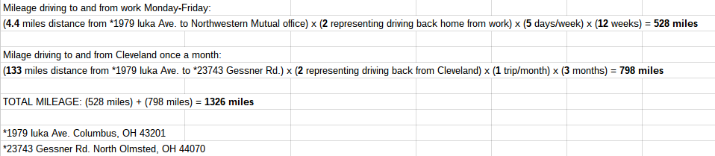

In calculating the monetary value, I took the total mileage of 1326 miles and multiplied it by $0.58, which is the value indicated in the S.T.E.P. document as what is acceptable in subsidization request, and received a figure of $769.08. Despite this being the number that I could ask S.T.E.P. financial aid towards, I will pay $269.08 myself. I am asking S.T.E.P. to subsidize the remainder of my projected cost of gasoline for this summer by $500.00.

Reporting Back

As a citizen of the university, I plan to share and showcase my experience in two ways:

- I will compose an essay via U.OSU.EDU that will outline in detail the value and depth of my project. In order to prepare properly for this final paper, on a weekly basis I will compose an entry that will share my experiences of that particular week. In this manner, I can culminate all of these entries and write an essay that is as accurate as possible in describing the developmental details of my project.
- I will present my project in an aesthetically pleasing and professional manner next Autumn at the S.T.E.P. Expo. This is a great opportunity for me to share with fellow faculty members, colleagues, friends, and Buckeyes the extent of my internship experience and how S.T.E.P. will have aided in my gaining such an invaluable professional and personal opportunity.

