OSU Central Receiving now offers a solution to track the status of central campus deliveries for parcels and freight received at 2650 Kenny Road.

***How do I access the OSU Shipment Tracking System?***

Web Site: osucentralreceiving.osu.edu

Login: OSU Username (Name.#) and OSU Account Password.

***What browsers are supported?***

Microsoft Internet Explorer (IE) versions 9 and above are supported.

The current versions of Mozilla Firefox and Google Chrome are also supported.

Contact your local IT area for support on browser-related questions.

***Who do I contact for Central Receiving Support?***

Contact customer service at (614)292-2694 or [osums@osu.edu](mailto:osums@osu.edu).

***Are there instructions on how to use the system?***

Yes, a [Shipment Tracking System Job Aid](https://assist.ocio.osu.edu/sites/default/files/shipping/STS-JobAid.pdf) is available on the [Shipping ASSIST](https://assist.ocio.osu.edu/shipping) page.

***How do I search for a shipment?***

Once the shipment has been received at 2650 Kenny Road, search the OSU Shipment Tracking System using the:

* FedEx tracking number
* UPS tracking number
* USPS tracking number
* OSU Purchase Order number (PO)
* OSU Stores Requisition number (MSR)

***What is a wildcard search?***

Use an asterisk (*) to replace any unknown values in a search.



***I only have my eRequest number. How do I search for my shipment?***

Searching is currently based on PO number, MSR number or tracking number.

For Tracking Number: Contact the vendor for the shipment to obtain the tracking number.

For PO or MSR number: Look for the Distribution Method section on the eRequest to find the

PO or MSR number.



A PO or MSR will not be generated if the eRequest was procured using a Pcard. If you cannot locate the PO or MSR, or have questions about your Pcard transaction, your [Departmental Service Center](https://dcm.osu.edu/content/groups/public/documents/job_aids/ja_ereq_svc_ctr_contacts.pdf) can offer assistance.

***I don’t know my PO, tracking or eRequest number. Can I still search for my shipment?***

Try searching by Org plus the wildcard. (The first five digits of a purchase order is the Org Number).



***I can’t find my shipment in the system. What do I do now?***

1. Confirm that the item was delivered to and received at 2650 Kenny Road.
2. Verify that you are searching with a valid FedEx, UPS, or USPS tracking number, OSU PO Number or OSU MSR Number
3. Contact OSU Central Receiving for support.

***What does the Status mean?***

Shipments are routed through OSU Central Receiving according to this flow:

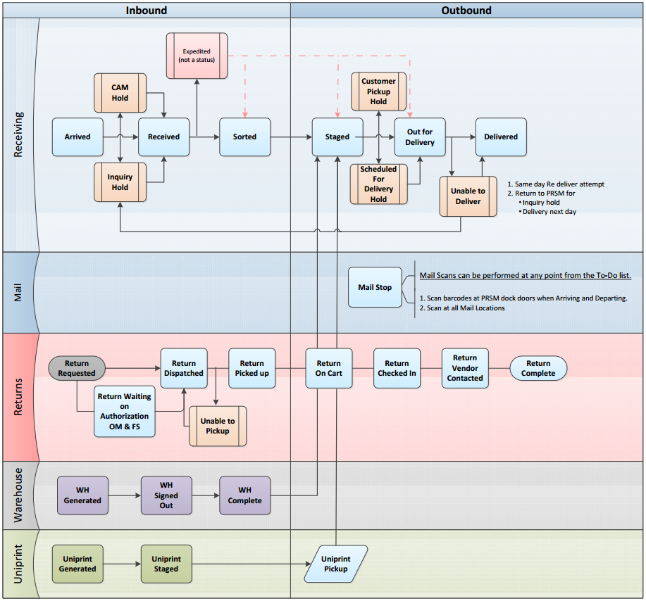

Status Definitions:

|  |  |  |
| --- | --- | --- |
| **Status** | | **Status Meaning** |
| Inbound | Arrived | The carrier shipment has been delivered to the inbound dock are of OSU Central Receiving. |
| Received | The shipment has been received against the packing list. |
| Sorted | The shipment has been sorted for delivery by campus location and delivery route. |
| Outbound | Staged | The shipment has been staged for delivery within the next business day. |
| Out for Delivery | The shipment is out for delivery by OSU. |
| Delivered | OSU has delivered the shipment. |
| Warehouse  (OSU Stores) | WH Generated | The warehouse order has been entered and a pick ticket has been printed. |
| WH Signed Out | The warehouse order has been assigned and the picking process has started. |
| WH Complete | The warehouse order is complete and ready for outbound staging. |
| Inquiry Hold | | The shipment is missing the delivery information. Please contact OSU Central Receiving to provide the ship to and delivery address. |
| CAM Hold | | The shipment is on hold for tagging through capital asset management (CAM). |
| Customer Pickup Hold | | The customer requested the shipment be held at OSU Central Receiving for customer pickup. |
| Scheduled for Delivery Hold | | The customer requested the shipment be held at OSU Central Receiving until it can be scheduled for delivery. |
| Unable to Deliver | | The shipment could not be delivered. OSU will attempt delivery within the next business day. You may also contact OSU Central Receiving to make delivery arrangements. |
| Closed | | The shipment could not be delivered. Please contact OSU Central Receiving for support. |

***Why am I receiving, or not receiving, email notifications?***

A confirmation email is sent automatically when the status of the shipment is Out for Delivery. The email is sent to the Ship to contact information listed on the eRequest. If you don’t want to receive the email notification, set up an email filter/rule to organize the messages in your email system. Contact your local IT area for support on email questions. Contact OSU Central Receiving for additional support.

***How do I submit a return request?***

The system can be used to schedule PO returns, OSU Stores returns, toner recycling or gas cylinders.

To be eligible for return, the item has to:

1. Have been ordered through eRequest.
2. Been received within the last 30 days.

UPS or FedEx pickups that cannot be placed in a campus drop box can also be scheduled through the system.

To schedule a return click on Request Forms and select the return form that best applies.

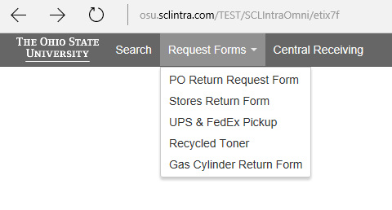

The system will generate a barcode when the return request is submitted successfully. Please affix this label to your return shipment.

You will also receive an email confirmation of the return request.

Please contact OSU Central Receiving for additional support.