OSU Central Receiving now offers a solution to track the status of parcels and freight deliveries received at 2650 Kenny Road.
This job aid explains the features of the Shipment Tracking System. For additional support, refer to the OSU Shipment Tracking FAQs or contact OSU Central Receiving customer service at (614) 292-2694 or osums@osu.edu.
OSU Shipment Tracking Website: osucentralreceiving.osu.edu
Login: OSU Username (Name.#) and OSU Account Password

To SEARCH for a shipment:
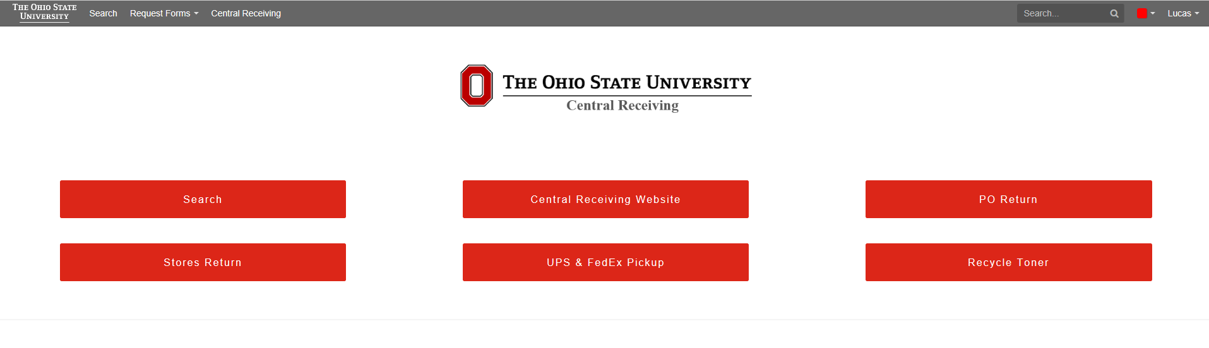

Click here to search by:
- FedEx, UPS, or USPS tracking number
- OSU Purchase Order Number (PO)
- OSU Stores Requisition Number (MSR)

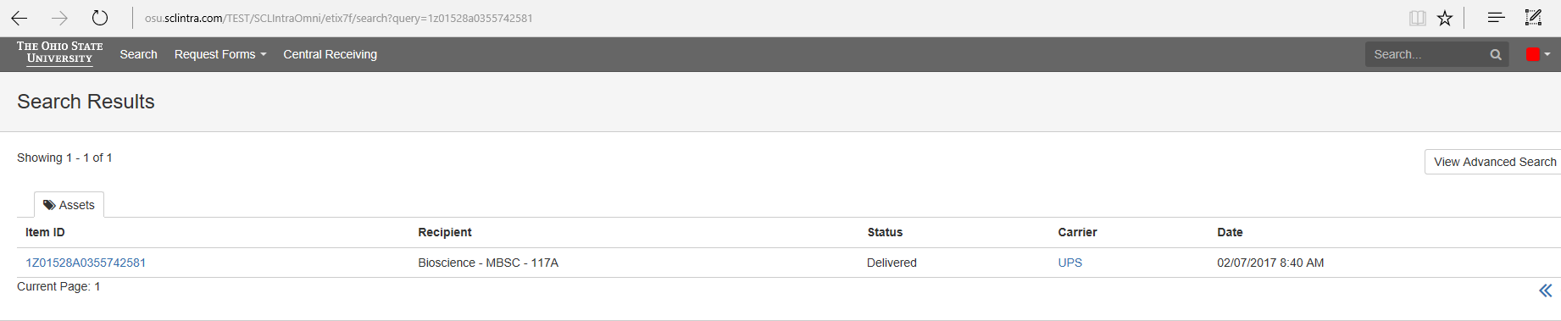
Click on the Tracking number to select the item.

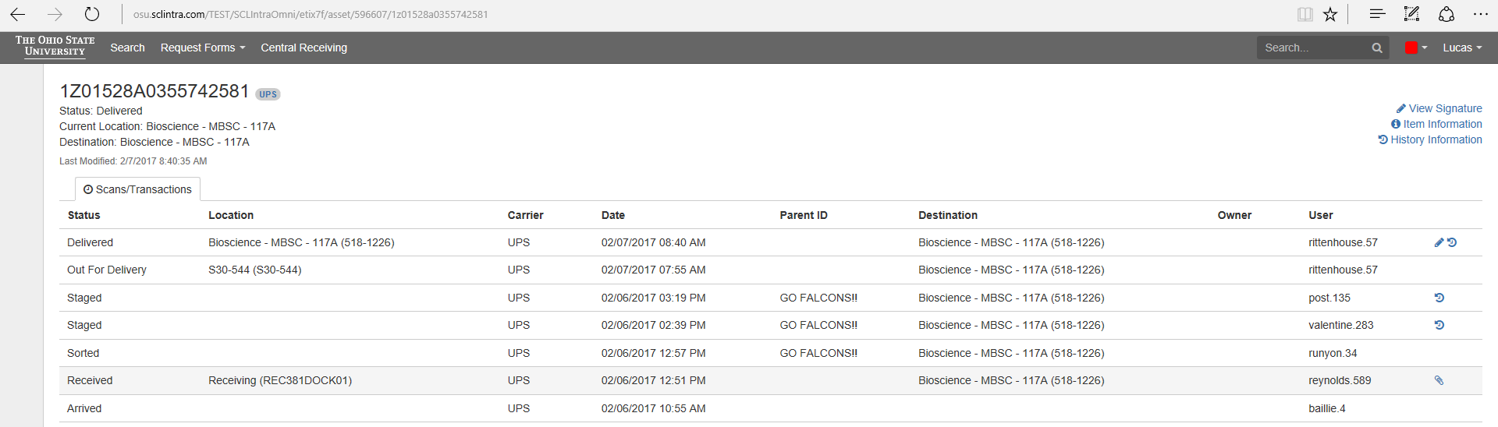
“View Signature” allows you to view the signature captured at time of delivery. (Pencil icon)
“Item Information” allows you to view all information about the item.
“History Information” allows you to see the name of who signed for the package as well as any comments input by the delivery driver. (Clock icon)

Click on the “Request Forms” tab and select the appropriate form. Alternatively you can use main screen for PO Returns, Store Returns, UPS/FedEx pickups, and toner recycling.

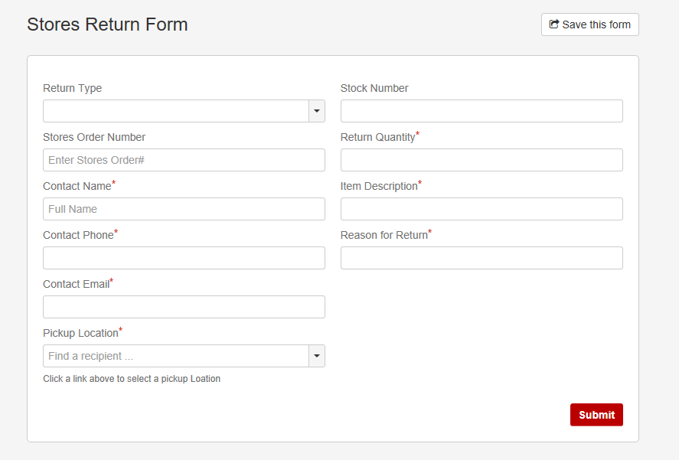
Complete the form and clock on the red SUBMIT button at the bottom to send the request. Fields marked with an asterisk (*) are required.

For additional support, refer to the OSU Shipment Tracking FAQs or contact OSU Central Receiving customer service at (614) 292-2694 or osums@osu.edu.

