Prepared for:
Dr. Jane Fife
Jesse Blanton

The Ohio State University
590 Woody Hayes Drive
Columbus, OH 43210

Prepared by:
John Capuano
Jamie Heidel
Ryan Jeon
Tayo Pedro

The Ohio State University
590 Woody Hayes Drive
Columbus, OH 43210

April 21, 2017
Recycling of Inedible Biomass
Final Report
Table of Contents
Executive Summary 3
Introduction 4
Background 6
Detailed Design Description 8
Design Evaluation 14
Results 16
Cost Analysis 18
Further Design Considerations 20
Conclusions and Recommendations 21
References 22
Appendix 24

List of Figures

Figure 1: Researchers testing the VEGGIE System (Source: https://www.nasa.gov/sites/default/files/styles/side_image/public/veggie_ksc_activation.jpg?itok=G3LeGwpH) 8
Figure 2: Rooting pillow from passive water delivery system (Source: Heidel 2016) 8
Figure 3: Ecotonix Green Cycler Food Shredder 11
Figure 4: SolidWorks Model of Bioreactor Body 12
Figure 5: Bioreactor and System Components in Laboratory Space 12
Figure 6: Air pump used in Bioreactor Design 13
Figure 7: Data Acquisition system and Breadboard 14
Figure 8: Change in Mass over Time during Moisture Removal 15
Figure 9: Efficiency and Cost of Air Pump 17
Figure 10: Change in Temperature of Composted Material Over Time 18
Figure 11: Change in mass of material over time 19

NASA X-HAB Project: Recycling of Inedible Biomass
The Ohio State University
590 Woody Hayes Drive
Columbus, OH 43210
April 21, 2017

Kennedy Space Center
SR405, FL 32899

Kimberly Simpson,
Attached you will find the team’s final report for the NASA X-HAB Challenge regarding investigation of recycling plant biomass for long term space missions. This report includes background information, description and evaluation of our design, as well as conclusions and recommendations for future iterations of this project. Based on information collected through research and experimental analysis, the team reached the following conclusions:
- Composting of inedible plant biomass using an aerobic bioreactor allows for recycling of valuable nutrients. Compost can be used as a growth substrate for future crops.
- Surface area to volume ratio is critical in reducing heat loss for a small scale bioreactor
- Pre-treatment of inedible biomass is necessary for efficient decomposition of biomass. This includes shredding of material to reduce particle size and dehydration of biomass to reduce moisture content.
- Incorporating pre-treatment into the bioreactor design will help make for a continuous process and reduce crew time
- Human byproducts on board the space ship would be beneficial for decomposition

The team would like to thank you as well as other NASA sponsors for providing us with this opportunity, and for your continuous advice and support throughout the course of this project. We would also like to express our special thanks and gratitude to our adviser Dr. Peter Ling, our capstone instructors Dr. Jane Fife and Jesse Blanton, as well as technical professionals Dr. Fred Michel, Dr. Harold Keener, and Professor Chris Gecik for their contributions of time and resources that helped make this project a success.

Executive Summary

This report provides information regarding the planning, analysis, and evaluation of a bioreactor to serve the purpose of composting plant biomass in microgravity. Currently, a system known as the VEGGIE system is utilized by NASA to grow fresh vegetables, such as basil and lettuce, in space stations where there is little to no gravity. This challenges the physics of plant growth knowledge to date. While the system has provided a generous amount of vegetative growth, there is still plant biomass that is considered inedible, and thus often packaged with trash. NASA would like the VEGGIE system to be further augmented to be able to utilize the nutrients locked in these inedible parts, and thus recycle biomass into what would have been disposed as waste. The main proposed design is to create an aerobic bioreactor that would compost this biomass into a usable growth substrate for future vegetation while requiring as little crew time as possible.
Using a Fishbone Diagram, the initial choice for the use of the inedible biomass was limited to either composting, pharmaceuticals, or as substrate for 3D Printers. After utilizing the Pugh Matrix, it was clear that aerobic composting was the most ideal, safe, and efficient way of utilizing the biomass. Professionals in composting, Dr. Harold Keener and Dr. Peter Ling, aided in the design and Mike Klingman executed the construction with aid from team members. This composter was designed and then built at the Wooster Research branch of The Ohio State University. The composter is schedule 40 PVC and is 47 inches in length with an inside diameter of 4 inches.
Upon completion of construction, the team was already planning on how to most efficiently compost the biomass. After extensive research, pretreatment of the plant mass was identified to be an extremely important part of composting. This consisted of both size reduction and moisture reduction. These were achieved by using a shredder to break down the pieces to approximately 2 cm, and also an oven to dry the material to 60%. Once this was finished, the biomass was loaded into the bioreactor. While in the bioreactor, temperature, weight and airflow were all measured. Temperature was expected to increase as microorganisms began breaking down the material the material, creating heat. Mass was expected to decrease as the decomposition process occurred. The results of our composter were both successful and unsuccessful, leading to concrete recommendations for the next iteration. There was an increase in temperature, however it did not reach the 60ºC to ensure optimal composting. Also the mass successfully decreased.
In the next iteration of the system design, a full-scale bioreactor will be used to improve the results of the success metrics set for the project. The scaled-down bioreactor meant for two crew members rather than the entire crew of six was used for the current system. The volume to surface area ratio is a crucial factor in establishing and maintaining the necessary temperature of 140⁰F. Moving forward with current system, the concluding steps will be to calculate a final moisture content, ash content and carbon to nitrogen ratio.

Introduction

The National Aeronautics and Space Administration (NASA) is an agency that does extensive research on space exploration and scientific discovery. Increasing emphasis has been placed on deep space exploration, which has driven technological breakthroughs for applications in space as well as on Earth. Space exploration has been restricted to short-term missions due to the inability of current systems to provide long-term life support for astronauts on board. Necessities such as food, water, and air cannot be supplied indefinitely, and systems that can regenerate these essentials to life must be developed if humans take space exploration deeper into space.
These challenges do not hinder success but create opportunities for groundbreaking innovation. The NASA eXploration Systems and Habitation (X-Hab) Challenge provides college students the opportunity to tackle these deep-space exploration challenges faced by NASA. While exciting progress in space travel raises hope for possible interstellar explorations, a current issue requiring further research is the development of a sustainable and reliable food production system. In order to achieve sustainability of this system, NASA has challenged students to research and develop a way to recycle inedible plant biomass, in particular plant nutrients. The NASA space crew needs to recycle inedible plant biomass to create products that will help sustain food production, reduce excess weight, and minimize crew time to maintain a functioning life support system. If this is accomplished, it will enable longer space missions, healthier astronauts, and potentially successful colonization of Mars.
This document provides background on the scope of the project, the definition of the problem specifically, discussion of viable design concepts, and a final selected design with rationale for its selection. Furthermore, a detailed description and evaluation of the team’s design are included in this report. Finally, results from testing and evaluation of the final design are included along with a cost analysis, further design considerations, and conclusions and recommendations.

Background

NASA’s current food production system designed for microgravity, known as VEGGIE, was developed to provide fresh produce and psychological benefits to astronauts on deep space missions. As seen in Figure 1 and Figure 2 the system utilizes a passive water delivery system with capillary tubes that connect directly from the water reservoir to the plant-rooting pillow. The system proved to be reliable in a 90-day longevity test, with bubble production and the lack of nutrient recycling being aspects that could use improvement (Ling, 2016). The goals for improving the current system are to ensure reliability and incorporate sustainability while utilizing minimal crew time and reducing the need for resupply.
The VEGGIE system lacks sustainability in regards to making use of inedible biomass. Therefore, it is necessary to recycle nutrients from inedible plant biomass to help sustain food production, reduce excess weight, and minimize crew maintenance time for the functioning life support system. Sustainability is essential because it lowers the cost of resupply associated with the system by utilizing the available nutrients. In addition, the system as a whole improves the contained environment in space and mental health of astronauts.
The existing VEGGIE system utilizes a matrix that consists of different components in order to facilitate water absorption. The system does not use soil as a growth medium, so water must be manually inserted directly into the roots as the microgravity environment would cause unwanted dispersion otherwise. Currently, the inedible plant biomass is incinerated. Incineration is a waste of valuable nutrients that can be recycled. Recyclability is of utmost importance because without it 80 kg of fertilizer is required per crew member per year to produce fresh produce (Hogan et al., 2001). In addition, nutrient recovery would reduce the need for resupply and associated costs and provide growth substrate for new seed germination.
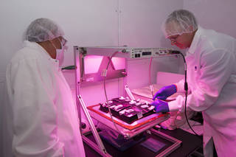
Figure 1: Researchers testing the VEGGIE System (Source: https://www.nasa.gov/sites/default/files/styles/side_image/public/veggie_ksc_activation.jpg?itok=G3LeGwpH)
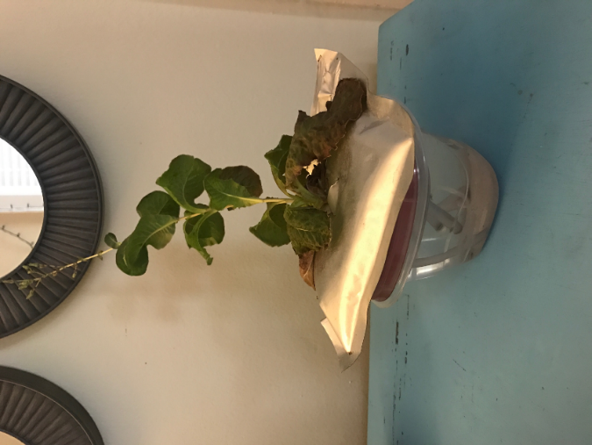
Figure 2: Rooting pillow from passive water delivery system (Source: Heidel 2016)

Water extraction, otherwise known as leaching, was investigated for its potential to create a nutrient solution that could be incorporated into a hydroponic system, as well as a pretreatment for oxidation of inedible biomass. Using wheat, potato, and soybean as experimental crops, leaching of inedible crop residues in deionized water proved effective in recovering the majority of inorganic nutrients. Additionally, it helped separate soluble organics from insoluble organic material, and the soluble organic material could easily be segregated from the inorganic nutrients, making the utilization of inorganics in a nutrient solution for hydroponic culture possible (Garland 1992). However, percent of nutrients recovered varied depending on the crop, and over time supplementation of nutrients was necessary because leaching alone could not sustainably provide enough required nutrients to the plants (Garland et al. 1993).

Detailed Design Description

After generating multiple design concepts, three main systems were chosen for further consideration based on customer needs and technical requirements: a continuously stirred tank reactor (CSTR), an anaerobic bioreactor, and an aerobic bioreactor. A continuously stirred tank reactor can be either a batch or continuous process. The inedible crop is added periodically to the system along with water, while an agitator is consistently running to stir the slurry. Because water must be added, this system has large volume and mass requirements. This is undesirable in space, as each kilogram of weight on the craft is equivalent to $70,000/kg (NASA).
Another design concept, anaerobic composting accomplished in sequential batches, converts waste to methane, carbon dioxide, and compost using maceration and several digestion stages. The material is pumped into a digester and goes through a conversion process for 7 days, while leachate is recycled to maintain moisture within the system. After 21 days, anaerobic digestion is complete and the compost can then be used as a nutrient-rich addition to plant growth medium (Keener 2016). This would have limited application in microgravity because specific liquid recycling and gas collection equipment would need to be created. This lengthy residence time and the need for leachate storage are disadvantages in space.
Finally, an aerobic reactor takes advantage of microorganisms to decompose organic matter under aerobic conditions. Oxygen and moisture contained in air facilitate the decomposition process, creating byproducts of heat, water, carbon dioxide and other trace gases that need to be captured. “In-vessel” reactors are another common large-scale composting technology, where variables such as temperature, humidity, aeration, and mixing can be monitored and controlled. Heat generated by microbes during the decomposition process is high enough to sanitize most products, even urine or feces, introduced into the reactor (Garland et al. 1998). This aerobic process also releases small amounts of trace gases that will need to be collected so that they are not released into the space craft.
Each of these design considerations falls under the category of a reactor, or a device used for containing and controlling a particular reaction or process. The aerobic reactor was chosen as a final design because it is the most feasible design to implement in microgravity. In addition, elements such as temperature, moisture, and oxygen availability can be controlled and monitored in the device, making an aerobic bioreactor a strong option for space travel (Abdelgadir et. Al., 2014).
Prior to beginning the composting process and loading the biomass into the bioreactor, a pretreatment was required. Pretreatment involved This was done through a drying and size reduction process. Some biomass was air-dried and some was dried using an oven in order to achieve a moisture of 60%. The size reduction was a large focus as well, and an Ecotonix Food Shredder was used, as seen in Figure 3.

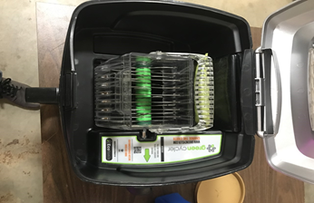
Figure 3: Ecotonix Green Cycler Food Shredder

The design of the bioreactor body can be seen in Figure 4 and Figure 5. The body, made of PVC pipe, is a schedule 40 PVC and is 47” in length. The "T" connection in the reactor is schedule 80 PVC. The nominal pipe size is 4". The inside diameter of the pipe is 4" and the outer diameter is 4.5”. On the ends of the pipe openings are 3 lids made of rubber, with air-tight seals. These have an outside diameter of approximately 4.6”. Plant biomass is fed by removing the lid at the top and feeding in plant biomass. By taking off the lid at the opening of the left side, a plunger, as seen in Figure 5, is inserted, in order to push the material all the way in to fully fill the composter, and create a compact environment that is needed for proper decomposition.
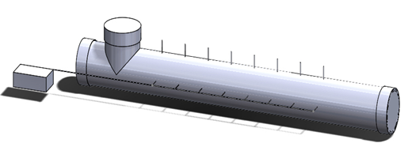
Figure 4: SolidWorks Model of Bioreactor Body

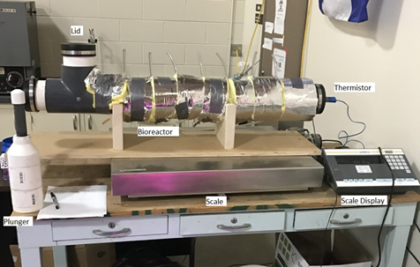
Figure 5: Bioreactor and System Components in Laboratory Space

The aerobic concept of the design is possible through the air system that is implemented. There are 8 small ¼” plastic tubes that run into the center and exhaust through the top, with air powered by a 1/20 HP pump, seen in Figure 6. This pump is run by an automated system so that it is run once every 2 hours for one minute. Without this automation, astronauts would have to manually control the temperature, which can not only be time consuming, but very tedious.
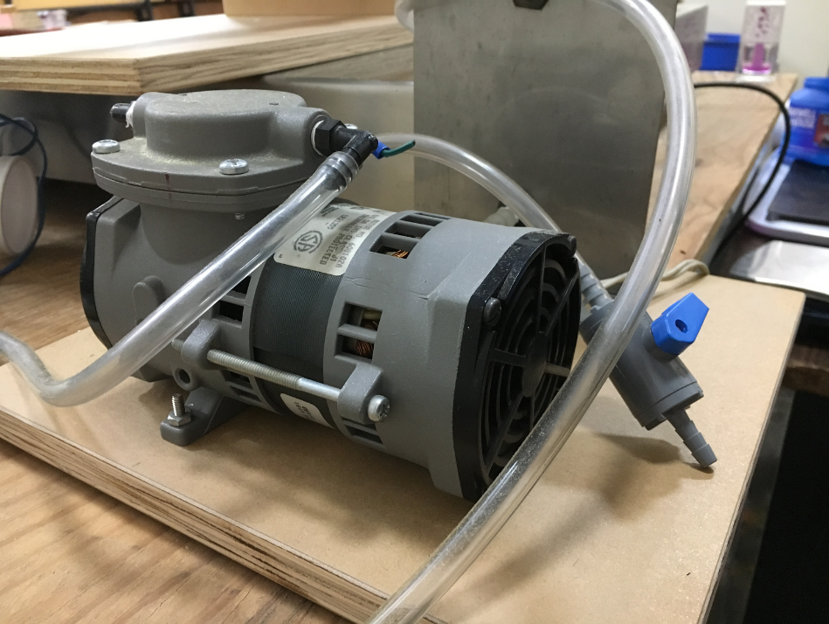
Figure 6: Air pump used in Bioreactor Design

It was extremely critical that a data acquisition device was implemented in the system. Integrating the NI DAQ 6008, the circuit, an air pump and finally a GUI on LabView to control it all, allows the bioreactor to compost at the ideal temperature and oxygen level, without having to be manually adjusted. Finding a temperature recording mechanism was the first step in starting the DAQ system.
A thermistor was chosen as it is more accurate than a thermocouple, and it was poked through the end of the lid and inserted into the center of the compost interior, for the most accurate measurement. An NI USB 6008 was used as well as a computer and all necessary cords. The NI USB 6008 provides not only a source of input, but also an output. This was critical in future parts of the DAQ system. The thermistor is a piece of metal connected to two long wires. These wires are implemented into a breadboard where those are connected to a source of voltage and a ground, all organized by the NI USB 6008 when connected to the computer. All necessary hardware can be seen in the Figure 7 below. It was assumed that a computer would be on board, as this data logging system used minimal energy from an already running computer.

Figure 7: Data Acquisition system and Breadboard

Design Evaluation

The design of the system methods and model was equally as important as the physical design of the bioreactor system. As was mentioned previously, pretreatment of drying and breaking down the biomass was the first step. A consultation with compost expert, Dr. Harold Keener identified 2 cm to be the ideal size of the mass and 60% moisture. The physical breakdown of the inedible biomass was executed by a home compost shredder called the Ecotonix, pictured in the figure above and it shredded the biomass to be approximately 1.5 - 2 cm. This increases the surface area for moisture to escape and speeds up the composting process. In order to determine what the compost’s approximate water percentage was, a simple design experiment was completed. The biomass was weighed and then placed in an oven at 95 C. Every 5 minutes the biomass was taken out and weighed again. This process continued until the initial weight was reduced to 60% of it’s original weight, which was found to be at 20 minutes. This experiment design could be more accurate and efficient in future iterations by using a higher quality oven, however within the scope of this project, 20 minutes was set as the drying time needed to achieve 60% moisture. The decrease in mass over time can be seen in Figure 8.
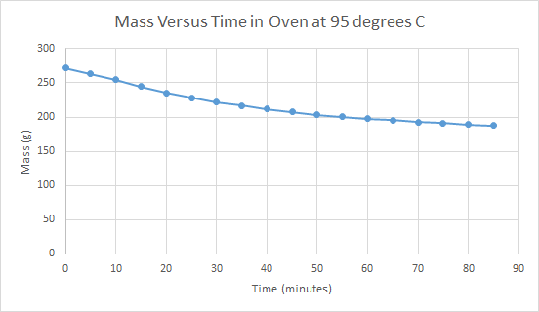
Figure 8: Change in Mass over Time during Moisture Removal

The remainder of evaluations of the design are made based on when the mass is inside the bioreactor itself. Again, recommendations were received from Dr. Harold Keener that keeping track of mass was necessary in order to track degradation. In addition, previous NASA teams have tried similar bioreactor designs, and the literature reviews stated the mass values being necessary for the degradation rate, k, calculation. (Zeitlin, Nancy, Raymond Wheeler, and Griffin Lunn). Once loaded in, an initial mass was taken of the entire system and the system mass was weighed twice a day manually for quick updates and recorded constantly by the data collection system. The design of the system had the entire system sitting on a scale at all times. Although this is very convenient, it’s not as feasible or spatially conscience on a small spacecraft. For that reason, the physical design of this aspect should be reconstructed in further projects to minimize space. On the other hand, the automated system taking weight readings is a great design as it requires very little maintenance from astronauts and is low energy.
Design evaluation also included temperature readings. Again, these were taken manually at least twice a day for the sake of the experiment so that quick evaluations could be made, as well as by an automated system. In designing this, a thermocouple was first used. However, after research and discussion with Professor Chris Gecik at The Ohio State University, it was determined that a thermistor, which measures resistance rather than using mercury balance, was a much more accurate measurement tool for this system. This thermistor design was successful and will be recommended for further iterations. As data was collected the temperature steadily rose, however it did not reach 60 C necessary for composting. Recommendations have been made regarding this as well.
The final design component is the air system. This is made up of plastic tubing and a small 1/20 HP air pump, Thomas Pump:107CAB18. Because the system is aerobic, this is a necessary part of the design. Again, automated by a computer program and system, this pump turns on for one minute every two hours to allow air to be circulated into the compost. This was recommended based on aerobic composting research, specifically from a previous project conducted by NASA. At 30 psi this pump has a CFM of 0.14. The times and volume of air was recorded during the duration of time the pump was on as well. This pump was rather large, and would need to be scaled down for deep space missions, however it was energy efficient and required little to no maintenance in the estimated one year; this can be seen in Figure 9. The data was evaluated based on previous experiments along with input from Dr. Harold Keener.
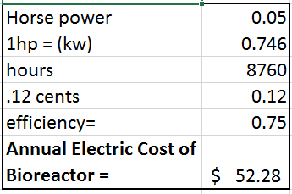
Figure 9: Efficiency and Cost of Air Pump

Results

A success metric and mode of experimental evaluation that was used was monitoring the internal temperature of the material in the bioreactor using a thermistor. A temperature of 140ºF is necessary for compost to properly degrade. The pretreated material placed in the bioreactor for a time span of 25 days failed to reach this temperature due to the surface area to volume ratio of the bioreactor. For small systems, achieving the necessary temperature is often a challenge because a significant difference between the surface area and the volume allows heat to escape. Although the risks of using a scaled down model of the bioreactor was known, the design was pursued due to recommendations of several advisors.
Currently, the temperature of the compost material is 86.4ºF. Figure 10 displays the change in temperature. The overall temperature increase was 18.5ºF with the lowest temperature being 68.4ºF and the highest temperature being 86.9ºF. As this temperature is 53.1 degrees lower than desired, the system was unable to reach the success metric. Fluctuations in temperature are associated with the fan running for one minute every two hours to provide aeration and prevent the compost from going into an anaerobic state.
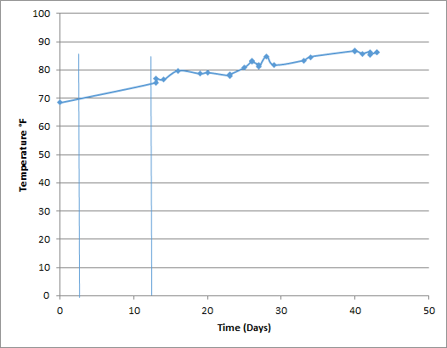
Figure 10: Change in Temperature of Composted Material Over Time

Another success metric was the decrease in mass over time of material fed into the bioreactor. Loss of mass is an indication that decomposition is taking place, as microbes convert biomass into waste products of compost and trace gases, as well as removal of additional moisture (Keener 2016). Ideally, mass would decrease steadily over time which can be seen in Figure 11. Mass measurements shown in Figure 11 only include dates after insulation was added per adviser’s suggestions.

Figure 11: Change in mass of material over time

Slight drops followed by increases in mass can be attributed to sensitivity of the scale, where positioning of the thermistor or thermistor wires may have caused discrepancies. However, the overall trend of the mass data shows it followed a steady decrease. Further analysis of the final composted material will tell whether or not this change in mass was due to decomposition or if the material simply lost additional moisture over time.

Cost Analysis

The cost to build and implement this design for one year is approximated to be $1,014.49, assuming that college researchers will be used for part of the labor at a wage of $10/hour. This estimated cost includes the cost for materials, services, energy used, labor to build and implement, and some maintenance. The breakdown can be seen in here in Table 1.

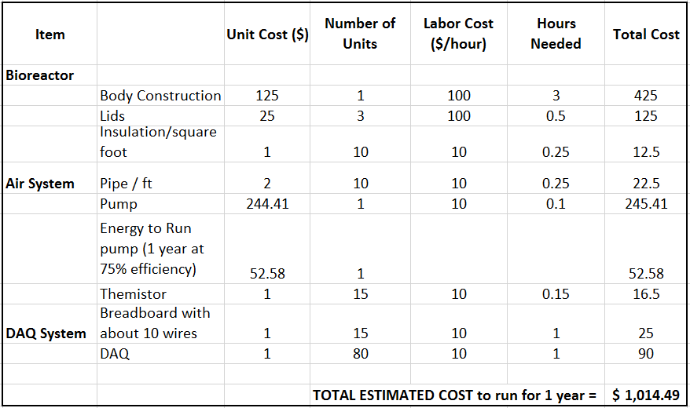
Table 1: Cost Breakdown of Bioreactor Design

As stated in the results, the temperature did not reach the necessary value of 60 C due to too small of a surface area to volume ratio in the bioreactor. This result indicates that either additional insulation needs to be added, or the bioreactor needs to be sized up. If the bioreactor size were to be increased to 1.25 times the size of its current volume, the price would increase approximately $106 in materials and labor. If additional insulation were added, it would be approximately $5 per layer added. Although the latter is the cheaper option, based on the small changes in temperature of the insulation that was added during the process, it is recommended that the bioreactor size be increased, rather than adding insulation, even though it is a much more expensive design change compared to insulation cost.
Another consideration was to use CPVC pipe instead of PVC pipe, because CPVC is meant for higher temperature uses. However, after further research, it was found that there is not a significant enough difference in pipe function because the temperature of 60 C is not high enough to need CPVC. In addition, CPVC costs six times the unit price of PVC ("What Are the Differences between CPVC and PVC?" ).

Further Design Considerations

Though the system will be tailored for use by astronauts aboard space missions, the technology may be useful in markets confined to planet Earth. Having a system for recycling food waste that is self-contained and in a compact design is ideal for residential use, specifically for those trying to recycle their food waste in small spaces. The system could potentially give those living in apartments or dorm rooms the opportunity to sustainably grow their own food using compost, without the need for land or excessive energy use. Restaurants or businesses that are low on space would have the ability to grow fresh herbs and vegetables right in their own kitchens.
Nutrient recovery from inedible biomass could have the potential for commercial use in agriculture to reduce fertilizer consumption as well. Fertilizer production and consumption has caused issues relating to surface runoff and sustainable crop production. If fertilizer could be generated through the recovery of nutrients from inedible biomass, it has the potential to qualify as “organic” in terms of food labeling, and would support the movement towards more sustainable agriculture in controlled environments (Zeitlin et al., 2015).

Conclusions and Recommendations

As the scaled-down size of the bioreactor prevented reaching the success metrics set for this project, it can be concluded that the surface area to volume is not conducive to reaching the necessary temperature of 140ºF that is needed to obtain a 30:1 carbon to nitrogen ratio, which produces compost fit for use as a supplemental growth substrate for new crop production during long term space missions. Additionally, it was found that pretreating raw material using both size reduction and dehydration is essential to begin the composting process. Starter compost in necessary as part of the composition of the first batch of material to introduce the appropriate microbial community.
From the data gathered, successes and failures of the system recommendations for pretreatment and raw material composition can be made. To have the most effective size reduction and dehydration of the raw material shredding the biomass before the drying process is ideal. For future iterations of this system design, attaching the pretreatment system to the bioreactor to make it a continuous process will reduce the amount of crew time spent preparing and loading the system, which aids in reaching the target of working on it for two hours per month. Food waste and human byproducts are the two categories of raw material that will assist in achieving a 30:1 carbon to nitrogen ratio necessary for end compost that can be used as a supplemental growth substrate for sustainable plant production. Inedible plant biomass and uneaten food are the recommended food waste to utilize, and within the category of human bioproducts filtered urine, sweat, hair and nail clippings can be used for nitrogen sources. Although not all success metrics were met using the system design pursued, valuable conclusions and recommendations were made based on the results of the project that can be used in the next iteration.

References

Abdelgadir, A., Xiaoguang, C., Jianshe, L., Xuehui, X., Zhang, J., Zhang, K., . . . N. L. (2014).
Characteristics, Process Parameters, and Inner Components of Anaerobic Bioreactors. Retrieved December 1, 2016, from https://www.hindawi.com/journals/bmri/2014/841573/

Allen R.G., L.S. Pereira, D. Raes and M. Smith. 1998. Crop evapotranspiration: guidelines for
computing crop water requirements. FAO Irrigation and Drainage paper No. 56. Rome.
"Exploration Systems and Habitation (X-Hab) 2017 Academic Innovation Challenge." National
Space Grant Foundation. National Space Grant Foundation, 2016. Web. 18 Nov. 2016.

Garland, J.L. (1992). Characterization of the Water Soluble Component of Inedible Residue
from Candidate CELSS Crops. NASA Technical Reports Server. Web. 4 Dec. 2016.

Garland, J. L., Mackowiak, C. L., & Sager, J. C. (1993). Hydroponic Crop Production Using
Recycled Nutrients from Inedible Crop Residues. SAE Technical Paper Series. Web. 4 Dec. 2016.

Garland, J., Alazraki, M., Atkinson, C., & Finger, B. (1998). Evaluating The Feasibility Of
Biological Waste Processing For Long Term Space Missions. Acta Horticulturae, (469), 71-78. doi:10.17660/actahortic.1998.469.6

Hogan, J.A., J.C. Ramirez Perez, W. Lertsiriyothin, P.F. Strom, and R.M. Cowan. 2001.
Integration of composting, plant growth and biofiltration for Advance Life Support
Systems. ICES SAE Technical Paper #01-2211, SAE, Inc., Warrendale, PA.

Keener, Harold M., and John A. Hogan. Biological Technologies. Tech. N.p.: n.p., 2016. Print.

Ling, Peter P. Passive Watering and Plant Biomass Recycling Systems for Exploration Habitat.
Proposal. N.p.: n.p., 2016. Print.

Loff, Sarah, and Brian Dunbar. "About NASA." NASA. National Aeronautics and Space
Administration, 14 Nov. 2014. Web. 18 Nov. 2016.

Mixing (process engineering) | Wikiwand. (n.d.). Retrieved December 1, 2016, from
http://www.wikiwand.com/en/Mixing_(process_engineering)

Rodriquez-Carias, A. A., Sager, J., Krumins, V., Strayer, R., Hummerick, M., & Roberts, M. S.
(n.d.). IN-WSSEL COMPOSTING OF SIMULATED LONG-TERM MISSIONS SPACE- RELATED SOLID WASTES. Retrieved December 6, 2016, from https://ntrs.nasa.gov/archive/nasa/casi.ntrs.nasa.gov/20030062829.pdf.

Strayer, Richard, Val Krumins, and Mary Hummerick. Bioprocessing to Recover Crop Nutrients from Advanced Life Support (ALS) Solid Wastes: Improving Rapid Biological Processing of ALS Inedible Crop Residues. Tech. no. 2001-01-2208. N.p.: International Space U, n.d. Print.

"What Are the Differences between CPVC and PVC?" CPVC vs PVC Pipe Comparison and Differences. N.p., n.d. Web. 18 Apr. 2017.

Zeitlin, Nancy, Raymond Wheeler, and Griffin Lunn. Plant Biomass Leaching for Nutrient
Recovery in Closed Loop Systems Project (n.d.): n. pag. NASA. Web. 22 Nov. 2016.
<https://ntrs.nasa.gov/archive/nasa/casi.ntrs.nasa.gov/20160006646.pdf>.

Appendix
JOHN J. CAPUANO
Capuano.25@buckeyemail.osu.edu |1453 W 6th Ave., Columbus, OH 43212|440-785-2370

OBJECTIVE
Current senior seeking full time position utilizing technical knowledge and skills obtained in food, agricultural, and biological engineering coursework.

EDUCATION
The Ohio State University, Columbus, Ohio Expected May 2017
B.S. Food, Agricultural, and Biological Engineering Overall GPA: 3.07 (4.0 Scale)
- Biological Engineering Specialization

SKILLS/QUALIFICATIONS
- Thermodynamics, Fluid Mechanics, Heat & Mass Transfer, System Dynamics, Instrumentation
- Statics & Mechanics, Physics, AutoCAD/SolidWorks, Matlab, C++, STELLA
- Food Engineering Unit Operations (in progress), Fermentation microbiology and brewing science (in progress)
- Microbiology, Organic Chemistry, Sustainable Waste Management, Sustainable Plant Production
- Operations Management , Accounting , Statistics, Microeconomics, Macroeconomics

ENGINEERING EXPERIENCE
Go Sustainable Energy, LLC, Columbus, OH
Engineering Intern, Sept. 2016 – Dec 2016
- Provided technical support for Dayton Power & Light’s Energy Efficiency Program
- Aided in technical report writing through research, energy engineering analysis, and data entry
- Investigated barriers faced by Ohio manufacturers seeking renewable energy credits and zero-waste goals

MPS Group, Inc., Avon Lake, OH
Environmental Intern at Ford Ohio Assembly Plant, May 2016 – August 2016
- Completed weekly inspections of hazardous waste satellite areas for large quantity hazardous waste generator
- Implemented recycling program for inbound shipments at 45 locations along truck assembly line
- Coordinated pilot program with local organic waste removal service for organic waste recycling in assembly plant cafeteria to determine economic feasibility

PROJECT EXPERIENCE
NASA X-HAB 2017 Challenge, August 2016 - Present
- Designing small scale bioreactor to recycle inedible biomass and recover nutrients in microgravity for NASA’s long-term space exploration missions
- Investigating ability to passively deliver water to food production system in microgravity

WORK EXPERIENCE
The Raisin Rack, Westerville, OH
Grocery/ Customer Service Associate, May 2015 – May 2016
- Stocked, merchandised, and ordered store products while managing inventory for various departments
- Provided quality customer service using industry knowledge of natural & organic products to educate shoppers

Cornucopia Inc., The Nature’s Bin, Lakewood, OH
Bulk Grocery Department Manager, April 2011 – August 2014
- Worked with sales representatives from various industries to determine appropriate products for store
- Participated in design collaboration and logistical strategy of renovated storefront and commissary

MEMBERSHIPS & CERTIFICATIONS
- Ohio State Sustainability Council Representative Fall 2015 – Spring 2016
- RCRA and DOT Hazardous Materials Transportation Certification

JAMIE L. HEIDEL
Heidel.8@osu.edu 513-787-1747
3190 Parkhill Drive
Cincinnati, Ohio 45248

EDUCATION
The Ohio State University, Columbus, Ohio
B.S., Food, Agricultural and Biological Engineering – Food Engineering Specialization GPA: 2.817
Graduation: December 2017
Provost Scholarship, Humanitarian Engineering Scholar

WORK EXPERIENCE
PepsiCo: Frito-Lay, Frankfort, Indiana
Supply Chain Leader Intern (May-August 2017)

PepsiCo: Frito-Lay, Wooster, Ohio
Supply Chain Leader Intern (May-August 2016)
- Planned and executed $1,700,000 renovation project; increased food safety and efficiency
- Planned and led meetings with contractors and plant managers
- Improved people processes according to new FSMA guidelines and company standards
- Identified outages sanitation schedule and developed sustainable solutions

MoreSteam.com LLC., Columbus, Ohio
Engineering Intern (May-August 2015)
- Created Lean Six Sigma E-learning software; rewrote code to increase efficiency
- Designed performance-check system that increased team’s work rate – Improved visual design by utilizing Adobe Illustrator

ACADEMIC ACHIEVEMENT
National Aeronautics and Space Administration (NASA), Columbus, Ohio
Senior Design Project (June 2016-May 2017)
- Led team of 4 to research and design recycling methods to utilize inedible plant biomass
- Designed and built small scale bioreactor fit for microgravity

3-D Modeling, Columbus, Ohio
SolidWorks 3-D Modeling, Project based class (January—May 2016)
- Constructed and designed toy for child with special needs using 3-D modeling and 3-D printing

TECHNICAL SKILLS
- SolidWorks Certified
- Programming: C++, HTML 5, C#, MATLAB, ColdFusion
- Beginners experience in 3-D Printing and welding
- Lean Six Sigma Yellow Belt Certified

INVOLVEMENT
Science and Engineering Business Club (SEBC), Member (January 2014), President (2017)
- Founded with purpose of providing business developmental opportunities for students in technical fields
- Coordinated logistic development of “Suits for Students” program

Aspiration for Women’s Advancement and Retention in Engineering and Sciences (AWARES) – Mentor/Mentee Program (August 2016-May 2017)

Alpha Gamma Delta
- Member and volunteer for Juvenile Diabetes Research Foundation (March 2014-present)

Habitat for Humanity Trip Leader- Oklahoma and Florida (January 2015)
- Managed all logistics including transportation, meals, and finances
- Directed 20-person team in a week long house-build
Ryan L. Jeon
14 West 8th Apt B, Columbus OH, 43201
(408) 893-6627 jeon.96@osu.edu

Objective
An engineering internship or Co-Op specializing in systems or chemical engineering

Education
The Ohio State University, Columbus, OH Graduation: May 2018
B.S. Food, Agricultural, Biological Engineering, Minor in Animal Sciences

Engineering Experience
National Aeronautics & Space Administration,
Recyclability of Inedible Plant Biomass, April 2016-May 2017
- Represented the team at Kennedy’s Space Station to present findings on the recyclability of inedible biomass in microgravity
- Developed a batch aerobic bioreactor as a group of four that digests inedible plant biomass into recycled compost for future crops to use, an effective augmentation to the current VEGGIE system that can also reduce costs of space travel
- Researched electronic systems to design a unique data acquisition system to automatically collect temperature data in a bio-reactor over an extended period of time
- Further improved salient wiring skills by adding a threshold temperature value to signal the computer to turn a turbine on or off, depending on the temperature gradient over a time value
Infectious Amyloidosis Transmission, Columbus Ohio
Data Analyst, January 2017- Current
- Determined appropriate statistical techniques to understand if the mode of Amyloidosis transmission in captive Cheetahs are due to genetics, infection, or an external catalyst
- Utilized VBA in Excel, MatLab, and R Software to interpret, polish, and discuss big data files
- Presented weekly deliverables in a fast paced environment
Advanced Energy Vehicle Design, Columbus Ohio
Coding and Instrumentations, August 2015-December 2015
- Spearheaded ideas into concrete code to regulate the speed and direction of a small vehicle, and successfully designed a path for the vehicle to automatically follow
- Utilized Excel and MatLab to successfully create charts and graphs to pinpoint areas of concern, such areas of lag between the computer and the vehicle, effectively increasing efficiency by 17%

Leadership and Involvement
Participant, LeaderShape Academy (August 2014)
- Enhanced social and leadership skills through trust building activities and discussions
Brother, Delta Sigma Phi Fraternity, Alpha Iota Chapter
- Strengthened team building skills through various social activities and fundraisers held throughout the year

Additional Engineering Qualifications:
Engineering Coursework: Fluid Mechanics, Heat and Mass Transfer, Principles of Biological Engineering
Chemistry Experience: Biochemistry, Physical Chemistry, Organic Chemistry, Thermodynamics
Programming Skills: VBA in Excel, MatLab, SOLIDWORKS, LabView, R Software, Stella
Laboratory Equipment: Dissolved Oxygen Reader, Data Acquisition System, Carbon Analyzer

Temitayo Pedro
3649 Wetherill Court |Avon, OH 44011| Phone: 440-822-7396| E-Mail: pedro.19@osu.edu

Objective
To obtain a full time position in research and development, quality assurance or packaging engineering which allows me to expand my skills and positively impact companies and the consumers they serve.

Education
The Ohio State University Spring 2017
Bachelors of Science: Food Agricultural and Biological Engineering
Focus: Food Engineering

Projects
NASA Exploration Systems and Habitation Innovation Challenge: August 2016 – May 2017
- Recycling Inedible Plant Biomass for Growth Substrate: Evaluating the feasibility of recycling plant biomass for growth substrate to reduce the resupply payload for plant production, with a focus on chemical and physical analyses of inedible plant biomass and growth substrate matrix using minimal external supplies.
Product Development and Processing: March 2016 – May 2016
- Used good manufacturing practices to create three 10lb batches of banana chocolate chip bread in the Howlett Plant with flour as the variable. Performed sensory and analytical tests to evaluate the acceptability of the products.

Relevant Courses
- Food Chemistry: Chemical, physical and functional properties of foods and effects of processing on those constituents using an array of chemical, biochemical and instrumental technologies in accordance with current food industry and regulatory agency practices.
- Mass, Energy Balances and Fluid Mechanics: Material and energy balances in food, agricultural and biological systems. Psychrometrics and applications in conditioning of air. Introduction to momentum transfer. Equation of continuity. Applications in fluid flow and mixing.
- Thermodynamics: Fundamentals of thermodynamics applied to food, agricultural, biological, and ecological systems.

Work Experience
Turner Construction Company | Field Engineering Intern | Columbus, OH January 2014-August 2014
Participated in The Ohio State University’s Wexner Medical Center expansion project, The James Cancer Hospital and Solove Research Institute
- Utilized Bluebeam and Vela software to increase efficiency and project deadlines
- Coordinated the work of over 30 subcontracting companies to ensure safety, on-time delivery and quality work with adherence to the project budget
Tech Corps | Instructor | Columbus, OH June 2015 – August 2015
Techie Camp Instructor for elementary school Techie Camps in the Columbus area
- Taught elementary school students programming and robotics
- Utilized strategies for engaging students in STEM curriculum

Leadership
National Society of Black Engineers:
- Executive Board: Treasurer (2016-2017), Conference Planning Chair (2015-2016),
- Retention Program Committee (2014-2015), Mentor (2014-2016), PCI Tutoring (2012-2013)
Girls Circle Project Facilitator:
- Facilitating an empowering program for adolescent girls (2013-2016)

Activities
- AWFE: Annual walk to provide college information and promote higher education in underserved communities (2012-2015)
- Engineering Castles and Cathedrals Study Abroad in England and Wales (May 2015)
- Preface: Engineering enrichment program at The Ohio State University for pre-freshman students (June- July 2012)
- Team MEP: Early arrival program to acclimate freshman minority engineering students to the college of engineering (August 2012)

Skills
- Programming Languages: Java, C++
- Applications: AutoCad, MatLab, Eclipse, Bluebeam, Vela, Microsoft Office Suite,

