Mario Franco-Di Tore
Final Strategic Life Plan-10702
12/3/15

This semester has helped me realize several things one of the most important being that I am undecided if I want to stick to being a biology major for four years. I think that I am leaning toward switching to a business major with a minor in biology so I have a back up plan and so I can finish my prerequisites for professional school. This would be a great secondary path so I can pursue an MBA if I do not get into dental school. This year has also helped me realize that there are so many resources to help me find a perfect career for me for example, www.explorehealthcareers.org and OnPace were helpful tools to see what careers matched up with my interests. I have also learned that balancing a social life and schoolwork is a little more challenging than expected. To keep order between the two I will be active in intramural sports and possibly join a fraternity and know when to make sacrifices for studying. This semester has taught me that the greatest source of wisdom I have is my older brother. He went through his ups and downs in college and he has helped me out a ton with my journey in college. Next semester I would like to get more involved by doing service and volunteering or finding a job at Postle Hall. In my opinion, my first semester has set me up to be successful for the upcoming semesters I have at The Ohio State University.

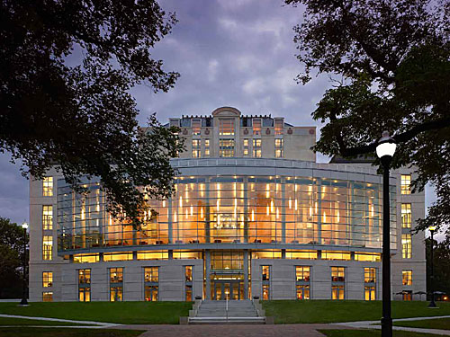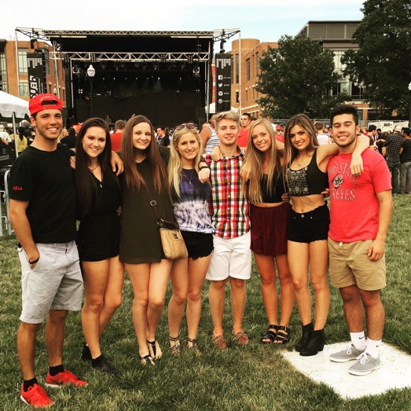

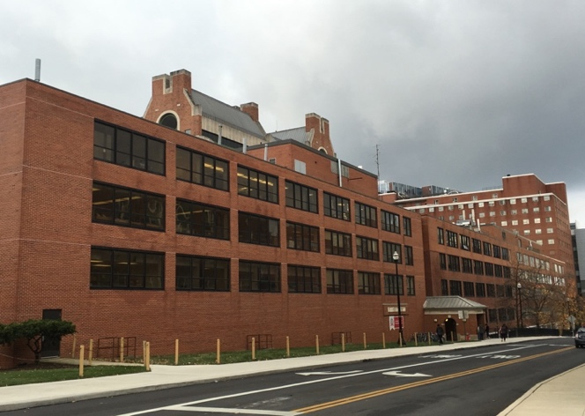

Mario Franco-Di Tore
Final Strategic Life Plan-10702
12/3/15

This semester has helped me realize several things one of the most important being that I am undecided if I want to stick to being a biology major for four years. I think that I am leaning toward switching to a business major with a minor in biology so I have a back up plan and so I can finish my prerequisites for professional school. This would be a great secondary path so I can pursue an MBA if I do not get into dental school. This year has also helped me realize that there are so many resources to help me find a perfect career for me for example, www.explorehealthcareers.org and OnPace were helpful tools to see what careers matched up with my interests. I have also learned that balancing a social life and schoolwork is a little more challenging than expected. To keep order between the two I will be active in intramural sports and possibly join a fraternity and know when to make sacrifices for studying. This semester has taught me that the greatest source of wisdom I have is my older brother. He went through his ups and downs in college and he has helped me out a ton with my journey in college. Next semester I would like to get more involved by doing service and volunteering or finding a job at Postle Hall. In my opinion, my first semester has set me up to be successful for the upcoming semesters I have at The Ohio State University.

