POLITICAL COMMUNICATION SURVEY COLOMBIA 2014

B. Demographic information
B1. Gender: Male (0) Female (1)

B2. ¿What is your current age? ___

B3. ¿What is the highest educational level you have attained?
a. None 1
b. Incomplete primary 2
c. Complete primary 3
d. Incomplete secondary 4
e. Complete secondary 5
f. Incomplete collage 6
g. Complete college 7
h. Graduate 8

B4. ¿What is the energy stratum of this household?

B5. In what range would you estimate the monthly household income of this household?
- Less than $500,000
- Between $501,000 and $1,000,000
- Between $1,001,000 and $2,000,000
- Between $2,001,000 and $3,000,000
- Between $3,001,000 and $4,000,000
- Between $4,001,000 and $6,000,000
- Between $6,001,000 and $8,000,000
- Between $8,001,000 and $10,000,000
- More than $10,000,000

B6. To what ethnic group do you consider that you belong to? (Interv
Indigenous
Black/Afro Colombian/Mulato
White
Mestizo/Mixed/Without ethnic affiliation

C. Media use
C7. We would like to ask you some questions about the use you make of certain media outlets. Using a scale from 0 to 5, where 0 means never and 5 means frequently, how often do you read, watch or listen to the following media:
- Radio news
- National daily newspapers
- Regional or local newspapers
- National news magazines (e.g. Semana)
- National television news
- Regional television news
- International cable news (e.g. CNN, BBC)
- Latin American cable news (e.g. NTN 24,Telesur
- Online news
- Social media

C8. Now we would like to ask you about your sources for specific events or issues. Using a scale from 0 to 5, where 0 means never and 5 means frequently, how often did you read, watch or listen to the following media, regarding the peace process with FARC:
- Radio
- Newspapers
- Magazines
- Television
- Internet
- Social Media

C9. On a scale from 0 to 5, where 0 means none and 5 means a lot, how much attention did you pay to the following types of news?
- Presidential election
- International news
- National political news
- City news
- Guerrilla peace process

C10. How do you evaluate the credibility of different news sources? For this question we will use a scale from 0 to 5 where 0 means not credible at all and 5 means very credible. In your opinion, who provides the most credible information on the presidential election?
- Radio news
- Newspapers
- Magazines
- Television news
- Internet
- Social media
- Political officers
- Friends
- Family members

C11. In your opinion, who provides the most credible information on the Guerilla peace process?
- Radio news
- Newspapers
- Magazines
- Television news
- Internet
- Social media
- Political officers
- Friends
- Family members

D. Internet

D17. Have you used the Internet in the last 12 months?
Yes 1 No 0 (Go to E25)

D18. How old were you when you first used Internet? ___

D19. How frequently do you use the Internet?

Almost Never 0---|---|---|---|---|---|---|---|---|---5 Everyday

D20. On average how many hours would you say you use Internet per day? ____

D22. Using a scale from 0 to 5, where 0 means never and 5 frequently. How frequently does .............., do the following activities on the Internet?
- Search for news information
- Seek Government Information
- Discuss the news and opinion columns that appear in the online media
- Participate in online discussion forums
- Visit political blogs
- Sign up to volunteer for a campaign/issues
- Support political protests
- Use Social Media
- Mobilize your contacts around social or political causes
- Express your opinion on social and political issues
- Keep in touch with family and friends
- Keep in touch with people related to work

D24. On average how many days per week do you visit an online news website?

D25. What is the online news site you visit the most?_______________________

E. Mobile phones

E26. Do you have a cell phone? (1) Yes (0) No

E28. Does your phone have data capabilities? (1) Yes (0) No

E33. Using a scale of 0 to 5, where 0 is never and 5 is frequently, how often do you?
              - Search for information on your phone in the moment to settle a dispute.
              - Search for relevant information on your phone while discussing politics or current affairs with others.

F. Social media

F35. Are you a member of online social Networks such as Facebook? Yes 1 No 0

F36. Do you use Twitter? Yes 1 No 0
(If NO to both F34 and F35 go to XXX. If yes to at least one ask the following as appropriate)

F37. How many contacts or friends do you have on your online social networks? ___

F38. How many people or entities do you follow on Twitter? ___

F39. How many people follow you on Twitter? ___

F40. How often do you?

a. Check Facebook  1-Several times a day  Once a day  2 or 3 times per week  Once a week  Once a month  6 -Never | b. Post on Facebook  Several times a day  Once a day  2 or 3 times per week  Once a week  Once a month  Never | c. Check Twitter  Several times a day  Once a day  2 or 3 times per week  Once a week  Once a month  Never | d. Post on Twitter  Several times a day  Once a day  2 or 3 times per week  Once a week  Once a month  Never

F41. We want to understand how you use Facebook and Twitter. On a scale from 0 to 5, where 0 means never and 5 frequently. On Facebook and Twitter how frequently do you: (Asked based on previous responses).
 | Facebook | Twitter
b. Express your views on current issues | Never 0-1-2-3-4-5 Frequently | Never 0-1-2-3-4-5 Frequently
d. Share news stories with your contacts | Never 0-1-2-3-4-5 Frequently | Never 0-1-2-3-4-5 Frequently
e. Read news articles posted by your contacts | Never 0-1-2-3-4-5 Frequently | Never 0-1-2-3-4-5 Frequently
f. Mobilize your contacts about social or political causes | Never 0-1-2-3-4-5 Frequently | Never 0-1-2-3-4-5 Frequently
h. Express your views on the presidential election | Never 0-1-2-3-4-5 Frequently | Never 0-1-2-3-4-5 Frequently
i. Post or shared photos, videos, memes o gifs created by you that relate to current events or politics | Never 0-1-2-3-4-5 Frequently | Never 0-1-2-3-4-5 Frequently
k. Receive messages or  Information from a politician or political party | Never 0-1-2-3-4-5 Frequently | Never 0-1-2-3-4-5 Frequently
l. Read the opinions of your contacts about political issues. | Never 0-1-2-3-4-5 Frequently | Never 0-1-2-3-4-5 Frequently
m. Click like, or share, political information. | Never 0-1-2-3-4-5 Frequently | Never 0-1-2-3-4-5 Frequently

F47. Using a scale from 0 to 5, where 0 means never and 5 frequently. How often have you started talking about politics with your friends because of social media?

F48. How often do you disagree with the political opinions your friends post on Facebook or other online social networks?
Never, almost never, sometimes, almost always, always

F49. Have you ever hid someone’s comments from your feed, because they do not share your political views? Yes (1) No (0)

F50. If yes how often have you done this?
Almost never (0) Frequently (5)

F51. Have you ever unfriended someone, because they do not share your political views? Yes (1) No (0)

F52. If yes how often have you done this?
Almost never (0) Frequently (5)

F53. Have you ever been unfriended by someone, because of political differences?
Never (0) Frequently (5)

F54. When you see a friend post an opinion about politics that you disagree with, do you:
        - Respond to it by posting a comment or posting something of your own. 1
        - Delete it from your wall. 2
        - Nothing. 3

F55. How often have you learned about your friends’ political orientation through social media?
Never (0) Frequently (5)

F56. Use a scale from 0 to 5, where 0 means none and 5 almost all. In the past presidential election about how many of your friends on Facebook:
- Became “friends” with one of the candidates
- Posted their political stance on key campaign issues.
- Revealed which presidential candidate they voted for.

F57. And how about you? Using the same scale, in the past presidential election did you:
        - Become “friends” with one of the candidates
        - Post your political stance on key campaign issues.
        - Revealed which presidential candidate you voted for.

G. Interpersonal communications

G62. Using a scale from 0 to 5, were 0 is never and 5 often, how often have you commented the news or talked politics with:
a. Family members
b. Coworkers or classmates
c. Neighbors
d. Friends or acquaintances

G66. Using a scale from 0 to 5, were 0 is never and 5 often, how often have you talked about the peace process with the FARC in Cuba with:
a. Family members
b. Coworkers or classmates
c. Neighbors
d. Friends or acquaintances

H. PARTICIPATION

H70. Now I want to ask you some questions about the recent presidential election. Using a scale from 0 to 5, were 0 is never and 5 often, during the final days of the campaign how frequently did you watch the presidential debates on TV? Watched the presidential debates on television.

H71. Regardless of which candidate you preferred, for which candidate did you see more political advertisements:
________________________________

J. POLITICAL EFFICACY

J74. Some people believe that they can have influence on political and community issues, while others believe that they don't really have much influence. Using a scale from 0 to 5, where 0 means total disagreement and 5 total agreement, how much do you agree or disagree with the following statements?
a. People like me, can influence what local government does.
b. I believe that the national government cares about what people like me think.
c. City government responds to the initiatives of individuals.
d. Sometimes government and politics are so complex that someone like me cant really understand what is going on.
L. POLTICAL INTEREST AND EVALUATIONS

L77. On a scale from 0 to 5, were 0 means not at all and 5 a lot, how interested are you in:
a. Local or regional politics
b. National politics
c. International politics
L79. What is the most important problem faced by Colombia? ________________________________
L80. In the last year the quality of life in Colombia:
a. Has worsened
b. Has remained the same
c. Has improved
L81. In the last year, poverty in Colombia:
a. Has worsened
b. Has remained the same
c. Has improved
L82. In the last year security in Colombia:
a. Has worsened
b. Has remained the same
c. Has improved
L83. In the last year security ... ... ... .. (Insert city in the survey):
a. Has worsened
b. Has remained the same
c. Has improved
L84. In the last year environmental conditions in Colombia:
a. Have worsened
b. Have remained the same
c. Have improved

M. POLITICAL VALUES

M87. Using a scale from 0 to 5, where 0 means total disagreement and 5 total agreement, how much do you agree or disagree with the following statements?
a. Most people are honest.
b. I trust the information I see in the news.
M88. Using a scale from 0 to 5, where 0 means no trust and 5 a lot of trust, how much do you trust the following institutions?
a. Congress
b. Judges
c. Armed Forces and Police
d. Political parties
e. The National Government
f. The Government of your City
g. The Supreme Court
h. Media
i. The church
j. Professional guilds (eg, ANDI, FENALCO, SAC, FEDEGAN)

O. The Peace Process

O90. Some people think that the issue of the guerrillas can only be resolved by military means, while others think a peace process is necessary to solve it. In your opinion, what percentage of people in Colombia support:
Military solution ___
A peace process ___

N91. And with respect to solving the guerrilla issue and using a scale where 1 is equivalent to a military solution and 7 to a peace process, where would you place:
a. Your own opinion on this issue
And where would you place the position of the following political actors:
b. National Government
c. Media

N92. If the peace process with FARC advances and an agreement is reached, using a scale from 0 to 5, where 0 means total disagreement and 5 total agreement how much do you agree or disagree with the following statements:
- Ex Farc members should be allowed to run for political office.
- I would feel comfortable having and ex Farc member as a coworker.
- I would feel comfortable having an ex Farc member as a neighbor.
- Ex Farc members should be allowed to express their views on national media
- Ex Farc members should be sent to jail.

N93. Using a scale from 0 to 10, where 0 means not important and 10 means very important, how important is it than in the peace process with FARC?
a. Victims get reparations
b. A historical memory of the conflict is established
c. The actions of FARC members should be judged
d. The actions of FARC members who have committed human rights crimes should be judged
e. FARC recognizes the human rights crimes that they have committed
f. The Colombian government recognizes the human rights crimes that it has committed

N94 Do you think that the peace in Colombia will be achieved:
a. Next year
b. In the next 2 years
c. In the next 3 years
d. In the next 10 years
e. In the next 20 years
f. It will take more than 20 years

GovPerf
Thinking back to the time of the election, to what extent were you satisfied or dissatisfied with the performance of the President/Prime Minister?
1 Very dissatisfied
2 Dissatisfied
3 Neither satisfied nor dissatisfied
4 Satisfied
5 Very satisfied
999 Don’t know

A.EconSit
How would you describe the present economic situation in [country]: very good, good, average, bad or very bad?
1 Very bad
2 Bad
3 Average
4 Good
5 Very good
999 Don’t know

People associate democracy with many diverse meanings. In order for a society to be called democratic, is each of the ones I will mention Absolutely essential, Important, Not very important or Not important at all?
B.DemMeanCrit
-- Freedom to criticize the government
B.DemMeanJobs
-- Jobs for everyone
B.DemMeanElec
-- Free and fair elections
B.DemMeanGap
-- A smaller income gap between rich and poor
3 Absolutely essential
2 Important
1 Not very important
0 Not important at all
999 Don’t know

B.MediaExtent
In your opinion, how much of a free and uncensored media does the [country name] have today?
3 Completely free media
2 Partly free media, with minor problems
1 Partly free media, with major problems
0 Not free media
999 Don’t know

I will read you some statements about your role in the political system. Please tell me if you Strongly agree, Agree, Disagree or Strongly disagree with each statement.
B.PolCompl
-- Generally, politics seems so complicated that people like me cannot understand what is happening.
B.DontCare
-- Politicians don’t care much about what people like me think.

1Strongly agree
2 Agree
3 Neither agree nor disagree [DO NOT ASK, BUT CODE IF THEY DO NOT AGREE OR DISAGREE]
4 Disagree
5 Strongly disagree
999 Don’t know

There are many ways to govern a country. Would you Strongly Agree, Agree, Disagree or Strongly Disagree with the following alternatives?
B.RejOneParty
-- Only one political party should be allowed to stand for election and hold office.
B.RejPresDict
-- Elections and the National Assembly should be abolished so that we can have a strong leader running this country.
B.RejMilRule
-- The army should govern the country.
B.RejReligRule
-- Religious leaders should govern the country according to religious principles

1 Strongly Agree
2 Agree
3 Neither agree/disagree [DO NOT ASK, BUT CODE IF THEY DO NOT AGREE OR DISAGREE]
4 Disagree
5 Strongly disagree
999 Don’t know

B.DemAuth
Which of the following phrases most closely reflects your own opinion?
3 Democracy is preferable to any other form of government
2 Under some circumstances, an authoritarian regime, a dictatorship, is preferable to a democratic
system
1 For people like me, one regime is the same as another.

B.DemExtent
In your opinion, how much of a democracy is [name of country] today? [READ FOLLOWING OPTIONS]
3 A full democracy
2 A democracy, but with minor problems
1 A democracy, but with major problems
0 Not a democracy

B.DemSat
In general, are you Very satisfied, Somewhat satisfied, Not very satisfied or Not at all satisfied with the way democracy is working in [name of country]?
3 Very satisfied
2 Somewhat satisfied
1 Not very satisfied
0 Not at all satisfied / Not a democracy
999 Don’t know

Many people, when they think about politics, use the words “left” and “right.”

C.LRSelf
According to your own political opinions, where would you place yourself on a scale from left to right…[pause], or do you not normally use these terms?

Don’t Know
LEFT RIGHT Don’t use scale
1 2 3 4 5 6 7 8 9 10 999

I would now like you to classify parties according to the same left-right scale. In which column would you place [the largest governing party, the largest opposition party, etc.]?

C.LRGov4
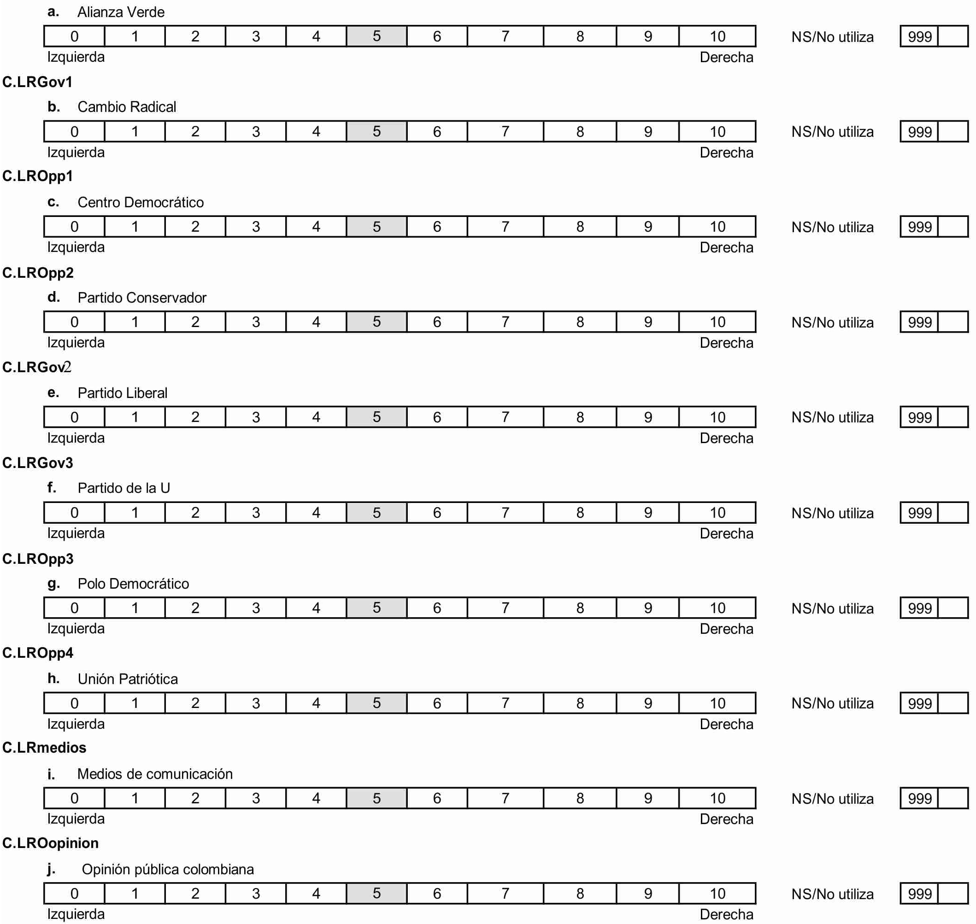

70 .C.PartyID
Many people feel close to a particular political party over a long period of time, although they may occasionally vote for a different party. What about you? Is there a particular political party that you feel closer to than all the other parties?
0 No
1 Yes
998 Refused to answer
999 Don’t know

71. [IF YES] C.PartyIDWhich
Which one?
1-n [List of all parties receiving significant numbers of votes]
995 NA [C.PartyID is not YES]

72. [IF YES to C.PartyID] C.PartyIDStrength
How strongly do you support this party: Very strongly, Somewhat strongly, or Not very strongly?
3 Very strongly
2 Somewhat strongly
1 Not very strongly
0 No PartyID [C.PartyID is not YES]
999 Don’t know

73.
C.ThermGov1Leader, C.ThermOpp1Leader, etc.
We would like to know your feelings towards some political figures and groups on a scale from 0-10. For example, if you feel very favorable towards one of the individuals or groups listed, you can give it a high score up to 10; if you feel very unfavorable towards this person or group you can give a low score down to 0 (zero); if you feel neutral towards it, you should give it a 5. If you have not heard enough about this person or group to have an opinion, feel free to indicate it.

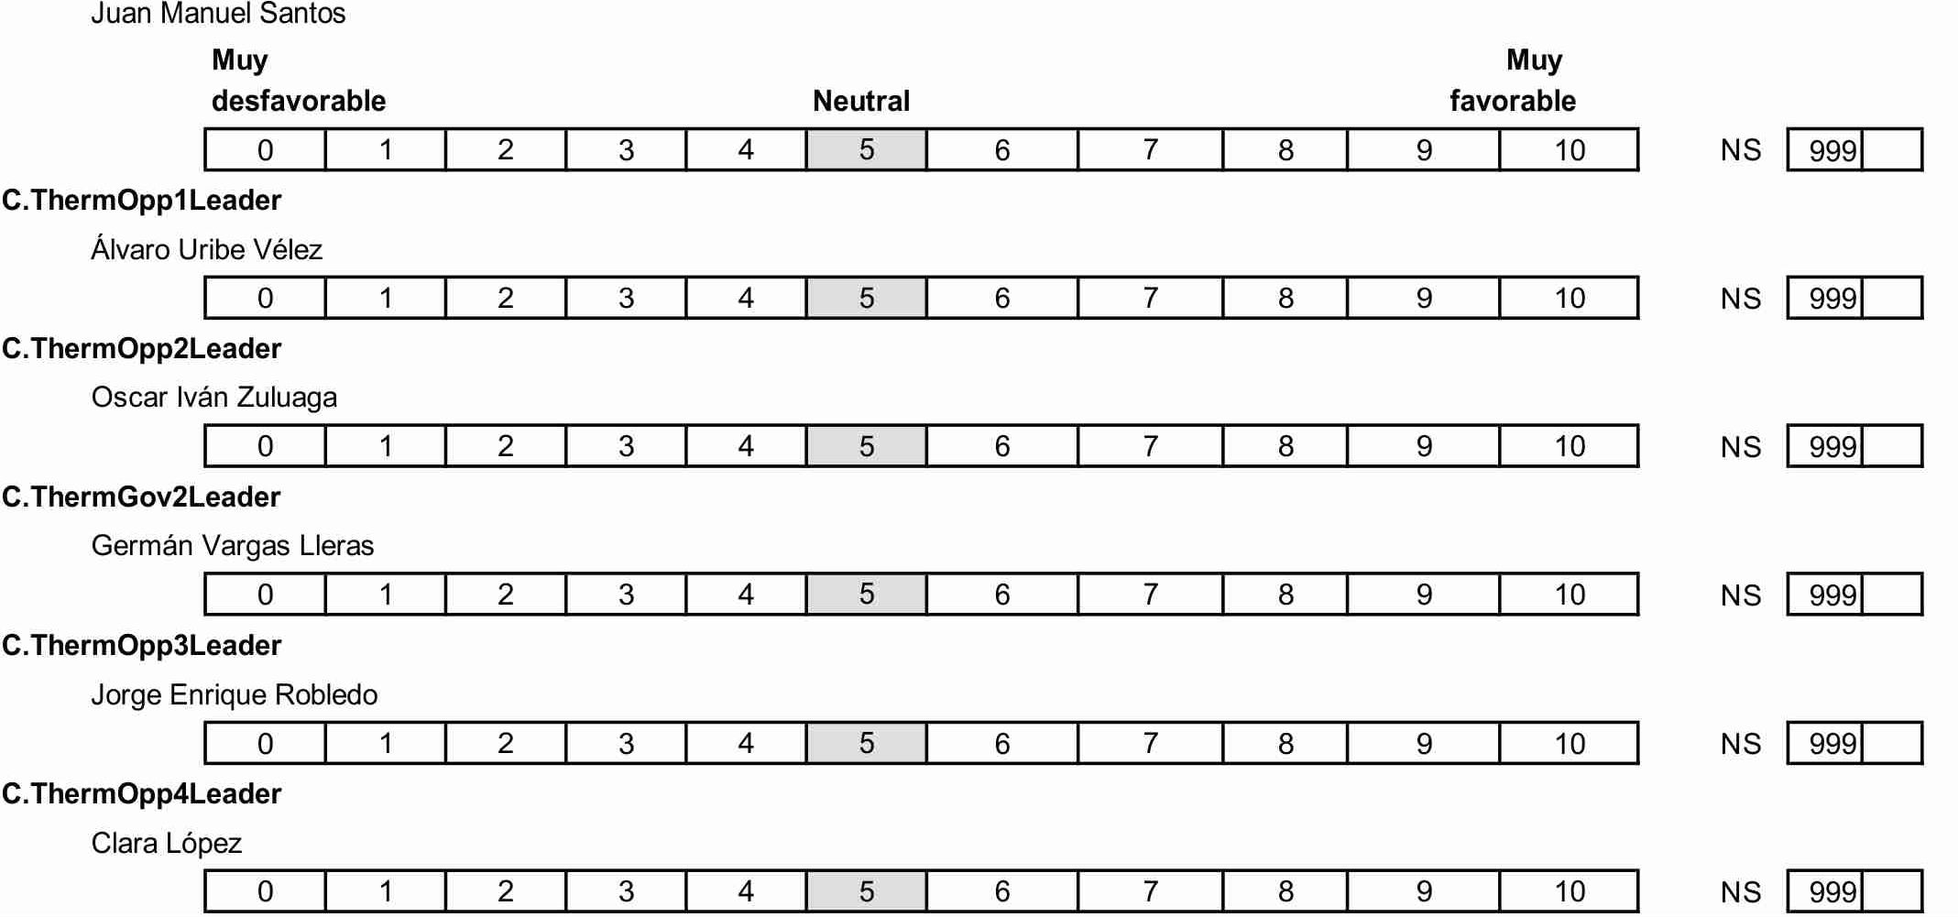

74 During the electoral campaign how frequently did you follow political news through…
D.CamPaper
…Newspapers, including online editions
D.CamRadio
…Radio, including online and satellite broadcasts
D.CamTV
…Television, including online broadcasts
D.CamInternet
…Other sources accessed by computers or mobile devices
0 Never
1-7 Number of days each week
999 Don’t know
C. SocialNetwork
… Twitter or Facebook

75. D.MediaAgree
Across all of the media sources you may have used to obtain information about the campaign, how many supported the same political party as you did?
3 All or almost all
2 Most
1 Some
0 None
999 NS
76. D.Paper
During the campaign, which newspaper did you read most often?

[Write name of paper—to be coded later]
999 Don’t know/Can’t remember
995 NR
77. [IF D.CamPaper is 1-7 days] D.Pap1Bias
Do you think this newspaper you read most often favored a particular political party or candidate?
0 No
1 Yes
995 Not Applicable [D.CamPaper is 0]
999 Don’t know
78. D.Pap1Part
Which political party or candidate? [Allow more than one response]

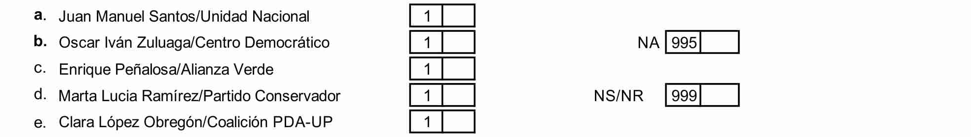

79 D.Rad1Bias
Do you think the radio program you listened to most often favored a particular political party or candidate?
0 No
1 Yes
995 Not Applicable [D.CamRadio is 0]
999 Don’t know

80. Which political party or candidate? [Allow more than one response]

81. D.TV1
During the election campaign, which news broadcasts did you watch most often on television?

[Write name of station or network and time—to be coded later]
999 Don’t know/Can’t remember
995 NS

82. D.TV1Bias
Do you think the television news broadcasts you watched most often favored a particular political party or candidate?
0 No
1 Yes
995 Not Applicable [D.CamTV is 0]
999 Don’t know

83. D.TV1Part
Which political party or candidate?

84. D.Internet Did you use a computer or mobile device to receive information about the election campaign from sources such as websites, e-mail, social networks, apps, or texting
O No or Don’t Know
1 Yes
85. [IF Yes (1)] How frequently did you use a computer or mobile device to receive information about the election campaign from… [ASK FOR EACH OF THE FOLLOWING]
D.InterNews News Media
D.InterParty Party or candidate sources
D.InterFriends Information/comments by people I know personally
D.InterOther Information/comments by other people online
D.InterInfo Other political information sources not linked to parties or candidates
[provide appropriate examples]
0 Never
1-7 Number of days per week
999 Don’t know
995 Not Applicable [answered “No” to D.Internet]

86. [IF YES to D.Internet] D.InterBias
Overall, across all of the electronic sources you may have used, do you think the information provided via computers and mobile devices favored a particular party or candidate?
0 No
1 Yes, mostly
2 Yes, completely
995 Not applicable

87. [IF D.InterBias YES] D.InterPart
Which political party or candidate? [multiple responses allowed]
1-n [List of all parties receiving significant numbers of votes]
995 Not Applicable [D.InterBias1 is not YES (1 or 2)]
999 Don’t know

88. [IF YES TO D.Internet] D.InterShare During the course of the election campaign, did you post your own personal thoughts or opinions about a particular candidate or party?

0 Never
1 Rarely
2 Sometimes
3 Often
999 Don’t know
995 Not Applicable [NOT yes to D.Internet]

89. Now thinking about people you talked to about the campaign…

E.FamTalk How frequently did you talk about the most recent election campaign with your family: often, sometimes, rarely or never?
E.FriendTalk How frequently did you talk about the most recent election campaign with your friends: often, sometimes, rarely or never?
E.NeighTalk And what about your neighbors--how frequently did you talk with them about the most recent election campaign: often, sometimes, rarely or never?
E.WorkTalk Finally, if you are employed or recently employed, how frequently did you talk about the most recent election campaign with your co-workers: often, sometimes, rarely or never, or are you not employed? [Ask the following two only if employed or recently employed]

90. E.DiscAgree
Across all of your conversations about the most recent election campaign, how many of you discussion partners supported the same political party as you did?

E.FamTalkPart Do you think that the members of your family supported the same party that you did; supported another party; or divided their support among different parties?
E.FriendTalkPart Do you think that your friends supported the same party that you did; supported another party; or divided their support among different parties?
E.NeighTalkPart Do you think that your neighbors supported the same party that you did; supported another party; or divided their support among different parties?
E.WorkTalkPart Do you think that your co-workers supported the same party that you did; supported another party; or divided their support among different parties?

3 Supported same party as respondent
2 Support divided among different parties
1 Supported another party
995 Not Applicable [NEVER discusses politics or not employed]
999 Don’t know
91. L.Married
Are you…
1 Single
2 Married / Living with partner
3 Divorced / Separated from/not living with spouse
4 Widowed
5 Other [Specify] _____________

92. E.SpouTalk
How often did you talk to your spouse/partner about the recent election?
0 Never
1 Rarely
2 Sometimes
3 Often
995 Not Applicable [not married or co-habiting]
999 Don’t know
93. E.SpouVote
Which party, if any, did your spouse/partner support in the last election? [add if any]
0 No party
1-n [List of all parties receiving significant numbers of votes]
995 Not applicable [not married or co-habiting]
94. E.Disc1
[IF RESPONDENT IS MARRIED OR LIVING WITH PARTNER]
Now I would like you to think of someone other than your spouse with whom you most frequently talk about matters that are important to you.

[IF RESPONDENT NOT MARRIED OR LIVING WITH PARTNER]
Now I would like you to think of someone with whom you most frequently talk about matters that are important to you. What is this person’s relation to you?

1 Close family member
2 More distant family member
3 Co-worker
4 Neighbor
5 Prominent community member
6 Close friend
7 Religious leader [NOTE: this is a new response category]
8 Other [SPECIFY] _______________________ [ALSO USE FOR INDIVIDUALS IN MORE THAN ONE OF THESE CATEGORIES]
995 Not Applicable [No Discussant]

95. E.Disc1Freq
How often did you talk to this person about the recent election?
0 Never
1 Rarely
2 Sometimes
3 Often
995 Not Applicable [No discussant]
999 Don’t know

96. E.Disc1Part
Which party, if any, did he /she support in the last election?

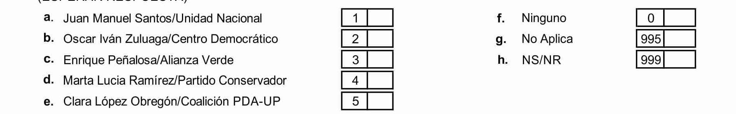
0 No party
1-n [List of all parties receiving significant numbers of votes]
995 NA [No discussant]

97. E.Disc2 Now I would you to think of someone else with whom you frequently talked about matters that are important to you? What is this person’s relation to you?
1 Close family member
2 More distant family member
3 Co-worker
4 Neighbor
5 Prominent community member
6 Close friend
7 Religious leader [NOTE: this is a new response category]
8 Other [SPECIFY] ______[USE FOR INDIVIDUALS IN MORE THAN ONE OF THESE CATEGORIES]
995 Not Applicable [No Discussant]

98. E.Disc2Freq
How often did you talk to this person about the recent election?
0 Never
1 Rarely
2 Sometimes
3 Often
995 Not Applicable (No discussant)
999 Don’t know

99. E.Disc2Part
Which party, if any, did he / she support in the last election?
[List of all parties receiving significant numbers of votes—See Appendix]

0 No party
1-n [List of all parties receiving significant numbers of votes]
995 NA [No discussant]

100. E.DiscNumber In total, how many different people did you talk to about the recent election campaign?

[WRITE NUMBER, FROM 0 to 9,999] _________________________

101. E.DiscAgree Of these individuals with whom you talked about the campaign, how many supported the same political party as you did?
3 All or almost all
2 Most
1 Some
0 None

102. E.ComLeaderAdvise1 [USE WHATEVER TITLE OR DESCRIPTIVE LANGUAGE MAKES THE MOST SENSE IN YOUR CULTURAL OR SOCIETAL CONTEXT]
Did you receive any advice from a community leader, a religious leader, or both concerning the best candidate/ party in the most recent election campaign?
0 No / Don’t Know
1 Yes, local community leader
2 Yes, religious leader
3 Yes, both

103. E.ComLeaderAdvise2
Which party/candidate was that?

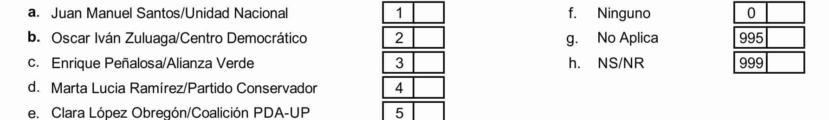

1-n [List of all parties receiving significant numbers of votes]
995 NA [No advice received]

104. F.AsoParty
Are you a member of a political party or other political group?
0 Not a member / Don’t know
1 Belongs
[NO OTHER CODES ACCEPTABLE]

105. Could you please tell me if you are a member of any of these types of organizations? [SHOW CARD OR READ LIST: MULTIPLE RESPONSES ALLOWED]
F.AsoTU -- Labor Union [use whatever terminology is most common in your country]
F.AsoProf – Professional, business or farmers’ organizations
F.AsoRelig -- Religious groups
0 Does not belong / Don’t know
1 Belongs
[NO OTHER CODES ACCEPTABLE]
F.AsoOther -- Any other type of organization?
___________________ [Write type of organization, to be coded later

106. F.AsoCont
Did you receive any information about the recent election campaign from any one of these groups?
0 No/Don’t know
1 Yes
995 Not applicable [Not a member of any organization]

[IF YES]
107. F.AsoContWhich
Which of these types of organizations provided you with this information? [CARD--MULTIPLE RESPONSES ALLOWED]

1 Labor Union
2 Professional or business
3 Religious
4 Political parties or groups
5 Other _______________ Write type of organization²
995 Not Applicable [“No” or NA to F.AsoCont]

[ASK NEXT TWO QUESTIONS IF RESPONDENT RECEIVED CONTACT DURING CAMPAIGN] [F.AsoCont is Yes)]

108. F.AsoContHow
Thinking of the most important of these groups providing information about the recent election campaign, how did you receive this information?
1 Mail or other printed material
2 Phone call
3 E-mail or other electronic media
4 Personal contact

109. F.AsoContPart
Which party or candidate did this group support?
0 No party supported
1-n [List of all parties receiving significant numbers of votes]
995 NA [no contact or not a member (F,AsiContHow = 995)]
999 Don’t Know

110. H.Interest
More generally, would you say that you are very, somewhat, not very or not at all interested in politics?
3 Very interested
2 Somewhat interested
1 Not very interested
0 Not at all interested
999 Don’t know

111. We would like to know to what degree [citizens of X country] are familiar with certain public figures our country political characteristics [EACH COUNTRY TO DECIDE WHAT IS MOST RELEVANT, BUT AVOIDING TEXTBOOK INFORMATION]:
H.InfoTest1
For example, do you remember the name of the current Colombia’s vice-president (Angelino Garzón)
H.InfoTest2
How about the name of the president of the Supreme Court? (Luis Gabriel Miranda Buelvas)
H.InfoTest3
Do you know the name of Defense Minister? (Juan Carlos Pinzón)
H.InfoTest4
Do you know which party got the majory of parlaments for the Congrees in the past elections? (Partido de la U).

0 Don’t know / can’t remember / incorrect answer
1 Correct name

112. H.Protest
Have you taken part in a protest demonstration in the last twelve months?
No 0
Yes 1

113. H.CamWork
Did you work for any party or candidate during the election campaign?
No 0
Yes 1

114. H.CamPersuade
During the campaign, did you try to persuade anyone to vote for or against one of the parties or candidates?

0 No / don’t know
1 Yes

115. H.Turnout
Did you vote in the recent election?
[if country teams want to include the stricken language or something similar to make respondents feel free to admit that they did not vote, they should feel free to do so, but this is no longer part of the “core”]
0 No / don’t know
1 Yes

[IF YES ON H.Turnout]

116. H.VoteWhichRecent
For which party [or candidate] did you vote [in the most recent election]?

1-n [List of all parties receiving significant numbers of votes]
993 Did not vote

117. H. Turnout2 Did you vote in the second round of the presidential elections?

0 No
1 Yes

(Yes in 117 H Turnout2)

118. H.Turnout2 For which party [or candidate] did you vote in the second round?

1-n [List of all parties receiving significant numbers of votes]
993 Did not vote

119. H. Voteporque. Could you tell us why do you decide to vote or not vote, or why did you decide to support the candidate that you choose vote for?

(Open question)

120. H.Decide
When did you decide to vote for that party [or candidate]?
1 On election day
2 Last week before election day
3 Few weeks before election day
4 At least a month before election day
5 Before election campaign started / Always intended voting for this party
995 Not applicable (no vote)
999 Don’t know

121. H.VoteWhichPrevious
And do you recall what party you voted for in the previous election in 2010, or did you not vote? Which party was that?

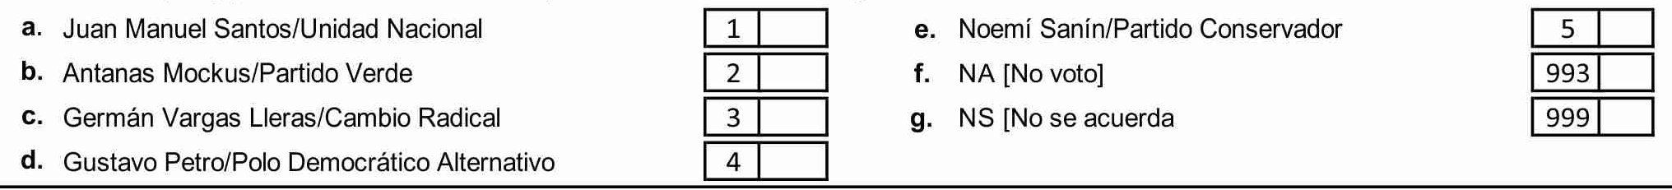

1-n [List of all parties receiving significant numbers of votes]
993 Did not vote
999 Don’t know/Can’t remember

122. I.PartyPers
Did a representative of any of the following parties contact you in person during the campaign?

[ALLOW MULTIPLE RESPONSES]

123. I.PartyContact
Did any of the following parties contact you in any other way during the campaign? [ALLOW MULTIPLE RESPONSES]

0 No / No Answer / Don’t know
1-n [List of all parties receiving significant numbers of votes]

124. I.MeetAny
Did you attend any party meetings or rallies during the election campaign?
0 No / Don’t know
1 Yes
[IF YES]

125. I.MeetPart
Which party?

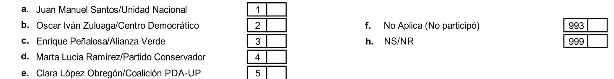

1-n [List of all parties receiving significant numbers of votes]
995 Not applicable [did not attend meeting]

126.I am now going to read you a series of alternative phrases. Could you please tell me to what extent you agree with one or the other. A score of 1 represents complete agreement with the first phrase and rejection of the second phrase. Conversely, a 10 indicates that you prefer and completely agree with the second phrase. And scores between 2 and 9 represent intermediate opinions.

COMPLETE AGREEMENT COMPLETE AGREEMENT
WITH FIRST PHRASE WITH SECOND PHRASE

1 2 3 4 5 6 7 8 9 10
J.ReligLaw
- Our religious beliefs should provide the basis for the laws of our country.
- No single set of religious beliefs should be imposed on our country

J.EqualInd
1. There should be a more equal distribution of wealth
2. There should be more incentives for individual initiative

J.OrderLib
1. Maintain law and order
2. Defend civil liberties

J.ServTax
1. Improve government services and social assistance, even if it means increasing
taxes
2. Reduce taxes, even if it means reducing government services and social assistance

J.SexRole
1. It is best for the woman to stay home and take care of the kids, and that men are the provider for the family.
2. It is best if both women and men equally share providing for the family and taking care of home and the kids.

J.OurWay
1. It is a good idea to copy good practices from other people all over the world
2. Our country should defend our way of life instead of becoming more and more like other countries.

J.Customs
- It is better for society if different [racial] into the larger and ethnic groups maintain their distinct society customs and traditions.
- It is better if these groups adapt and blend into the larger society.

127. K.ElectsFF
On the whole, how would you rate the freeness and fairness of the most recent national election?
0 Not free and fair
1 Free and fair with major problems
2 Free and fair with minor problems
3 Completely free and fair
999 Don’t know

Please tell me if any of the following happened to you personally or to someone that you know.
[IF YES TO ANY OF THE FOLLOWING]
Did that happen to you, personally?

128. K.PrevMeet
Prevented from attending an election event, like a campaign rally, by intimidation or fear
0 No / Don’t know
1 Yes, respondent personally
2 Someone respondent knows

129. K.PrevList
Prevented from voting because your name was not on the voter list or because you were prevented from registering to vote

0 No / Don’t know
1 Yes, respondent personally
2 Someone respondent knows

130. K.PrevVote
Prevented from voting by intimidation or fear

0 No / Don’t know
1 Yes, respondent personally
2 Someone respondent knows

131. K.BribeVote
Offered a reward or compensation to vote for a specific candidate or party

0 No / Don’t know
1 Yes, respondent personally
2 Someone respondent knows

132. L.ReligHowMuch
How religious do you consider yourself?

0 Not religious at all
1 Not very religious
2 Somewhat religious
3 Very religious
999 Don’t know

133. L.Religion [CATEGORIES SHOULD CONTAIN COUNTRY’S MAIN GROUPS OR DENOMINATIONS, AS RELEVANT IN COUNTRY]
With regard to religious affiliation, do you consider yourself …
1 Christian, Roman Catholic
2 Christian, Protestant
3 Christian, Orthodox
4 Muslim
5 Hindu
6 Jewish
7 Confucian
8 Buddhist
9 Taoist
10 Shintoist
11 Other [SPECIFY] ________________
12 No religion
999 Don’t know

134. L.ReligFreq
Could you please tell me how often you have gone to church/attended religious services during the past year?
0 Never
1 One, two or three times a year
2 More than three times up to once a month
3 Two or three times a month
4 At least once a week
995 Not Applicable [L.Religion coded “No religion”]
999 Don’t know

135. L.Occupation [IMPORTANT— Most survey research firms will have their own standard items for collecting this occupational information. However this information is solicited, it must be recoded into the following categories. Ideally, these categories should capture the following: (1) Is the respondent working or not? (2) Does R work for himself or for others? (3) What is his/her specific job? (4) Is this work in the informal (underground) or subsistence economy, or is it officially recognized employment in the monetary economy. The recoded variable should have the following categories:]
1 Stay-at-home spouse
2 Retired [ASK L.FormerOccupation]
3 Student
4 Never been employed [DO NOT ASK L.FormerOccupation]
5 Looking for work, unemployed [ASK L.FormerOccupation]
6 Unskilled manual worker in the informal sector
7 Vendor / Hawker / Trader (small scale) in the informal sector
8 Artisan / skilled manual worker in the informal sector
9 Works for others: Unskilled worker (industrial blue collar, farm worker or low level employee)
10 Works for others: Skilled worker (industrial blue collar, farm worker or artisan)
11 Works for others: Salesperson
12 Works for others: Mid-level employee
13 Works for others: Mid-level supervisor and foreman
14 Works for other: Mid-level professional
15 Works for others: Upper-level professional
16 Works for others: Upper-level manager
17 Self-employed: Subsistence farmer (produces only for home consumption)
18 Self-employed: Peasant farmer (produces both for own consumption and some surplus produce for sale)
19 Self-employed: Unskilled manual worker or artisan who owns small business
20 Self-employed: Own small farm (produces mainly for sale)
21 Self-employed: Own medium / large farm
22 Self-employed: Own small business, company, firm
23 Self-employed: Own medium, large business, company, firm
24 Self-employed: Own small professional firm
25 Self-employed: Own medium, large professional firm

136. L.FormerOccupation [ASK ONLY IF RETIRED OR UNEMPLOYED AFTER PREVIOUS EMPLOYMENT]
What was your main occupation?
6 Unskilled manual worker in the informal sector
7 Vendor / Hawker / Trader (small scale) in the informal sector
8 Artisan / skilled manual worker in the informal sector
9 Works for others: Unskilled worker (industrial blue collar, farm worker or low level employee)
10 Works for others: Skilled worker (industrial blue collar, farm worker or artisan)
11 Works for others: Salesperson
12 Works for others: Mid-level employee
13 Works for others: Mid-level supervisor and foreman
14 Works for other: Mid-level professional
15 Works for others: Upper-level professional
16 Works for others: Upper-level manager
17 Self-employed: Subsistence farmer (produces only for home consumption)
18 Self-employed: Peasant farmer (produces both for own consumption and some surplus produce for sale)
19 Self-employed: Unskilled manual worker or artisan who owns small business
20 Self-employed: Own small farm (produces mainly for sale)
21 Self-employed: Own medium / large farm
22 Self-employed: Own small business, company, firm
23 Self-employed: Own medium, large business, company, firm
24 Self-employed: Own small professional firm
25 Self-employed: Own medium, large professional firm

137. L.WorkPrivPub
Do/did you work for a private firm or a government agency?
1 Private
2 Public
995 Not Applicable
999 Don’t know

138. L.SubjClass1
Many people say that they belong to a social class. Do you ever think of yourself as belonging to the Upper, Middle or Working class?
0 No
1 Yes

139. L.SubjClass2
[IF L.SubjClass1 IS YES] With which class would you say you belong?
[IF NO] If you had to make a choice, with which class would you say you belong?
[CARD]
5 Upper class
4 Upper-middle class
3 Middle class
2 Lower-middle class
1 Lower or Working class
999 Don’t know

140. During the electoral campaign many people ask for personal favors for the parties or candidates. Do you know if someone in your neighborhood asked for a favor to a candidate during the last campaign?

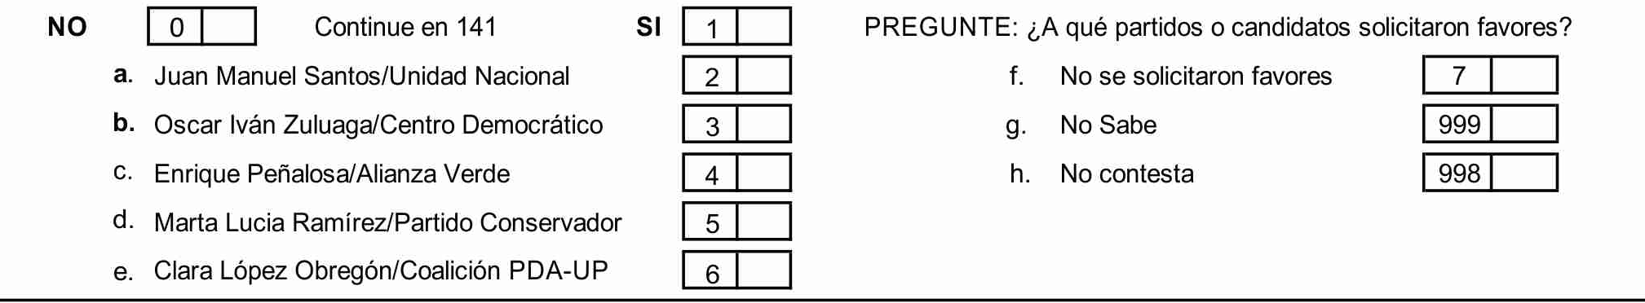

141. In general, in the TV news that you most watch, journalists talk more about good news or bad news in the country?

- Good News
- Bad News

142. In the TV news that you most watched during the elections, journalists talk about candidates as:
1. Enemies
2. Politicians competing with ideas.

143. Define in one word Juan Manuel Santos

144. Define in one word Oscar Iván Zuluaga

145. For the interviewer (Skin Color Palette 1 -11 from lighter to darker)

IMPORTANT: The questionnaires used in each country study should include the names or initials of all significant political parties in a list of response options numbered 1-n. However, before the data set is submitted for inclusion in the CNEP merged data set, parties should be renamed using the generic descriptors Gov1 [for the largest governing party at the time of the election under study], Gov2 [for the second-largest party in a governing coalition], … Opp1 [for the largest opposition party], Opp2… etc. The corresponding list of names and generic equivalents should then be added to the Appendix.
[“Other” organizations should be coded as follows after the interview]: F.AsoMove-- Environmental, feminist or peace groups F.AsoComm-- Community groups, neighborhood associations, parents groups F.AsoSocial-- Sports clubs; Youth, women’s or senior citizens’ social groups; Educational, artistic or cultural groups F.AsoFrat -- Fraternal organizations, veterans’ associations, ethnic associations, charitable associations F.AsoCharity -- Charitable organization, religious or otherwise

